**Name: Gourav Kashyap**

Project: Aws Capstone

Setup VPC for Load Balancer, Application EC2 instance and RDS Database - one public and two private subnets.

• Create Load balancer and Auto Scaling Group.

• Create RDS DB instance and DynamoDB table.

• S3 Bucket

• Get domain name and map it with Load Balancer

• Create instance profile that has to be attached to the EC2 instances being launched. Instance profile should have

permission to access RDS, DynamoDB and S3 bucket.

• Lambda function to get triggered when an object is uploaded to the bucket

• SNS Topic for Lambda and user email id subscription

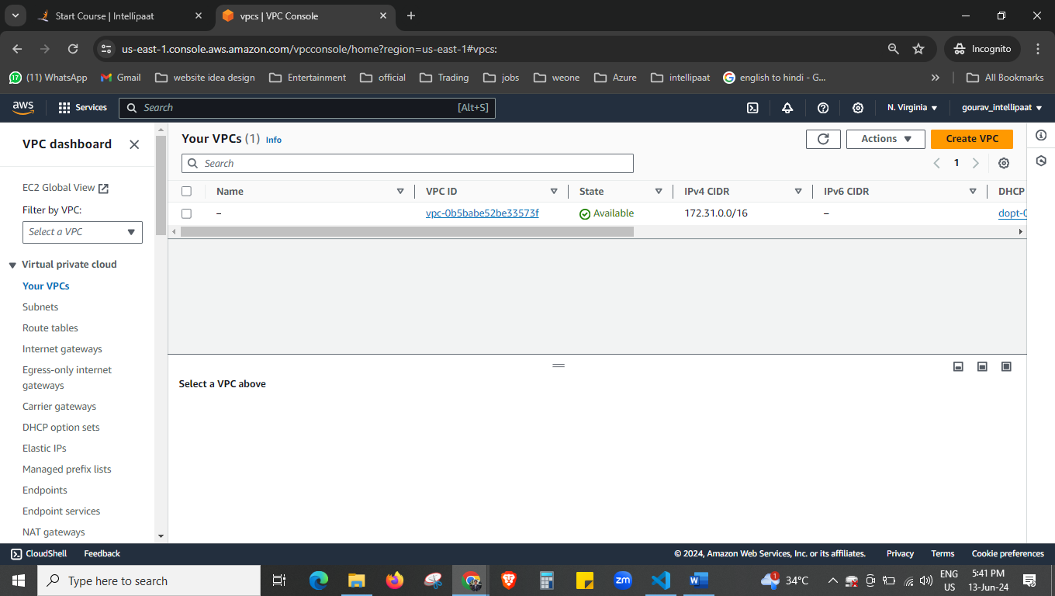

First we are creating the VPC

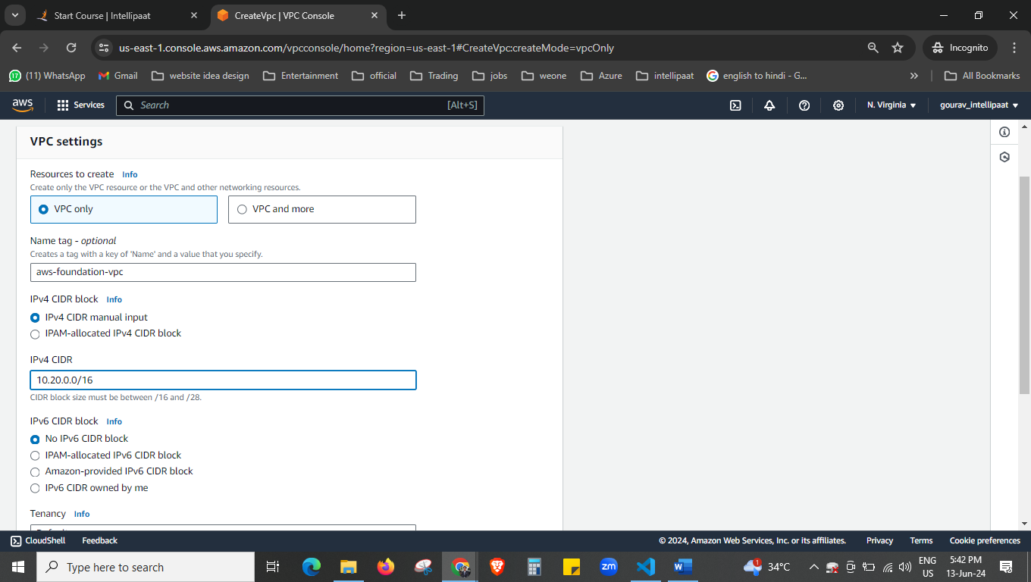

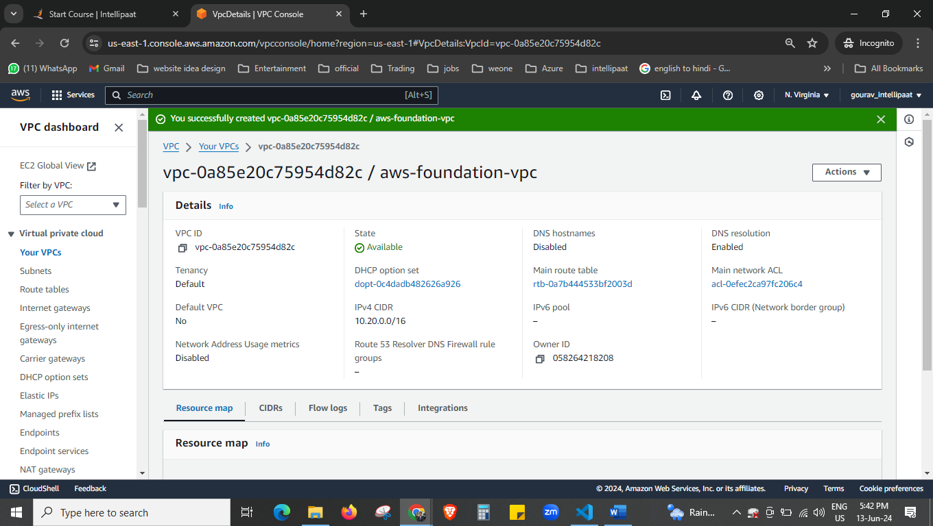

VPC is created now.

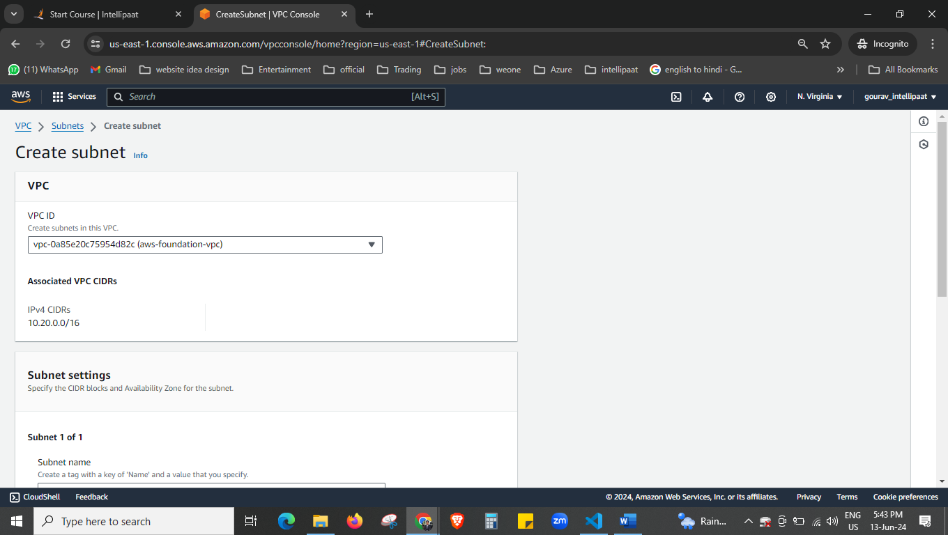

Creating the subnet now

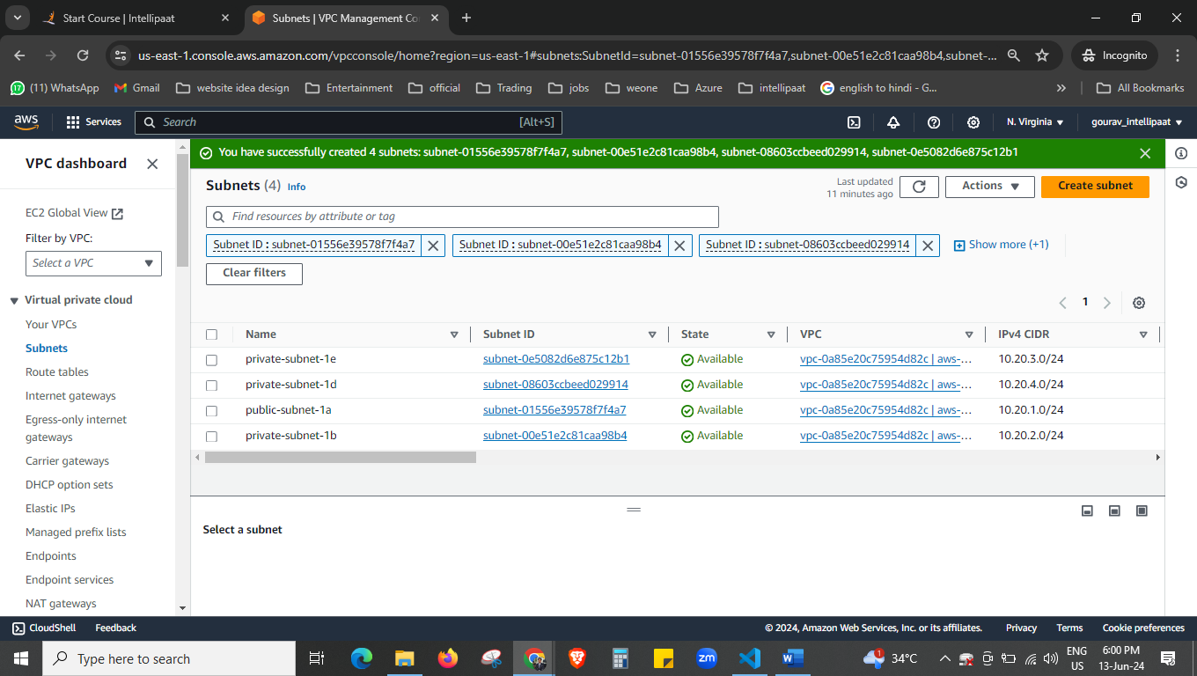

Here we have created the subnets,

1 public subnet

3 private subnet

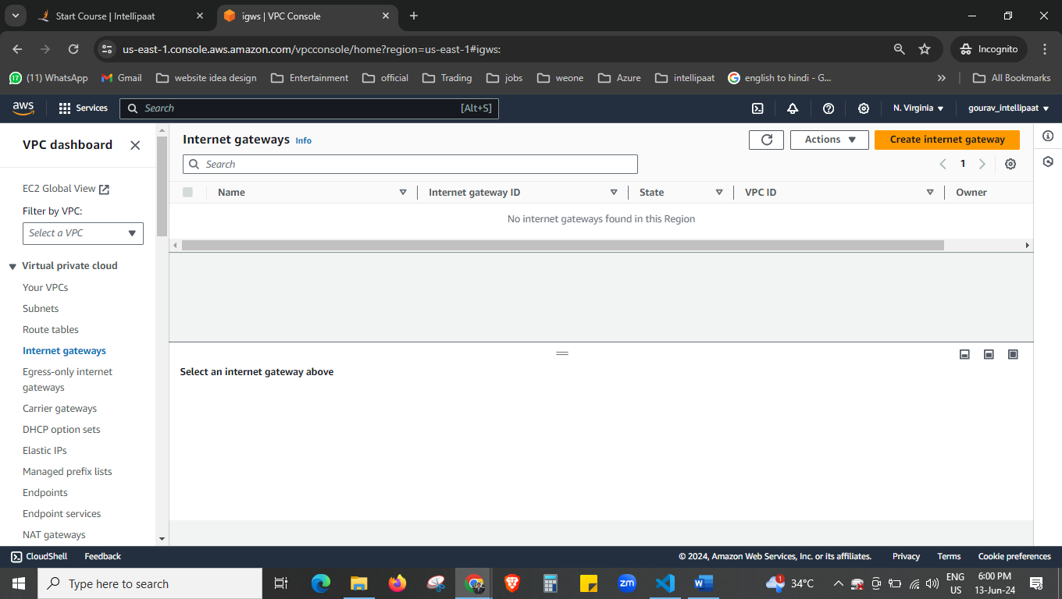

We will create the internet gateway now.

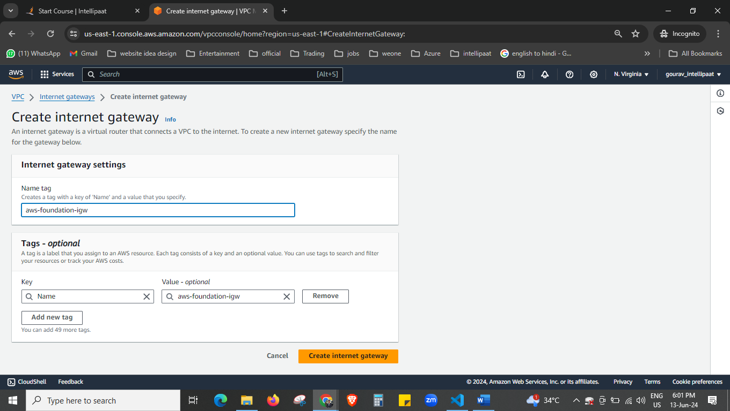

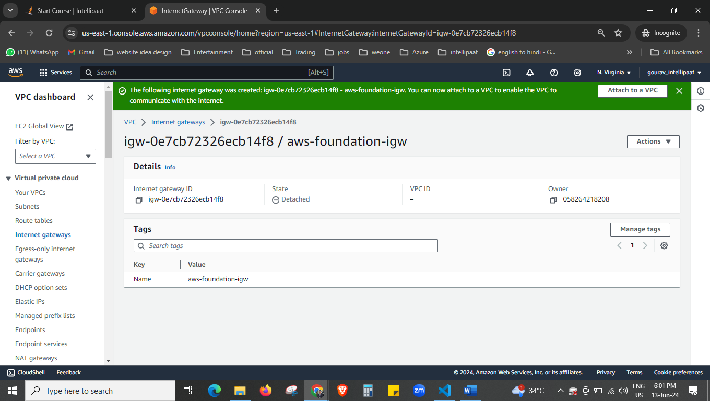

Internet gateway is created now.

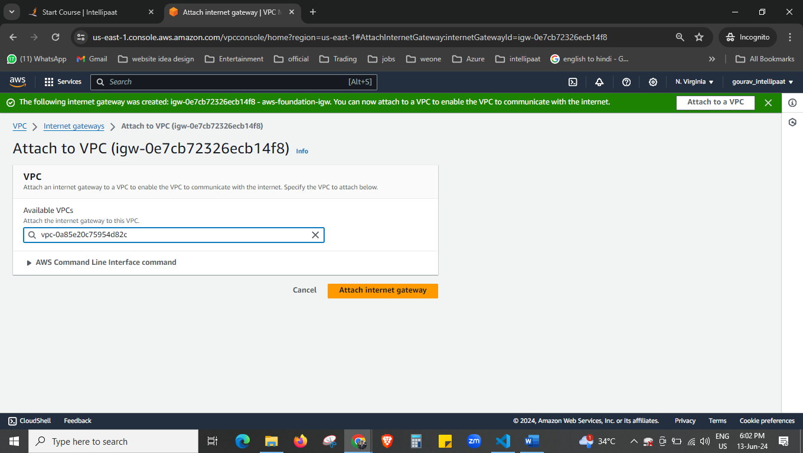

Now attach the internet gateway to the VPC.

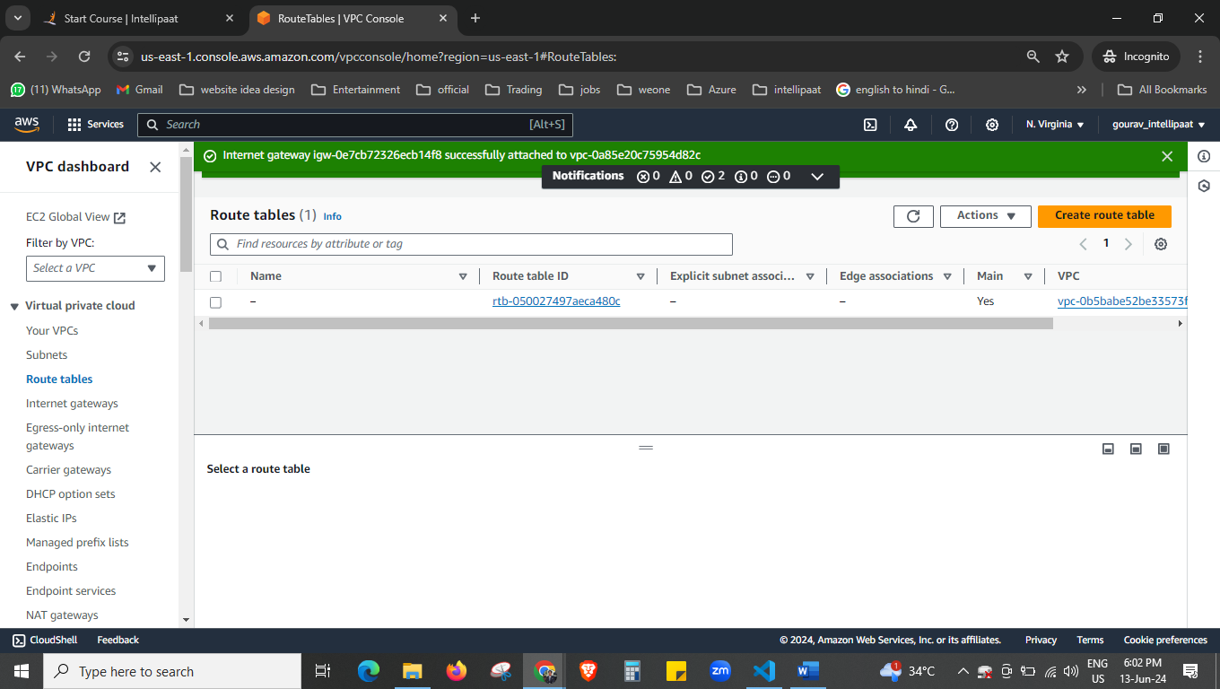

We will create the route table now.

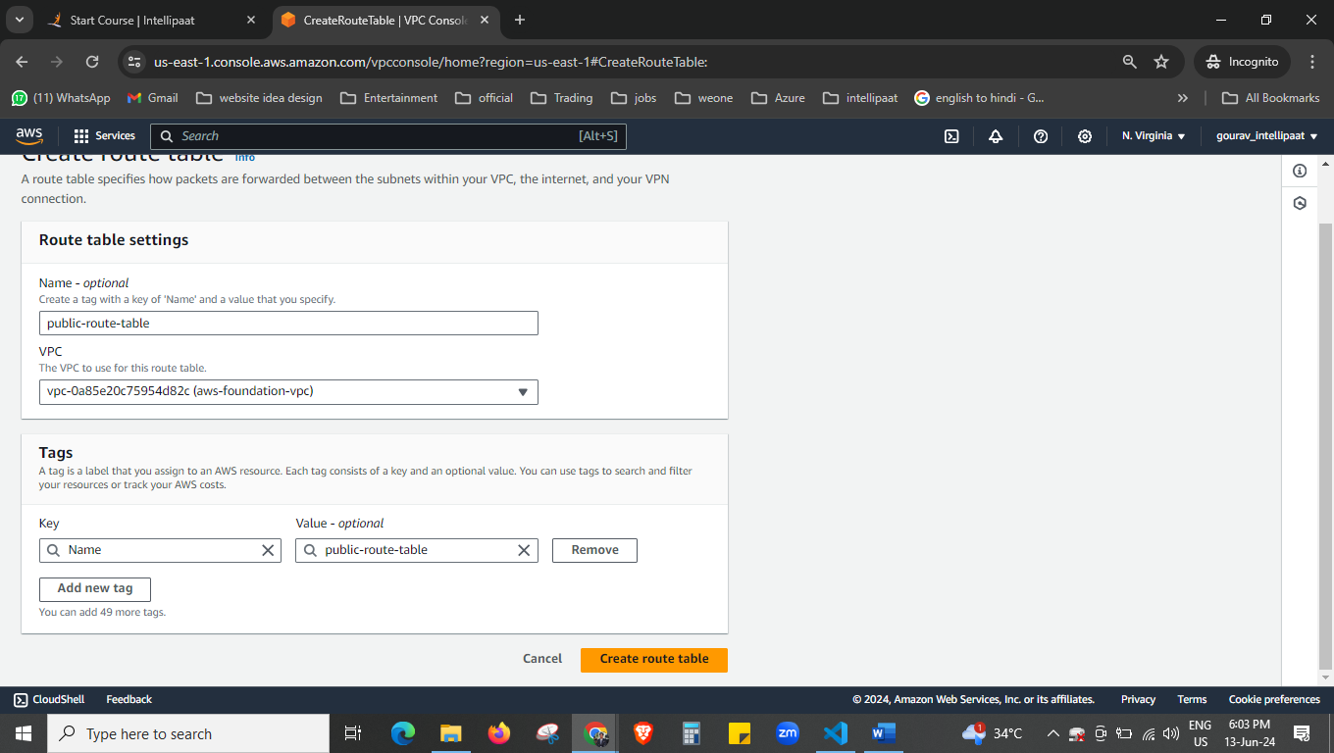

Create the route table for public

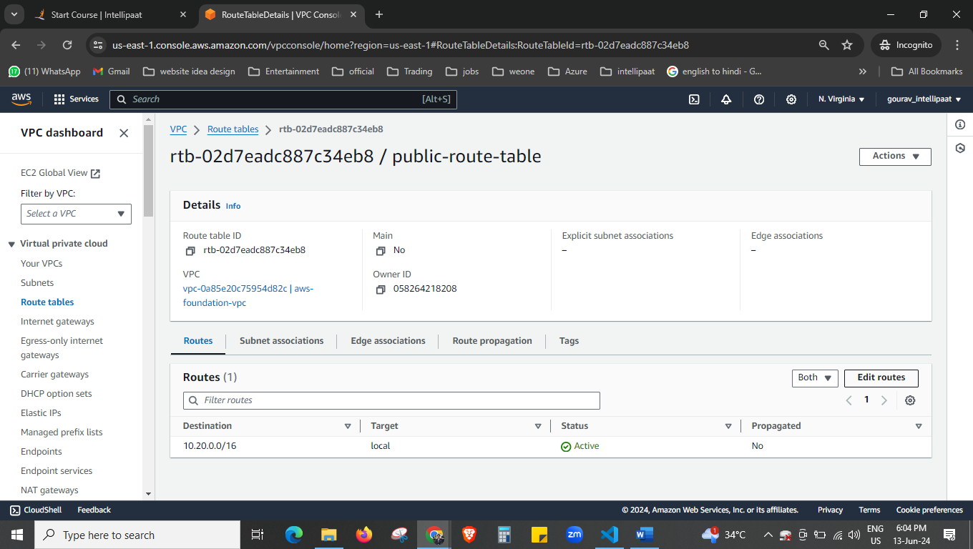



Click on edit route.

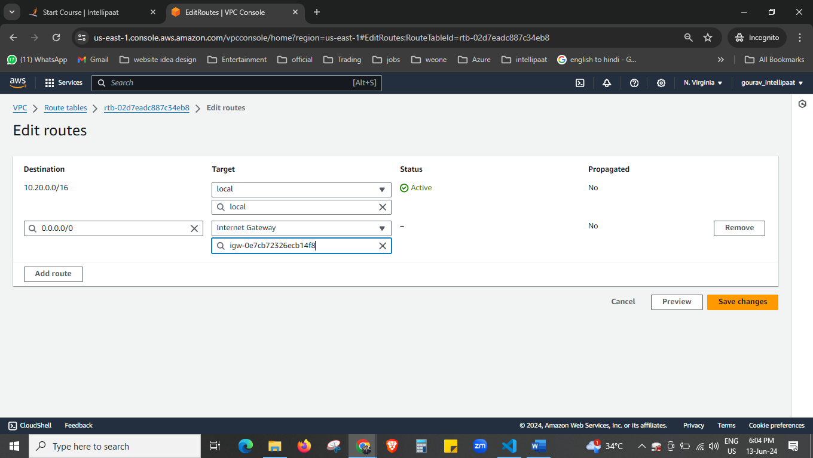

Add route link this.

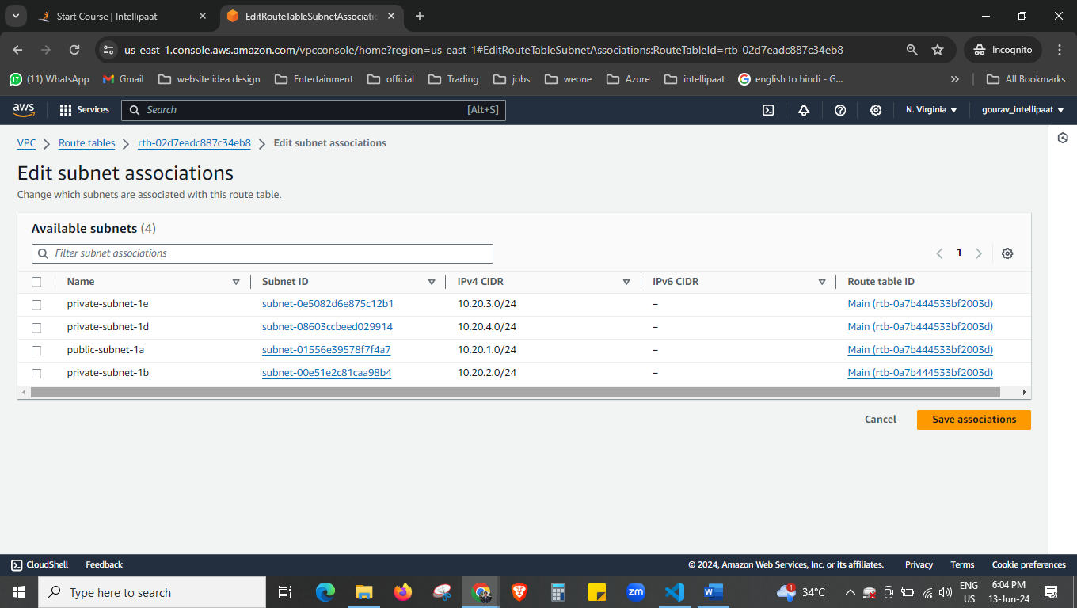



Edit the subnet association select here the subnet that you want to connect to this route.

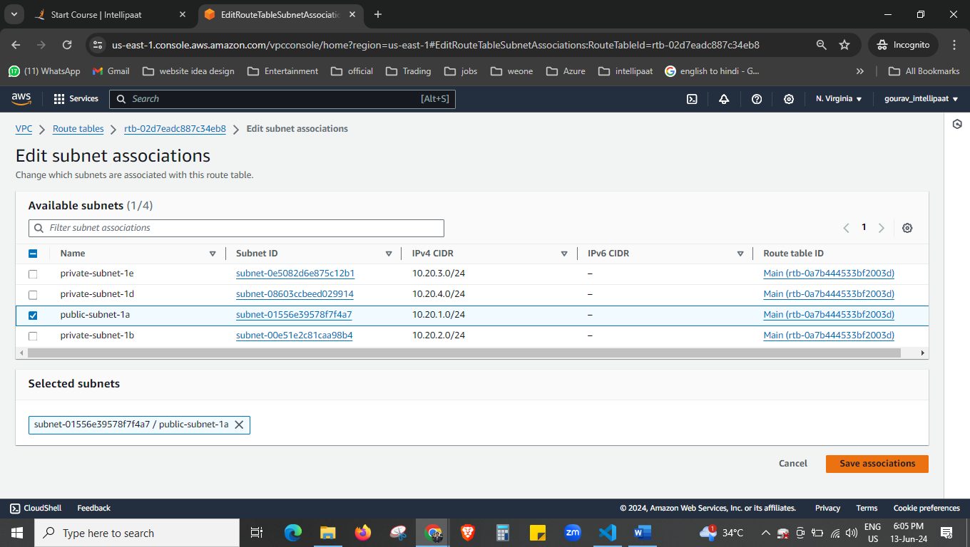

I select public subnet.

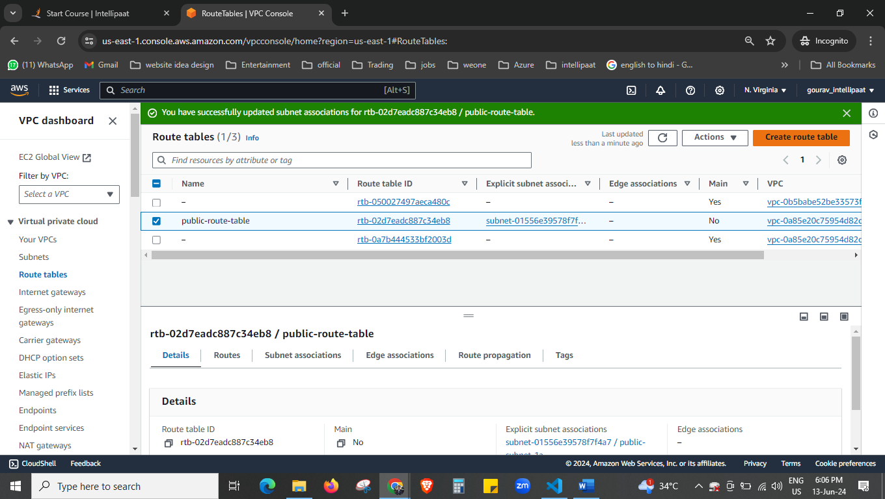



Create another route table now.

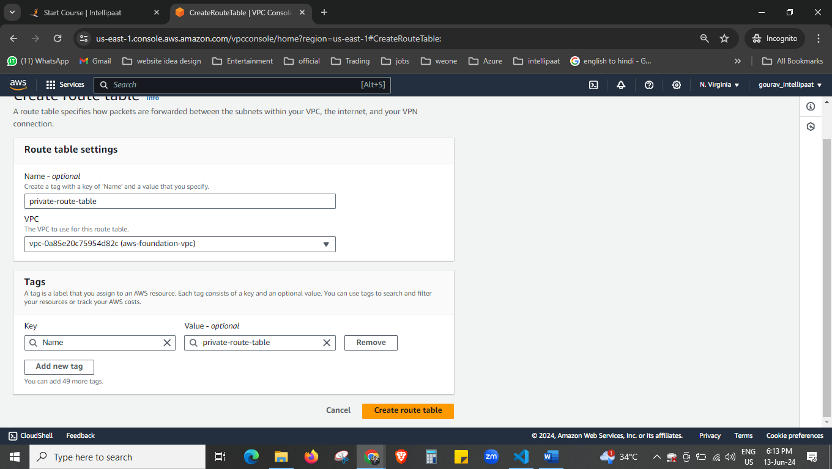

Now we have created the private route table.

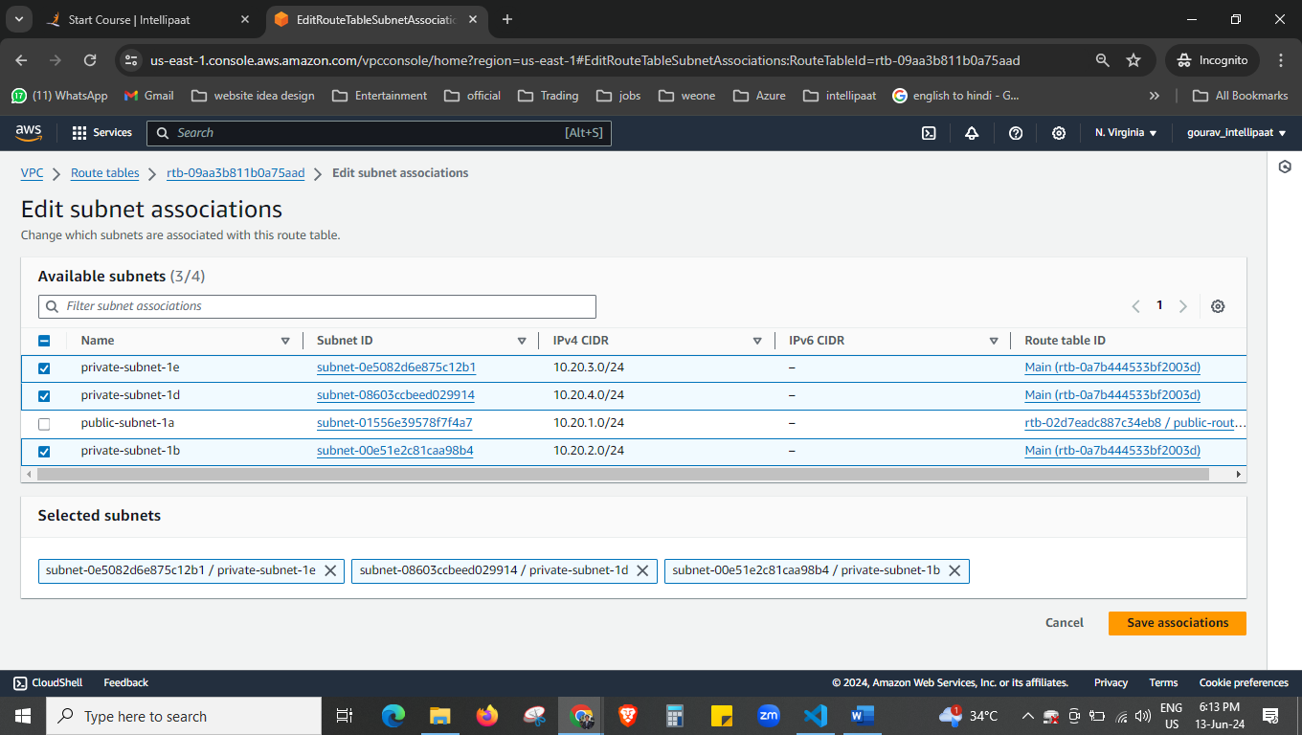

Select your all-private subnet and add them.

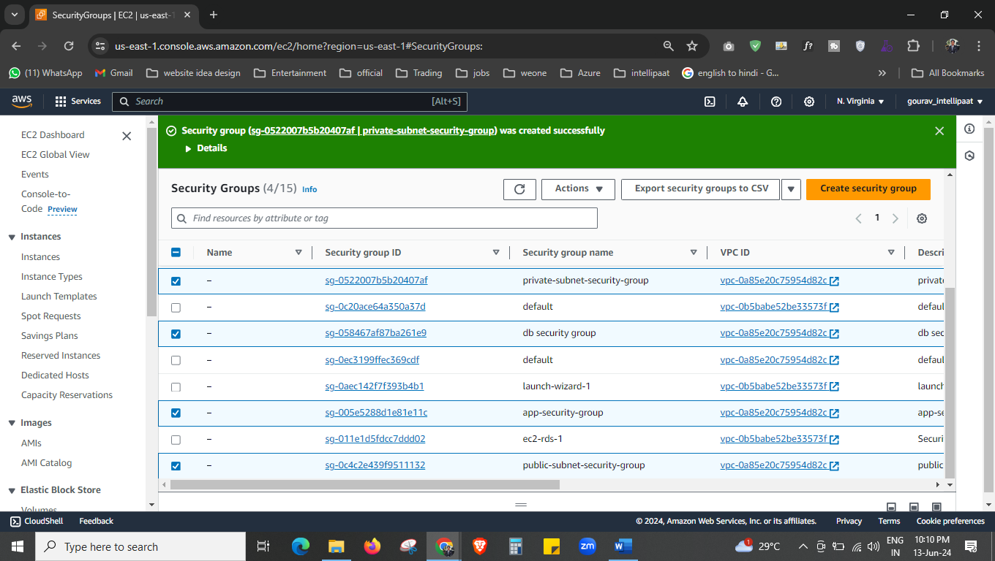



We have created the 4 security group.

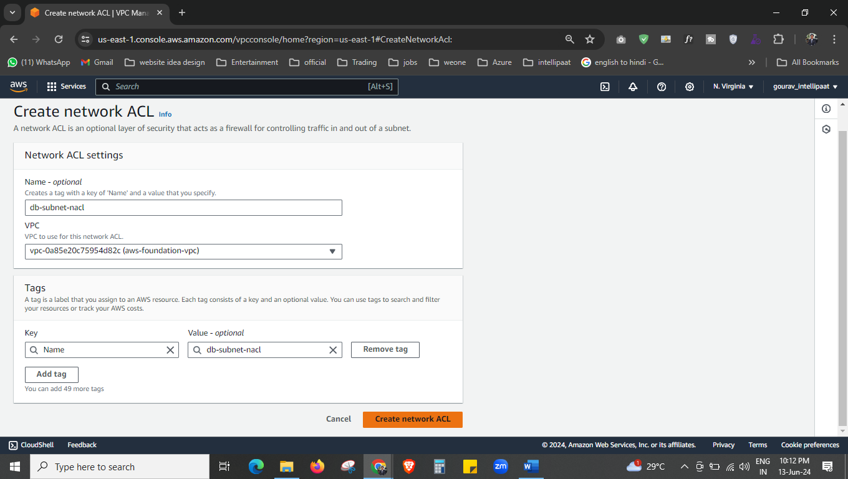

Create the network ACL

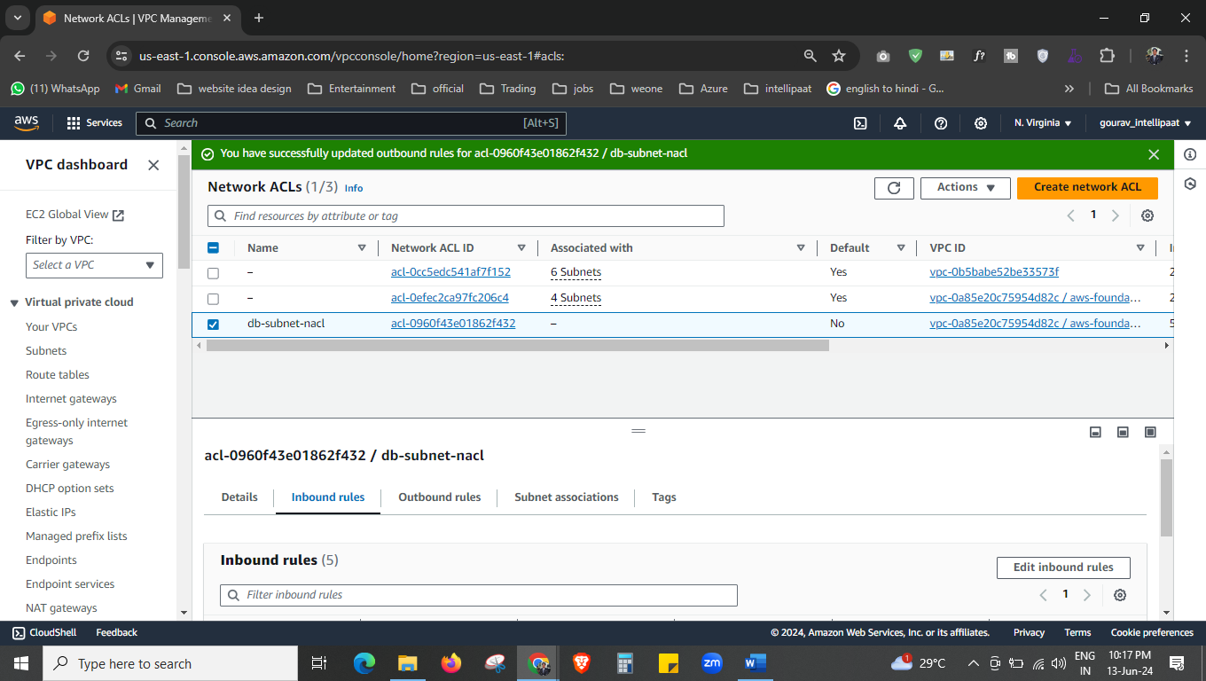

We have created the db-subnet-nacl

With inbound and outbound rule and subnet association.

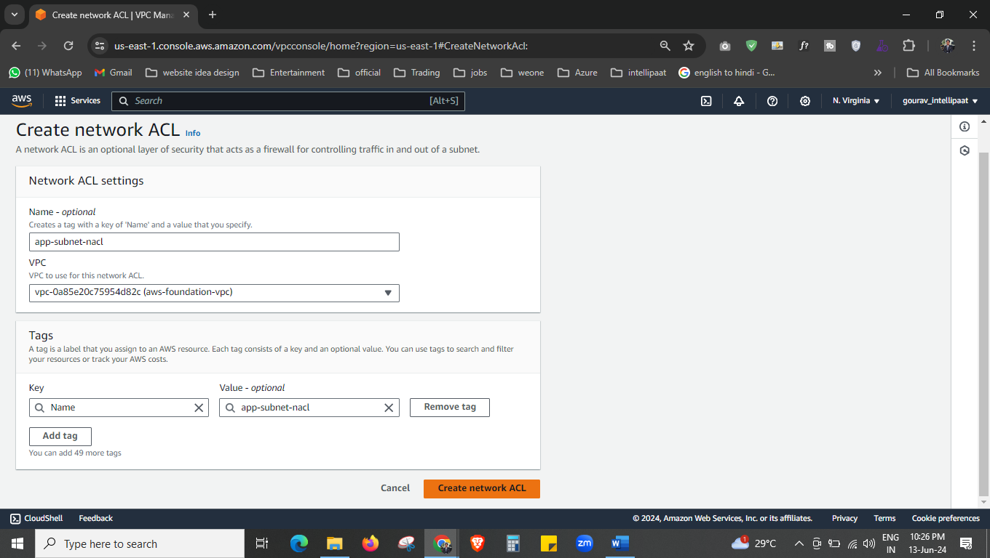

Other ACL is created for app subnet

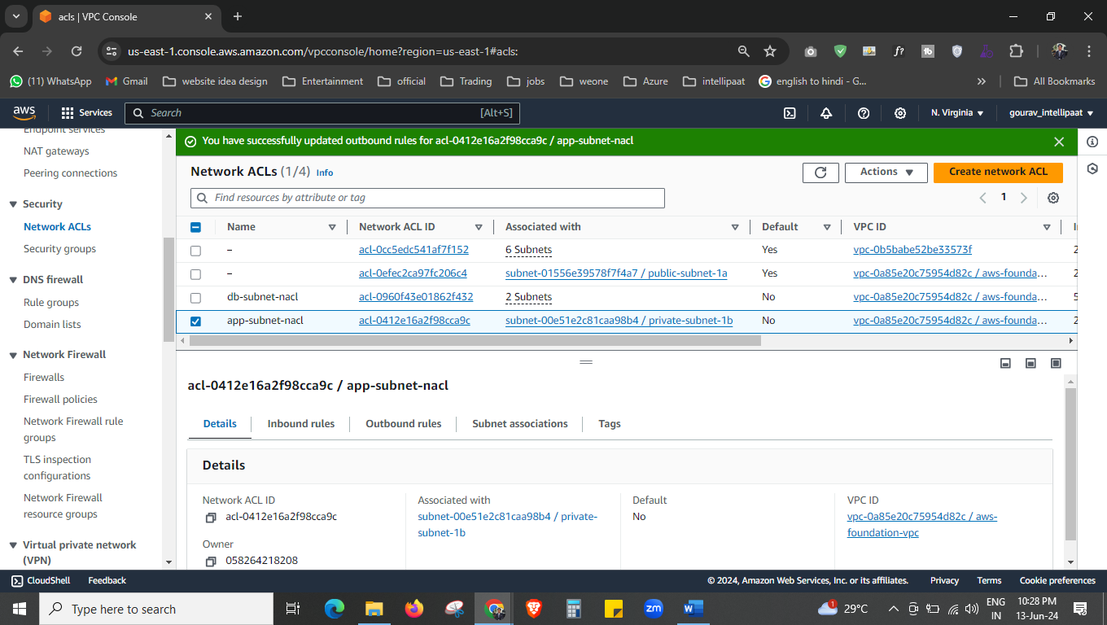

We have created the app-subnet-nacl

With inbound and outbound rule and subnet association 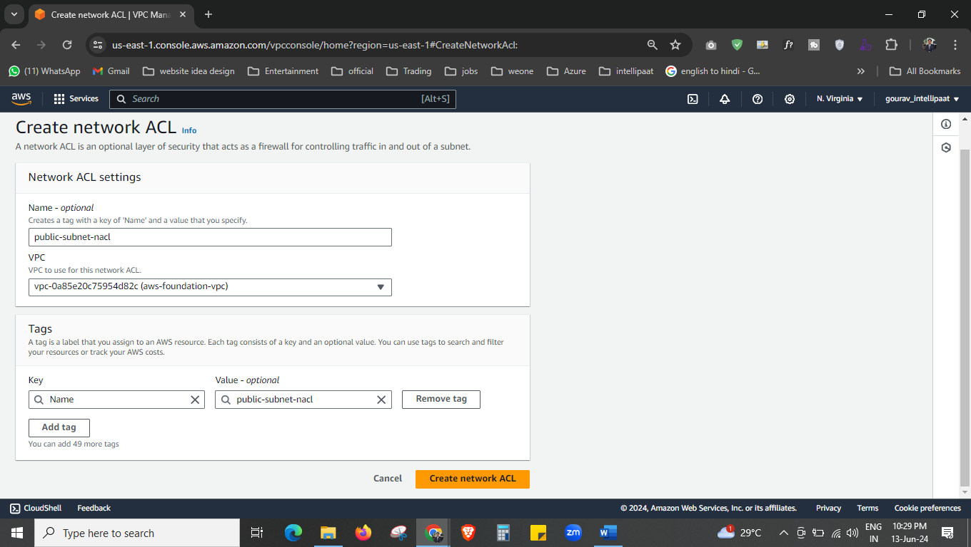

Created public-subnet-nacl also with inbount, outbound, and association.

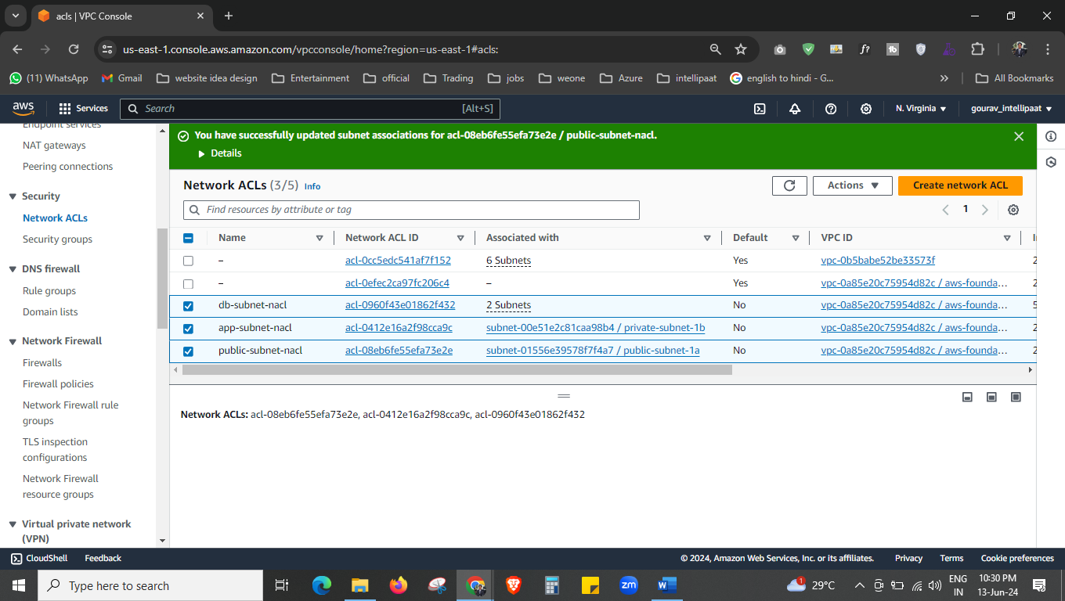



3 nacl is created now.

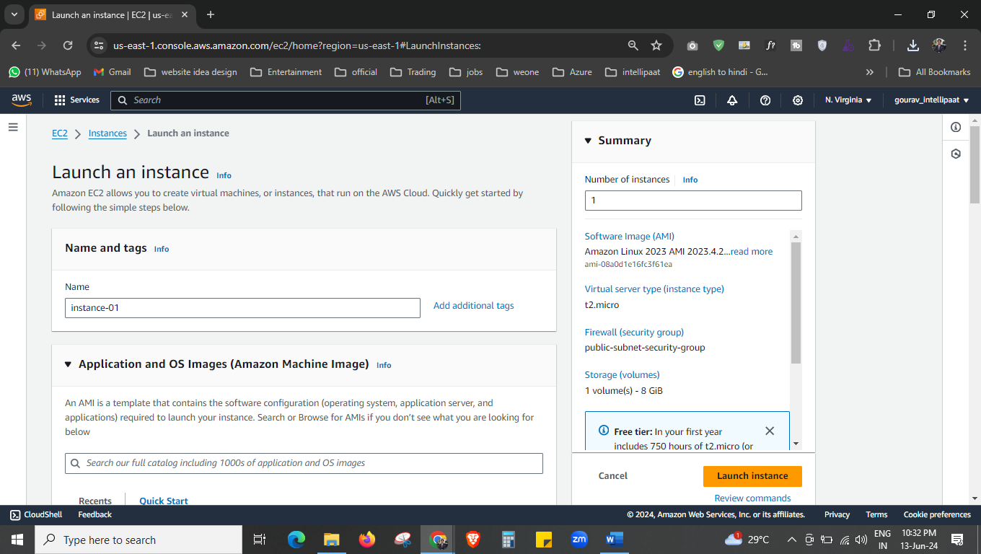

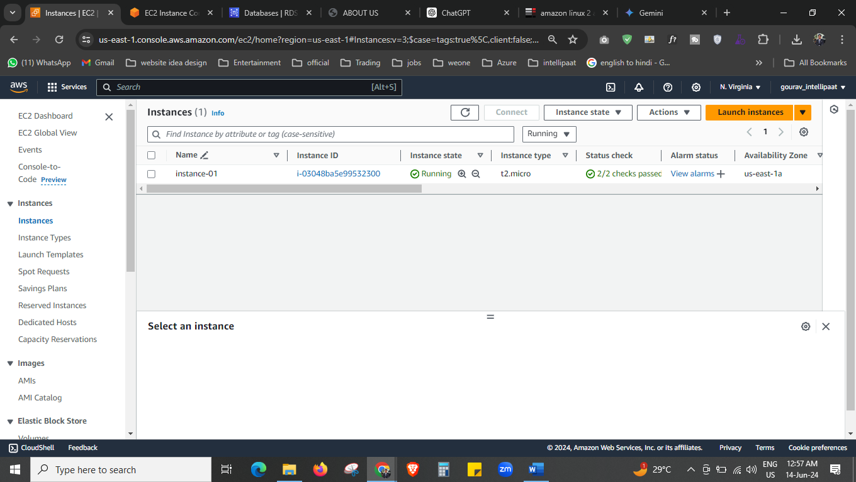 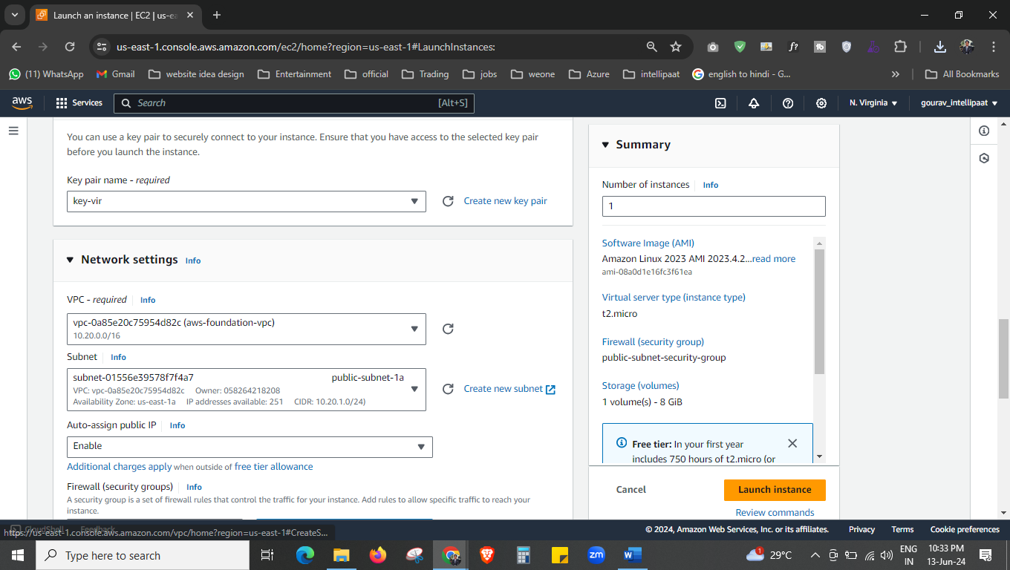 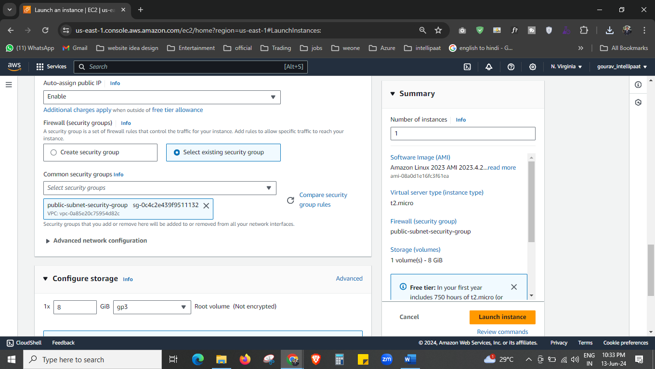



We have created the EC2 instance now.

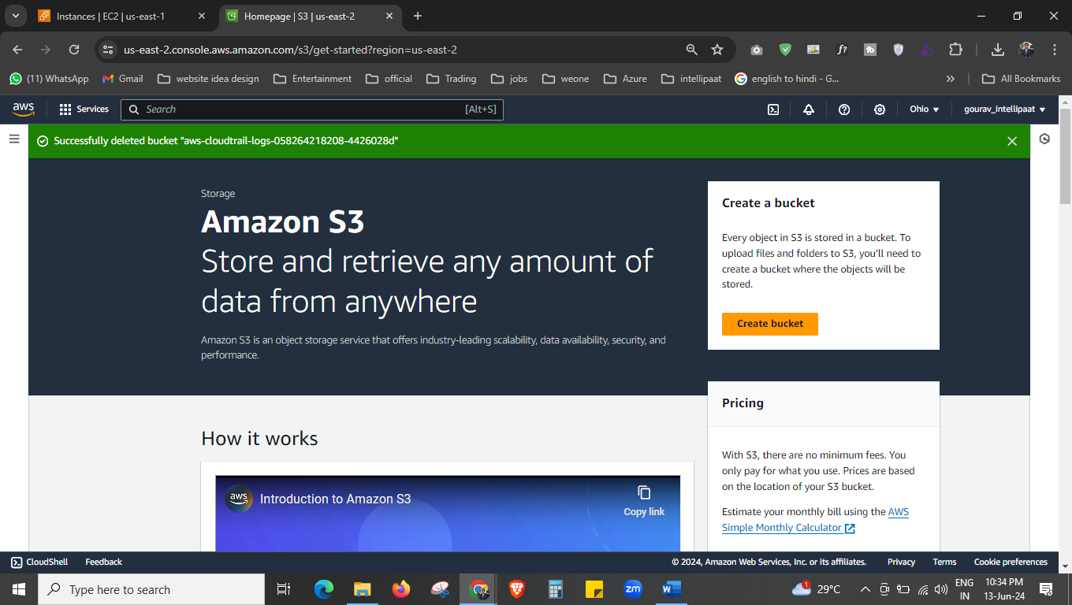



Now we will create the 2 S3 bucket, 1 for static website and 1 for upload images from website. 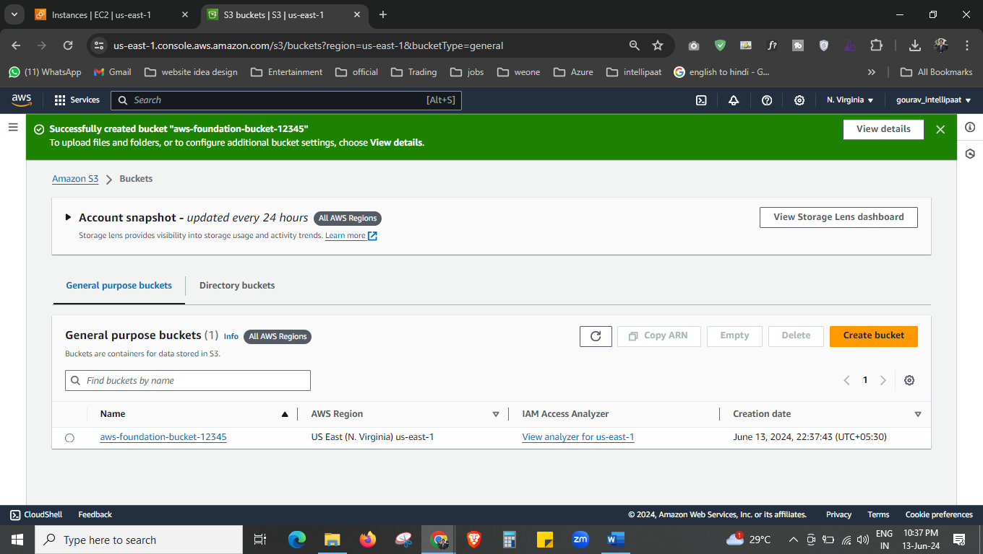



This bucket is private this is for the upload images..

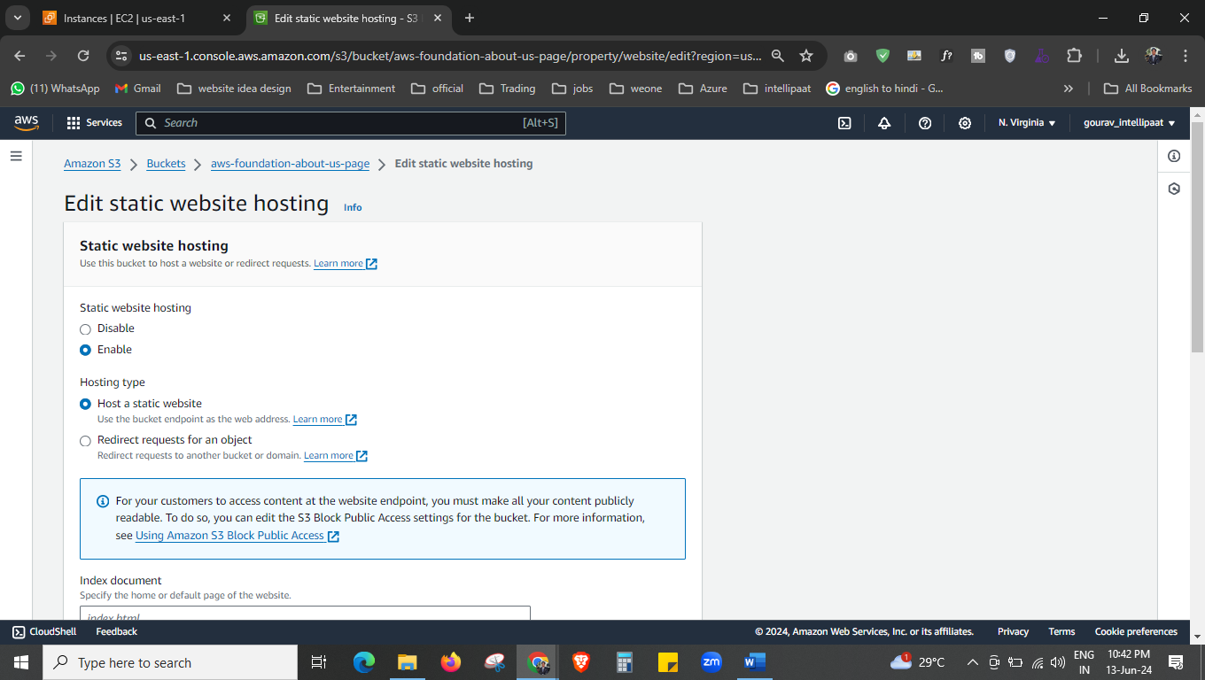

Make this bucket enable for the static website.

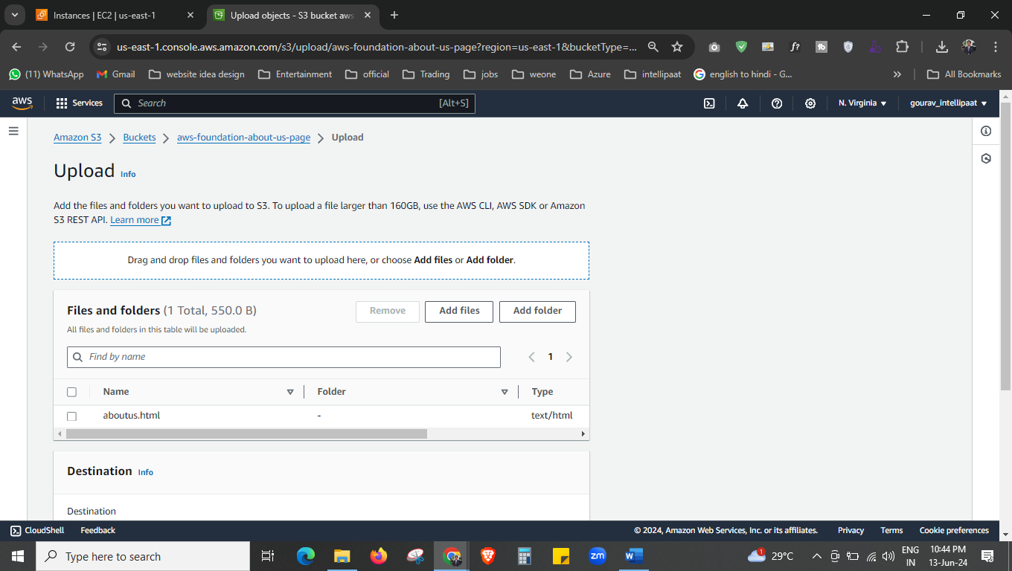

I upload my aboutus.html page

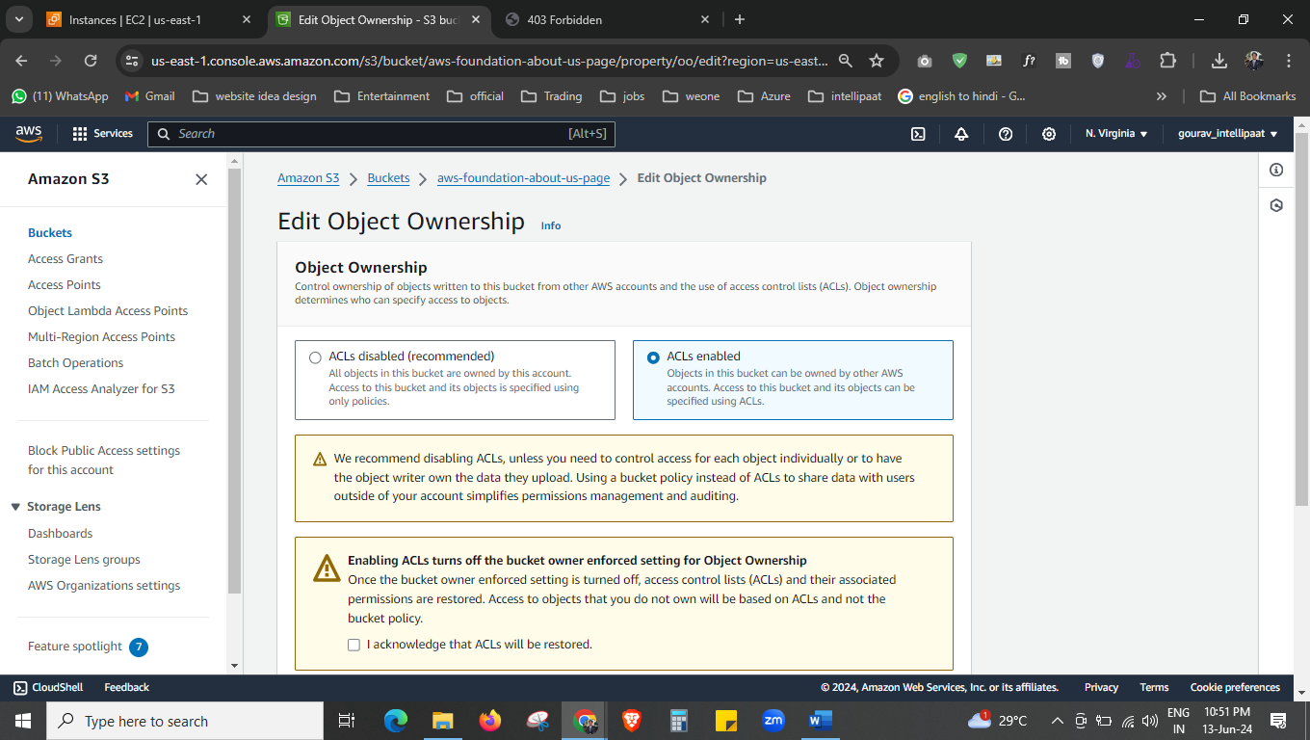

Make this bucket accessable.

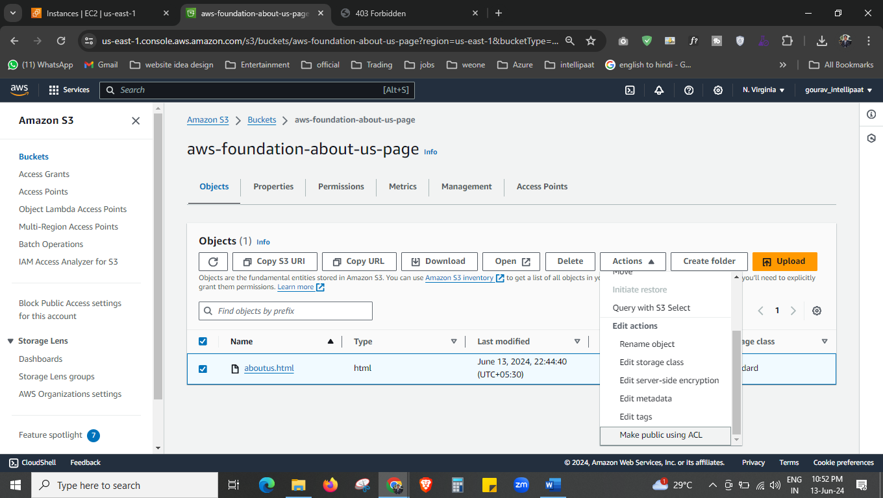



Make it public.

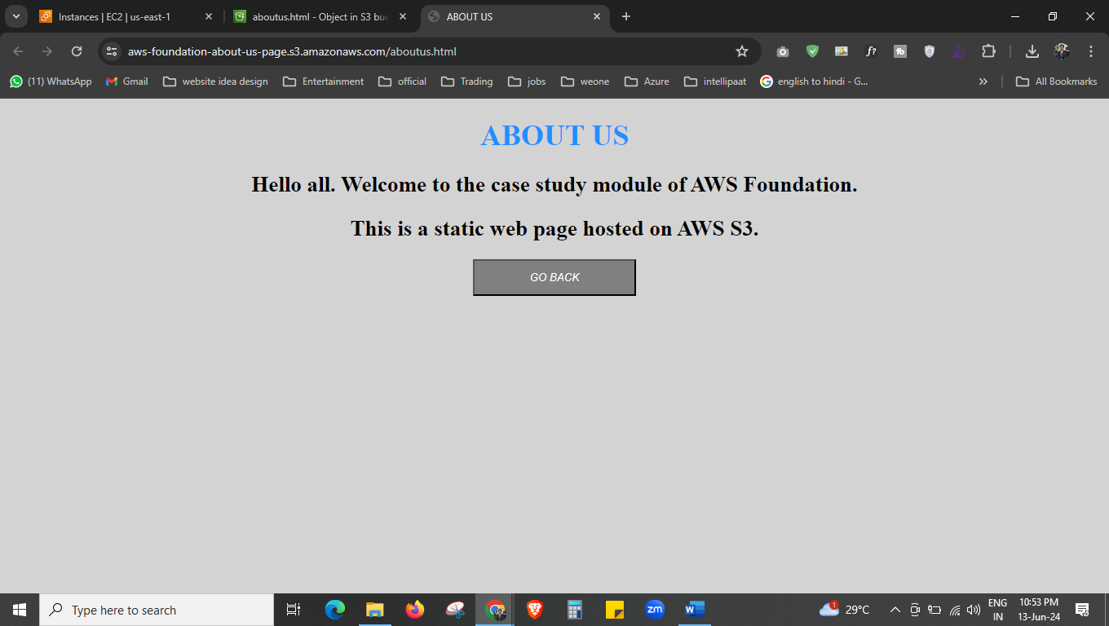

You can see here our bucket aboutus page is working fine now.

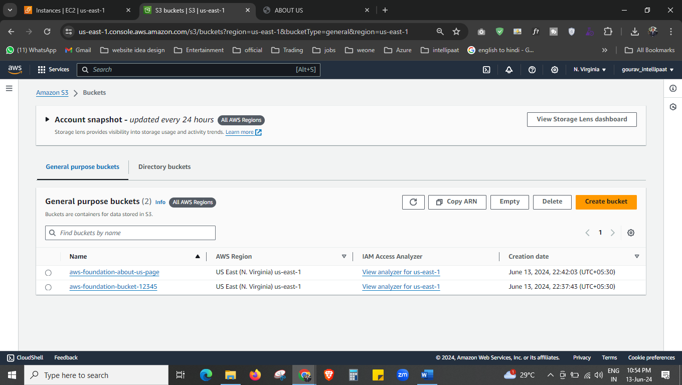

Both bucket are created now, and 1 bucket I used as a website bucket where I can upload pages. Other bucket are used for the upload the images that user want to upload through the website.

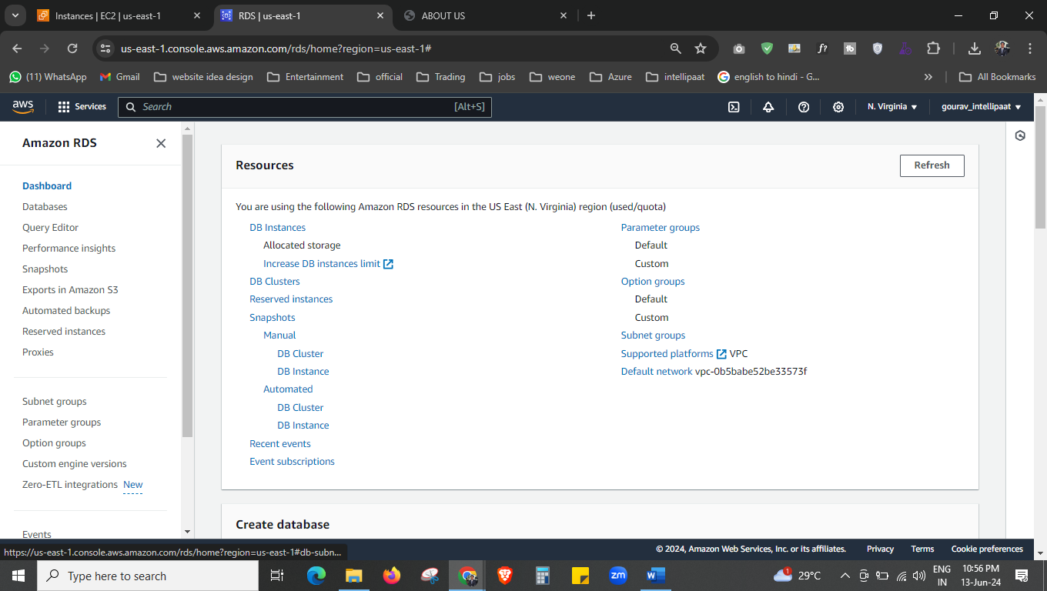



Now we will create the database but first we have to create the subnet-group.

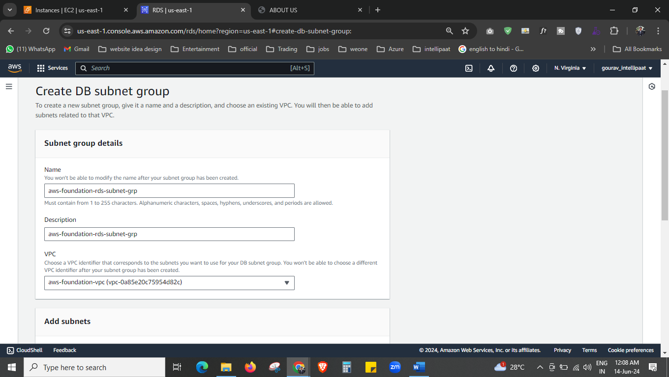 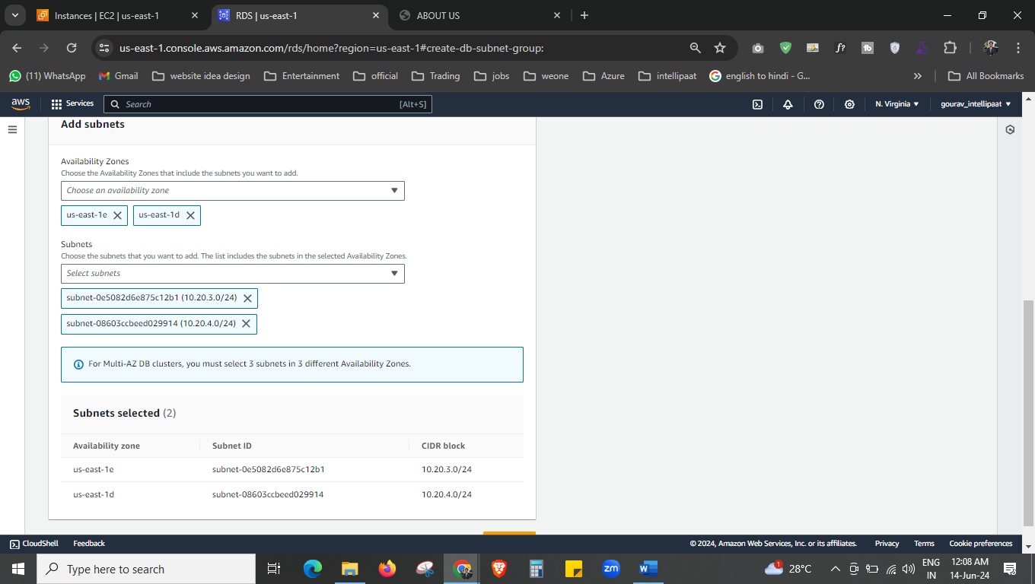



Create it now.

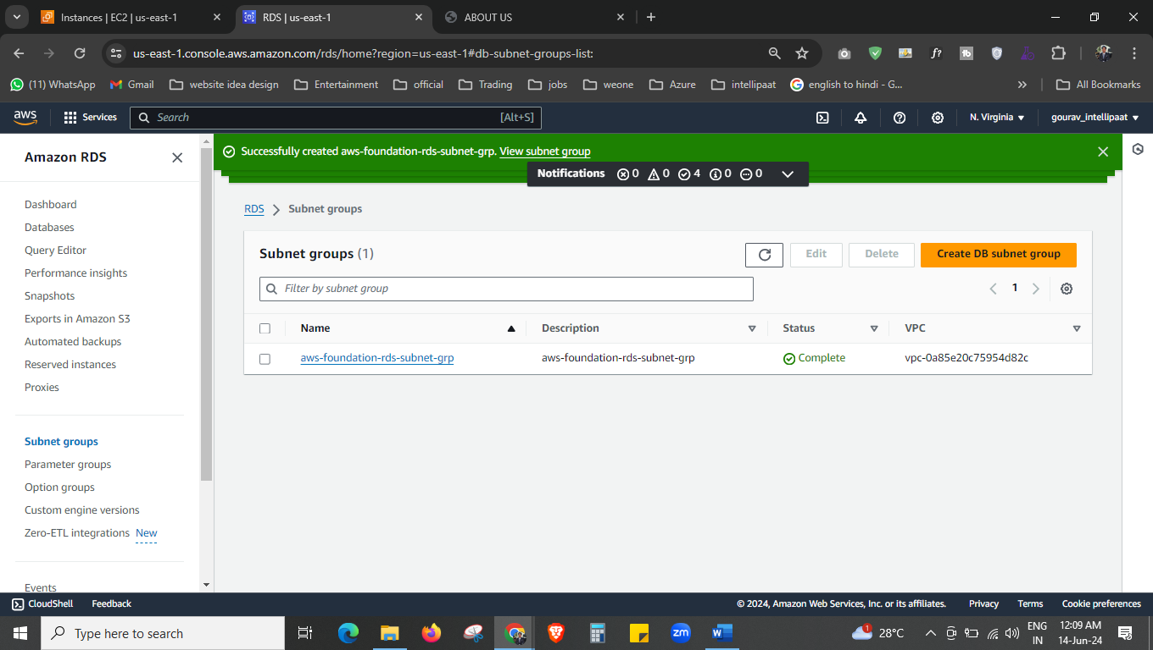

Subnet grp is created now.

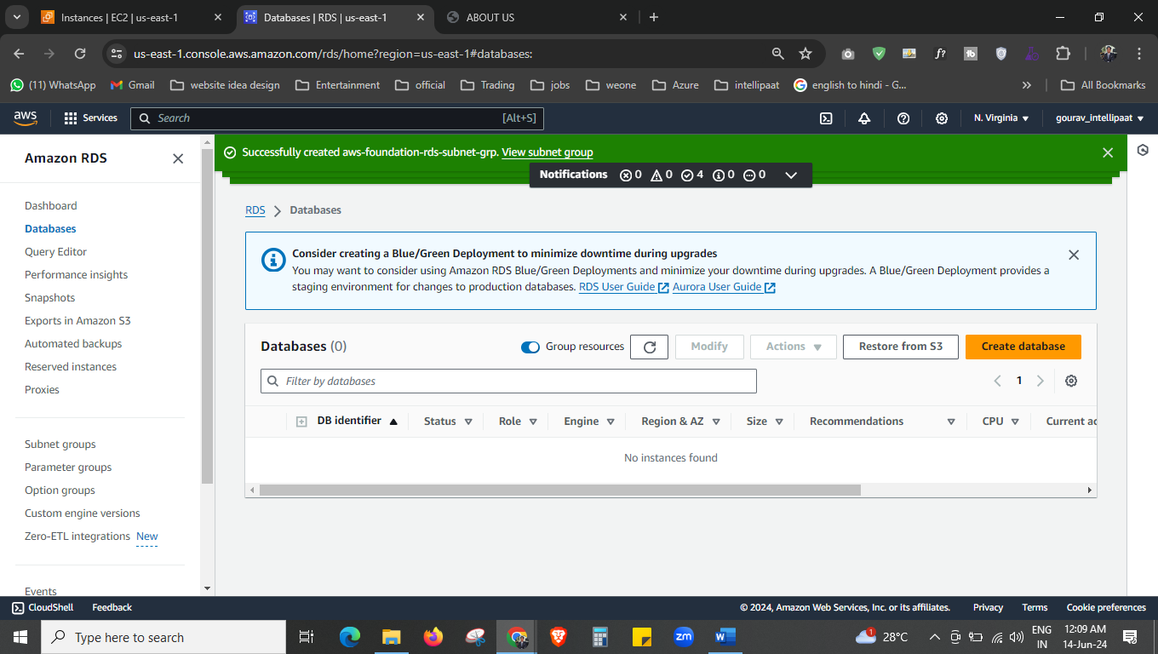



Create the database now.

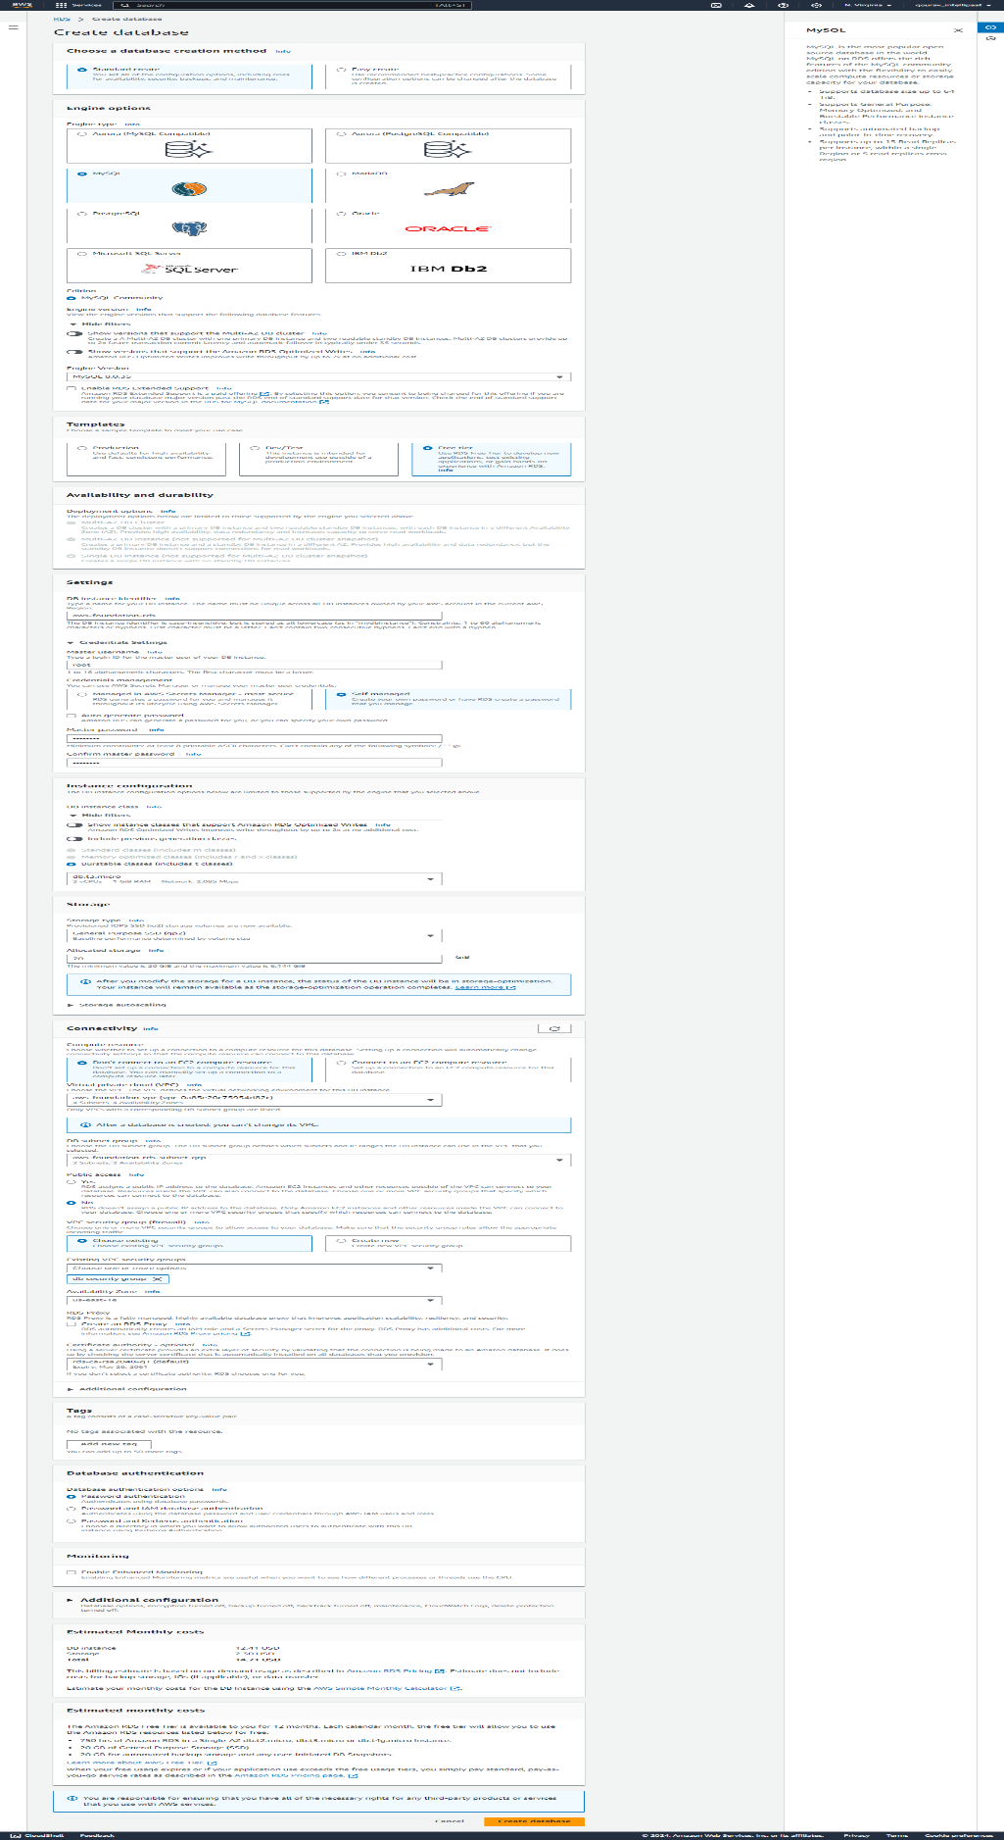

Create the database using this option.

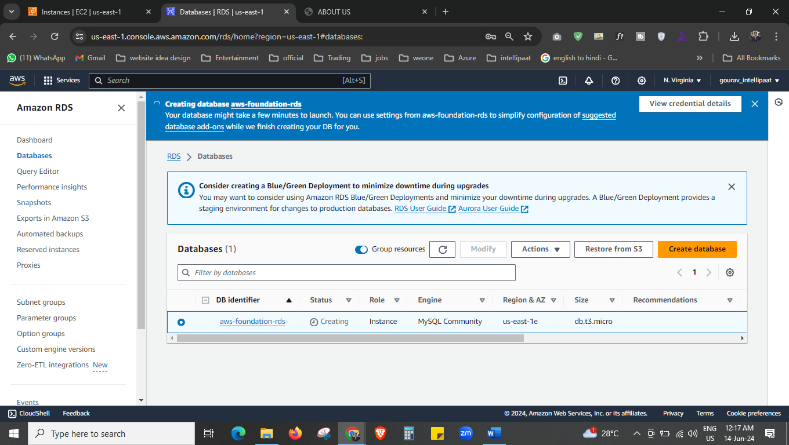

Our data base is creating now.

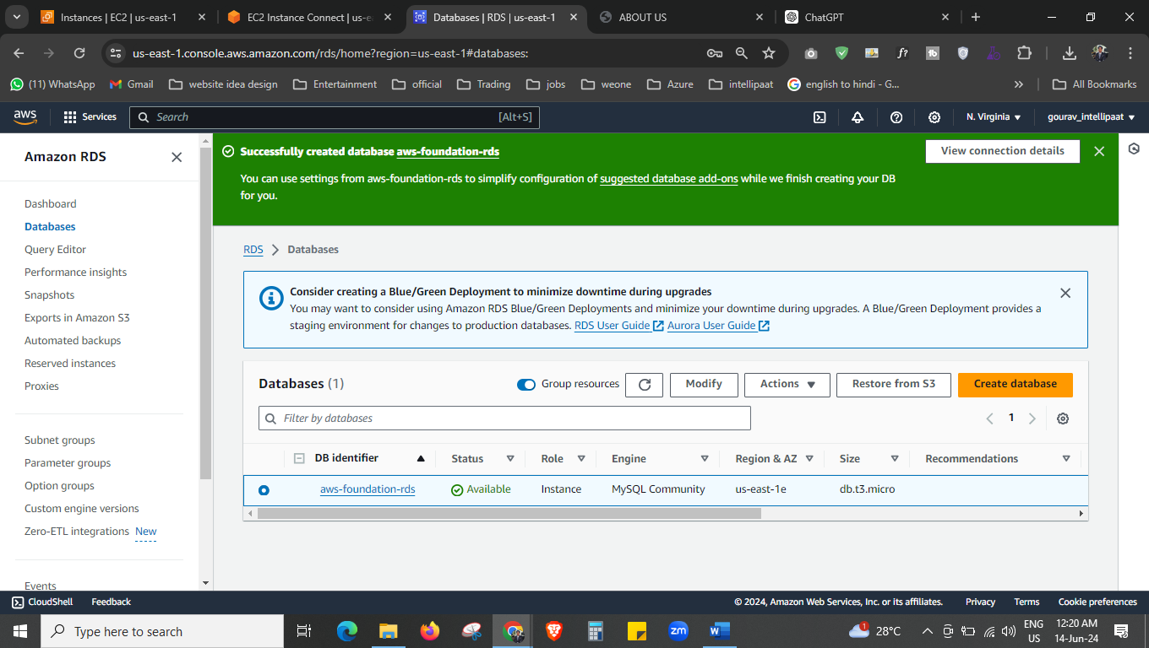

Our database is created now.

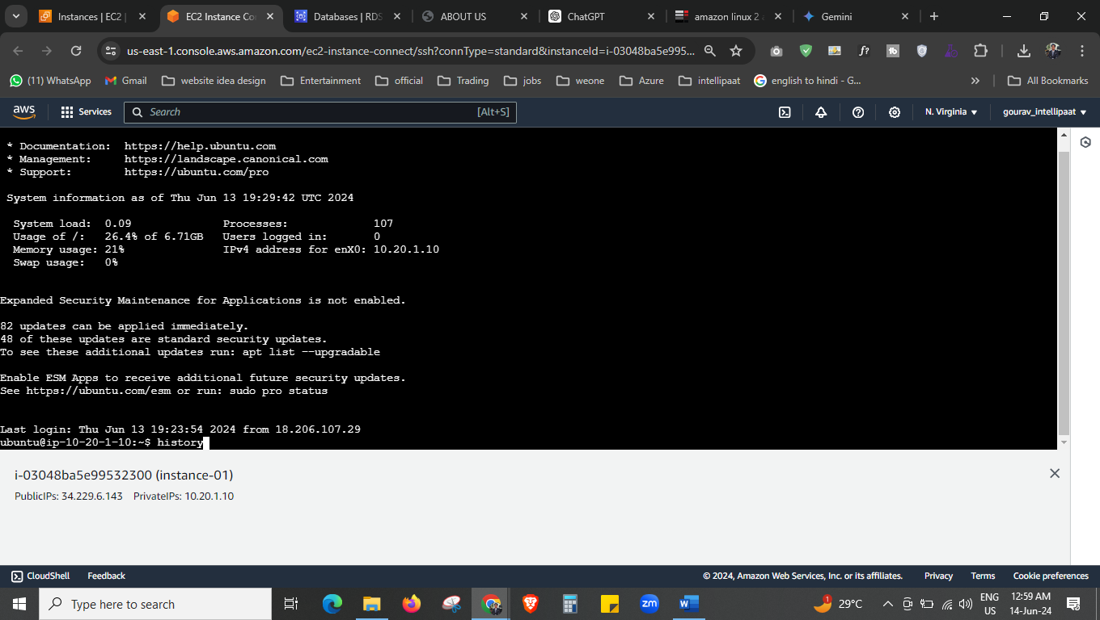

Now install the msql client in the instance.

1 clear

2 sudo apt-get update -y

3 mysql --version

4 .sudo apt install mysql-server

5 sudo apt install mysql-client-core-8.0

6 sudo apt install mariadb-client-core

7 mysql –version

Connect the msql noq

mysql --host=aws-foundation-rds.c1kwquuyetxc.us-east-1.rds.amazonaws.com --port=3306 -u root -p 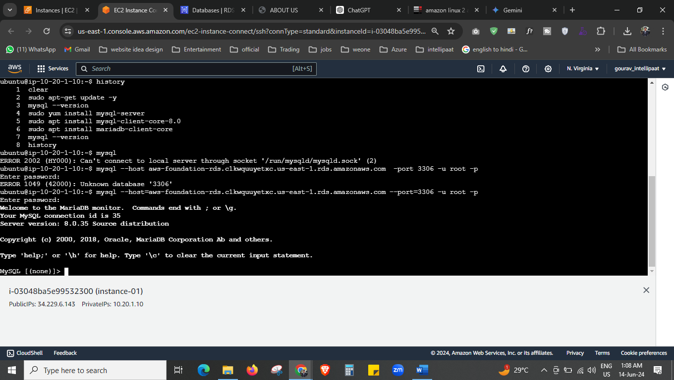



mysql --host=aws-foundation-rds.c1kwquuyetxc.us-east-1.rds.amazonaws.com --port=3306 -u root -p

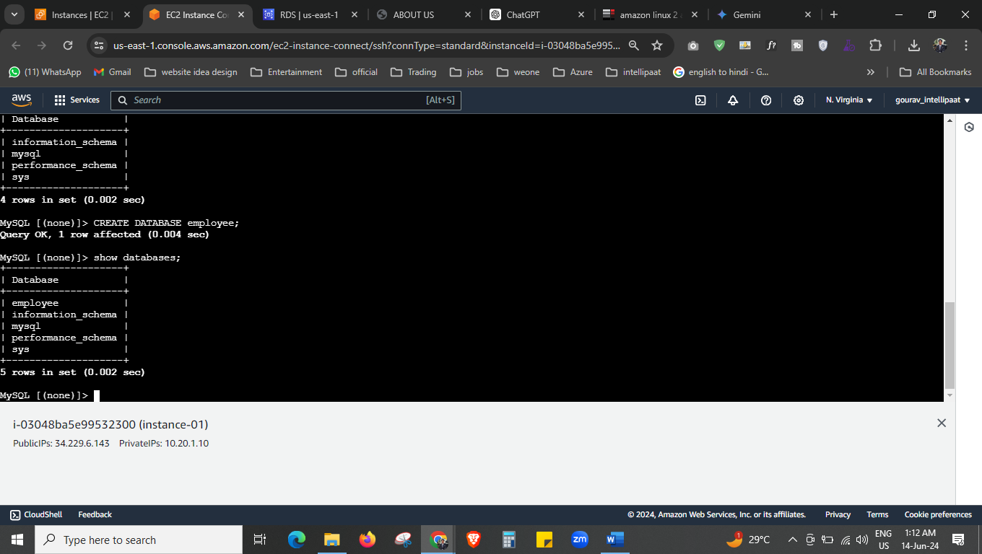



CREATE DATABASE employee;

Use this command to create the database.

CREATE TABLE employee (

emp_id integer,

first_name VARCHAR(40),

last_name VARCHAR(40),

pri_skill VARCHAR(40),

location VARCHAR(20)

);

Use this command to create the table.

* Describe employee;

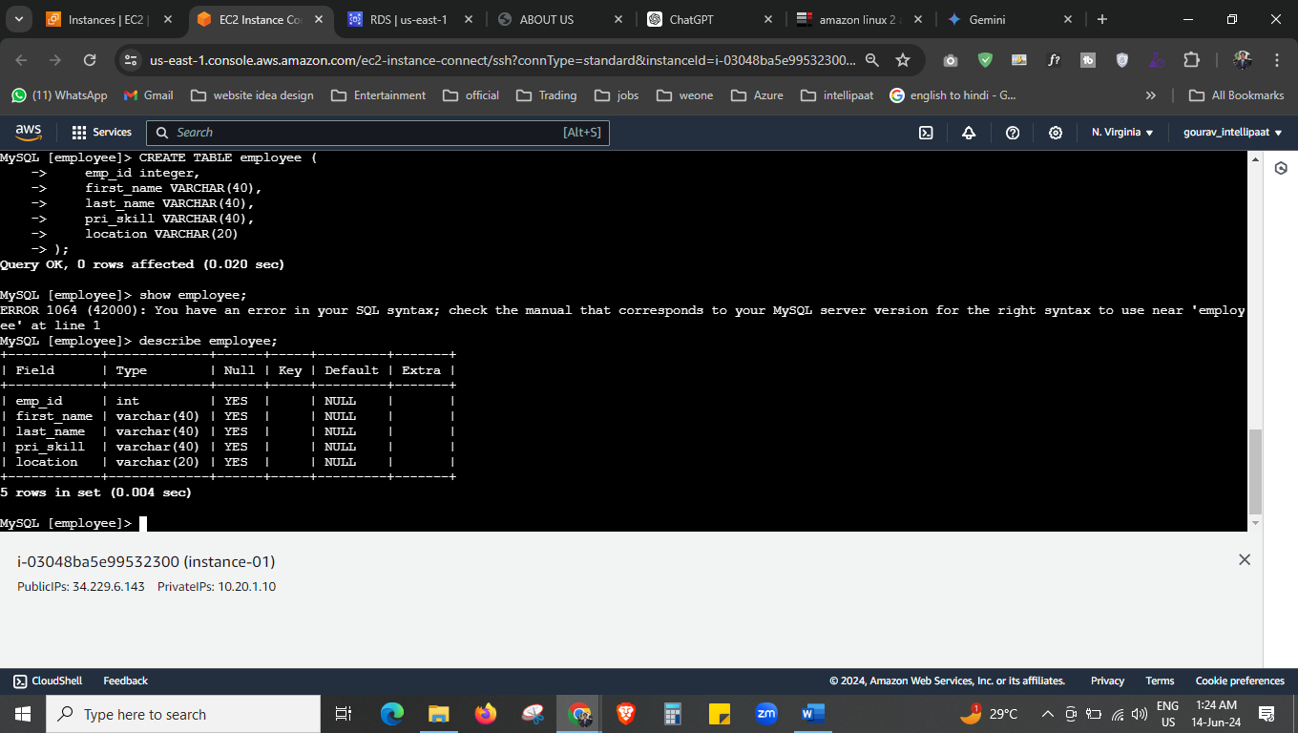



Now we have successfully created the table “employee”

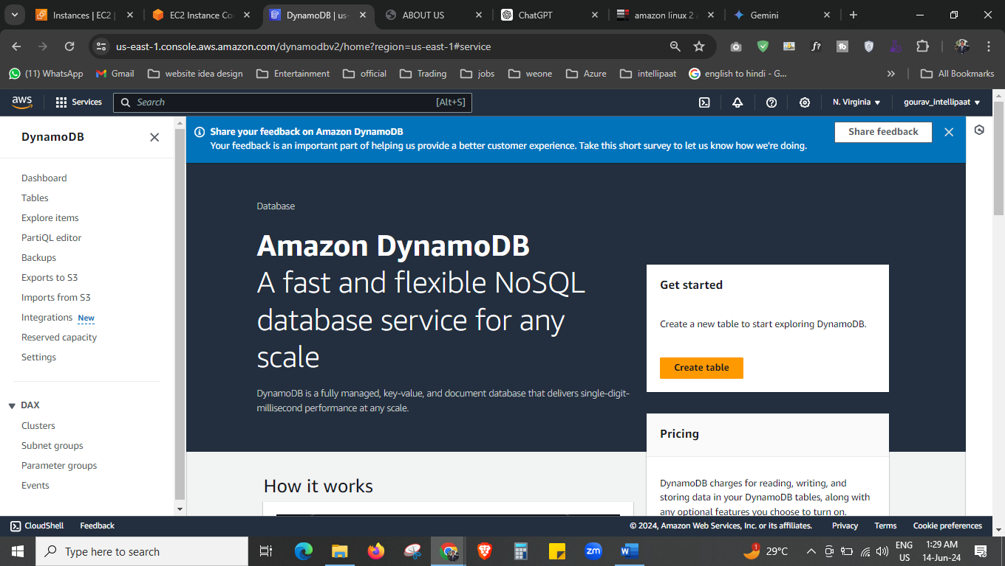



We will create the DynamoDB now.

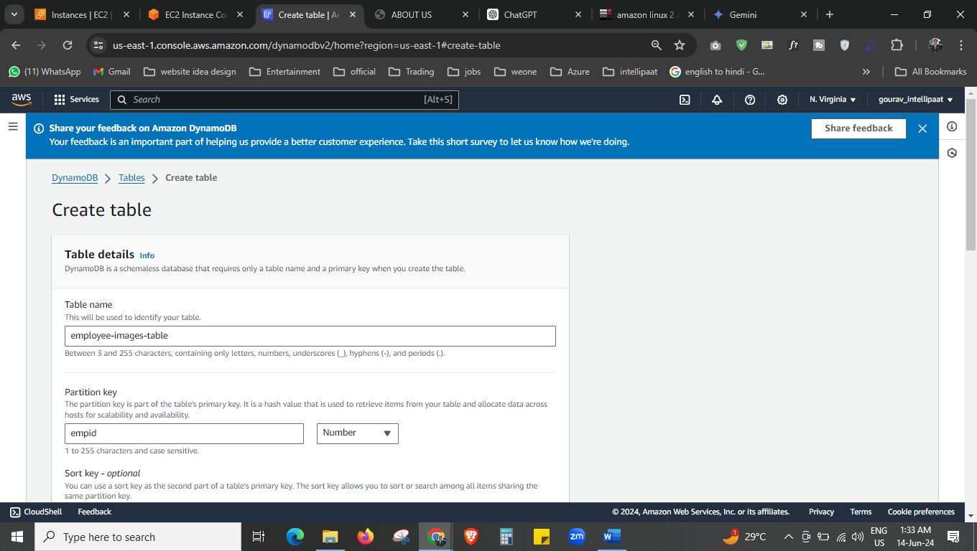 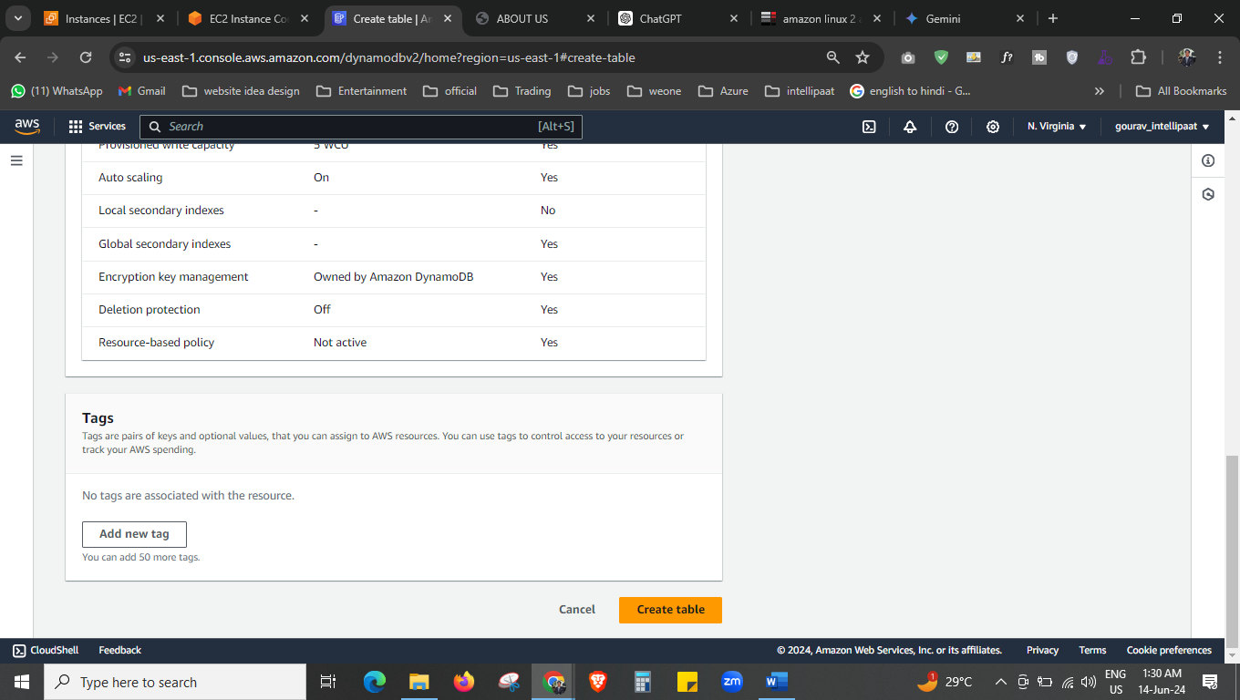



Create the table.

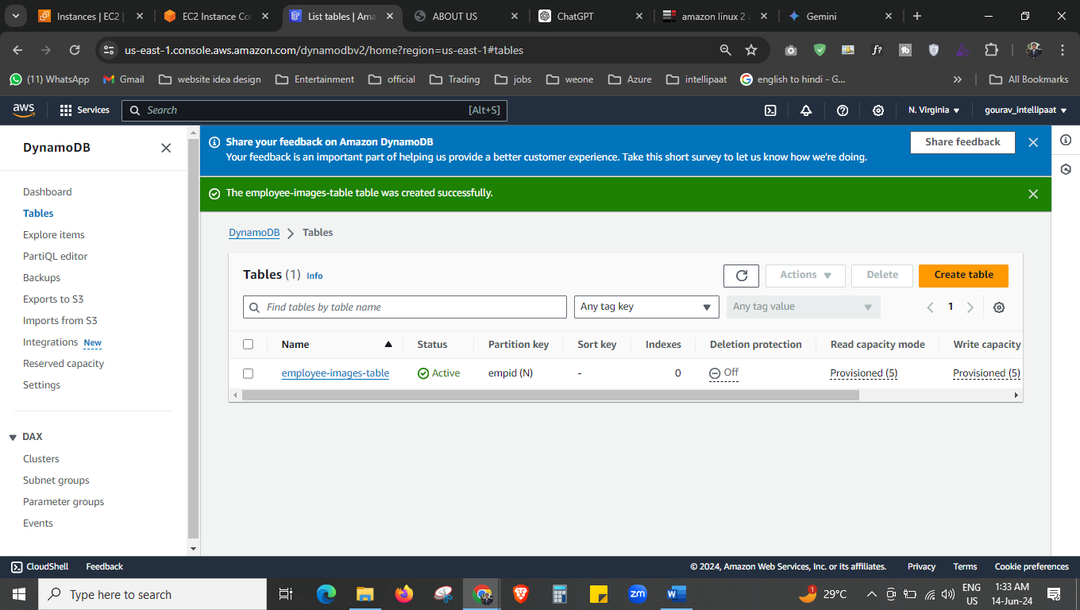

Our DynamoDb table is ready now.

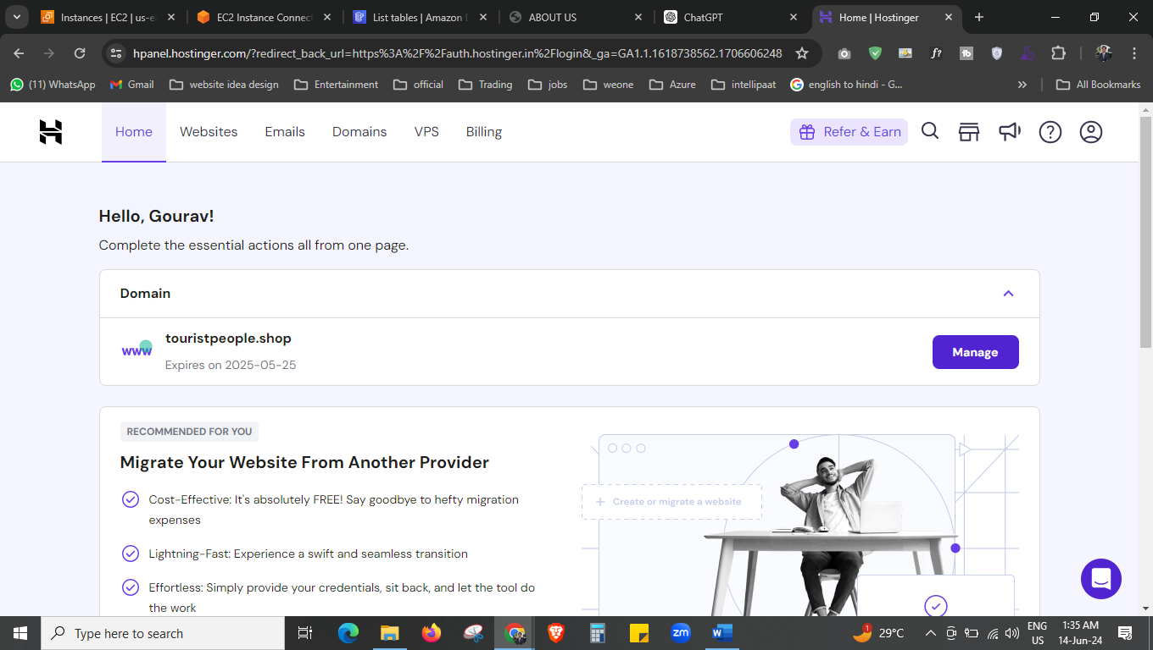



Now we purchased this domain form hostinger.

Now we will moved to the route 53 topic.

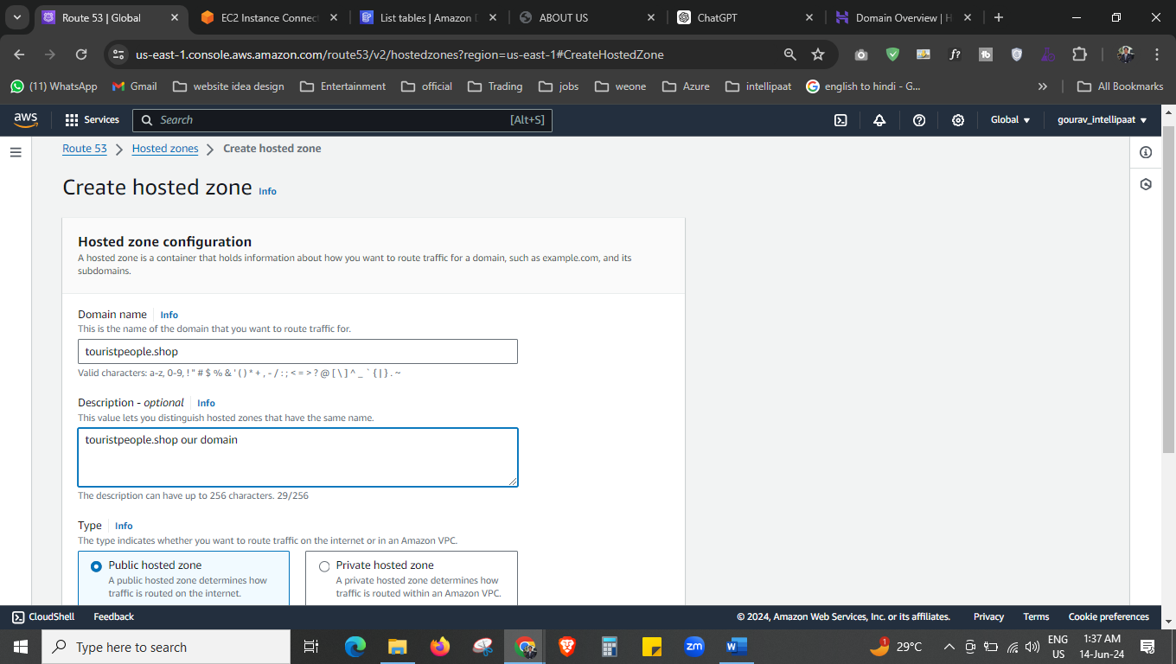 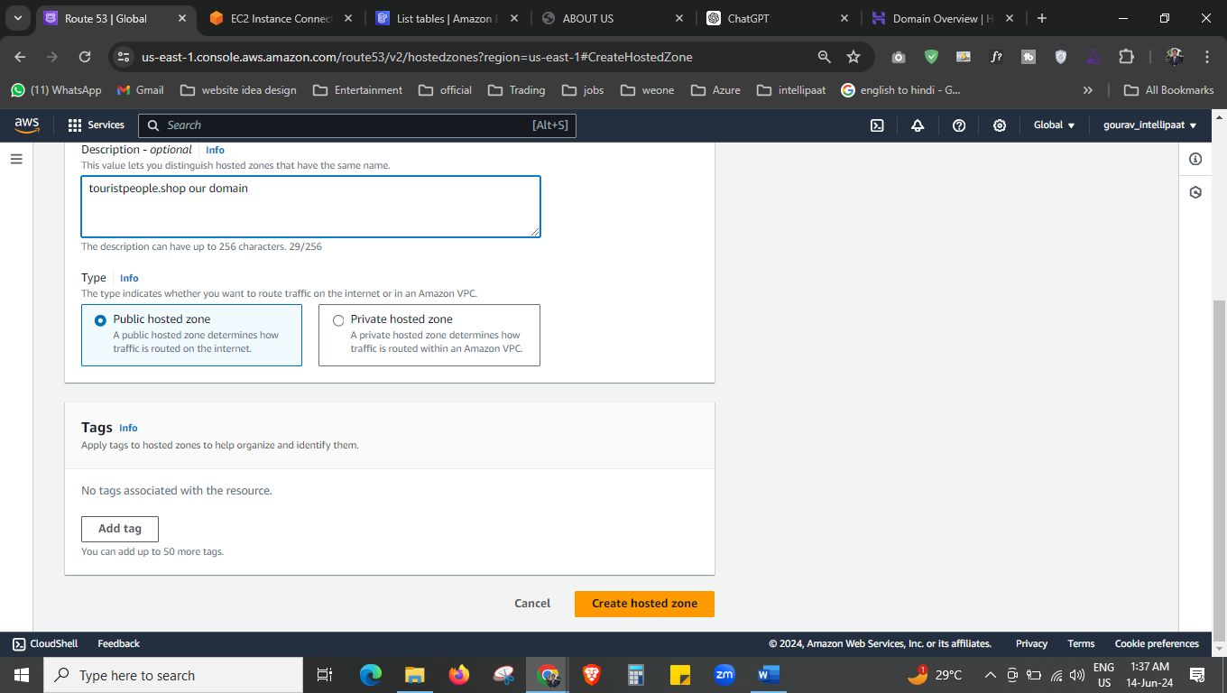



Now we are creating the hosted zone.

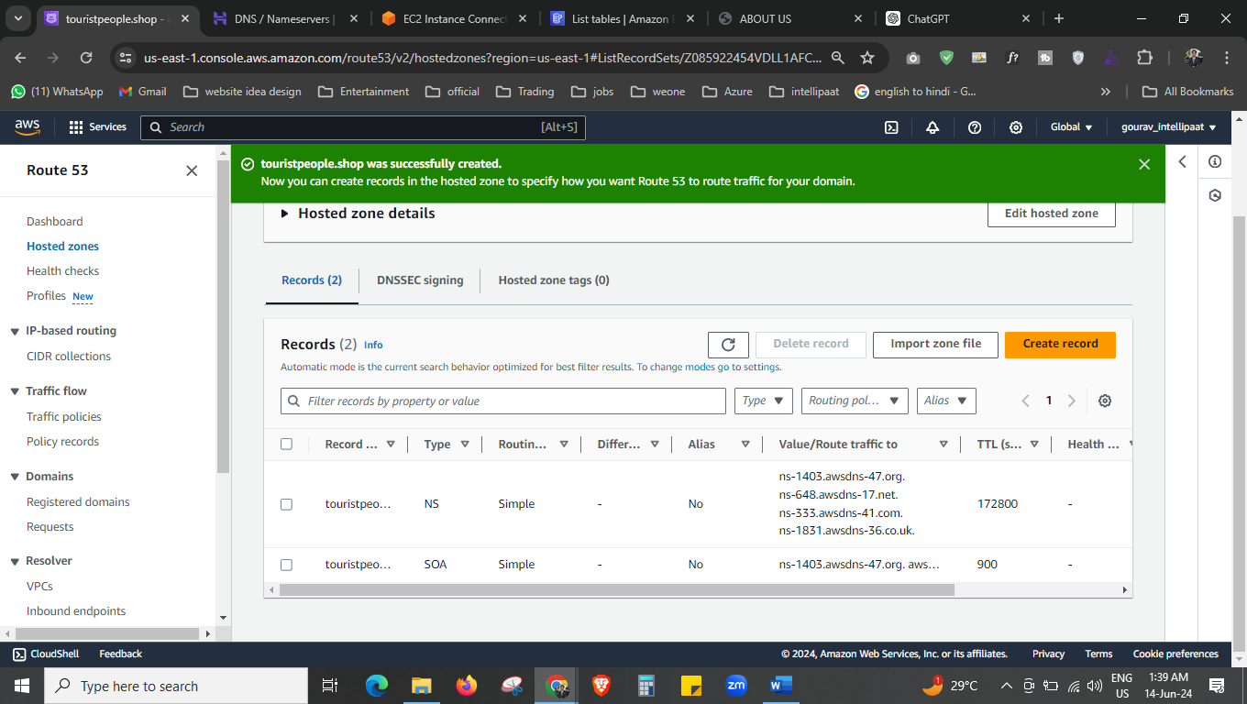



You can see we have this name server, copy this name server and paste to the hostinger website.

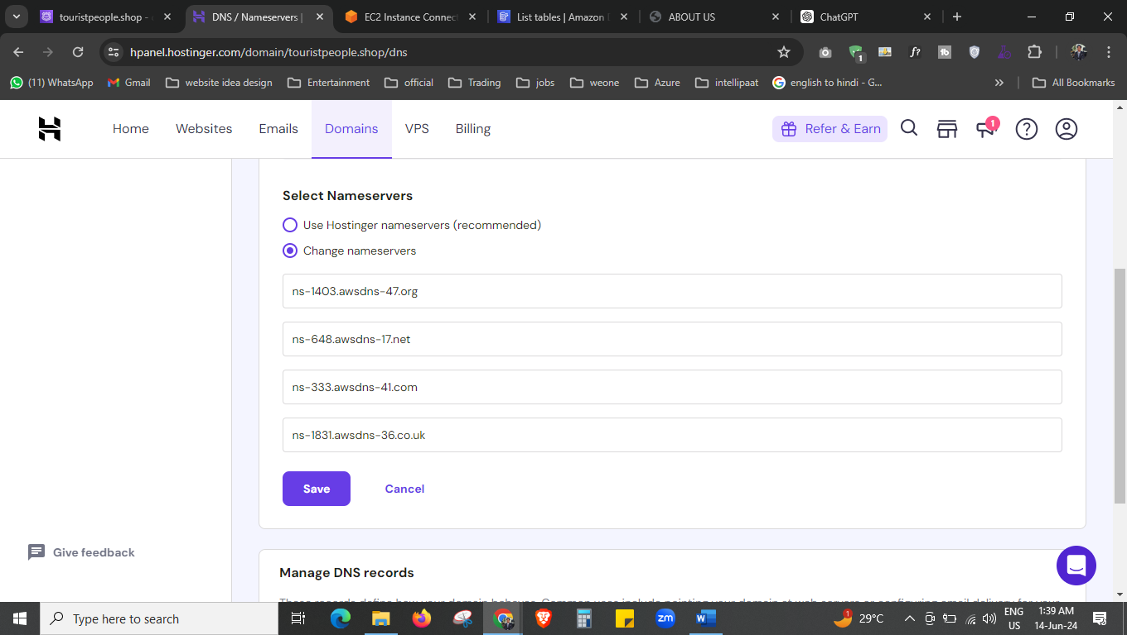



This is our new nameservers that we have copy.

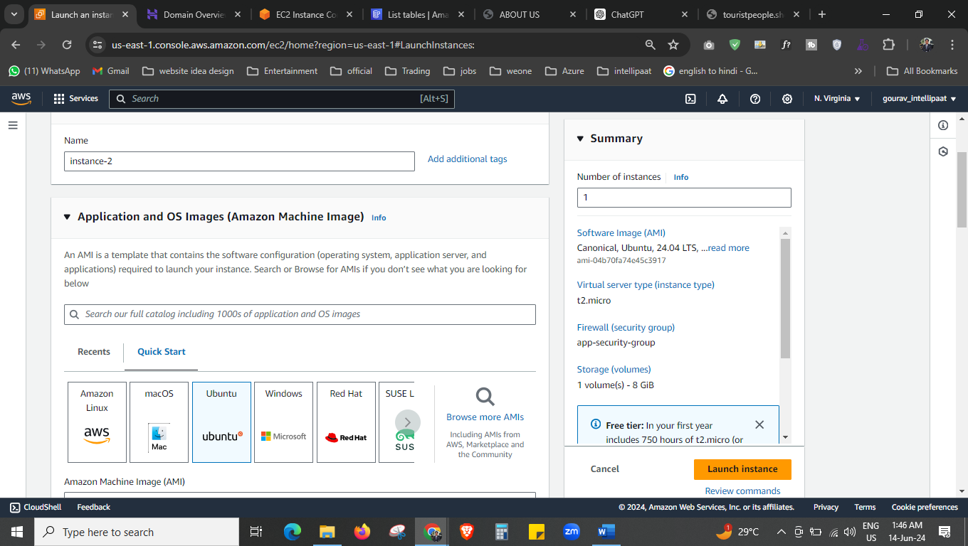

Now create the other instance i:e 2nd instance

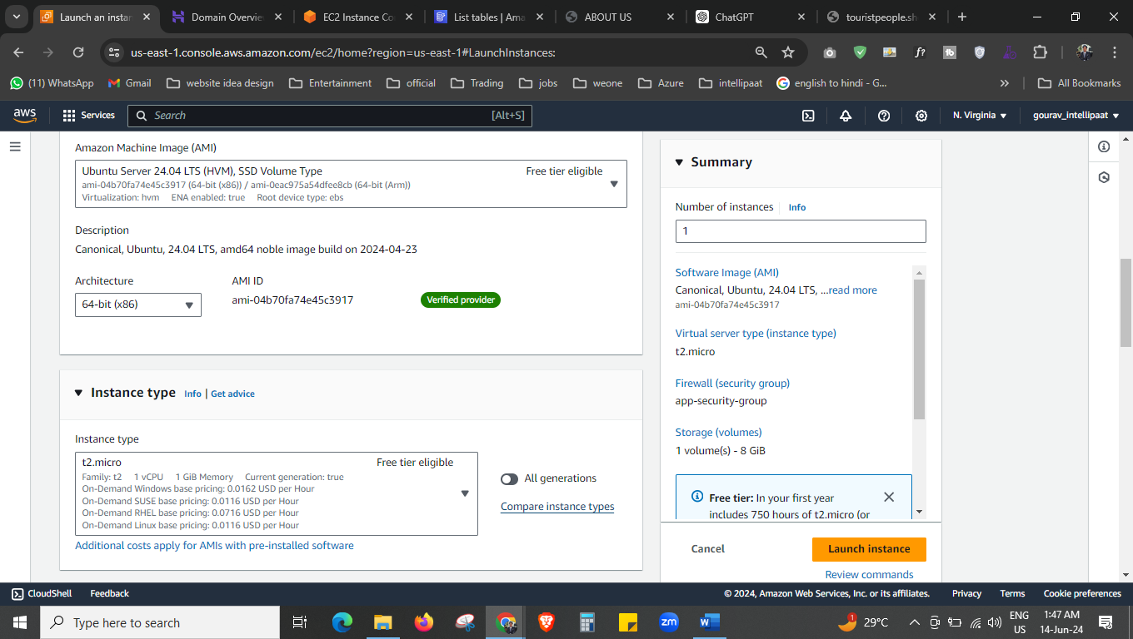

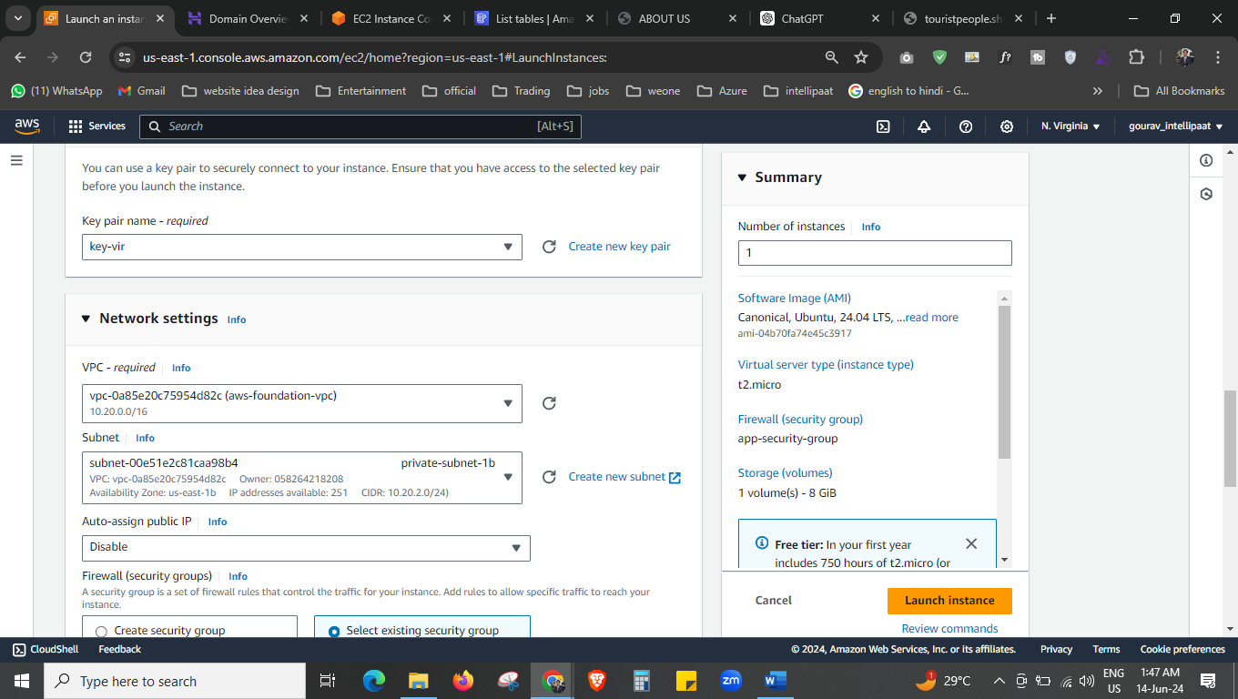

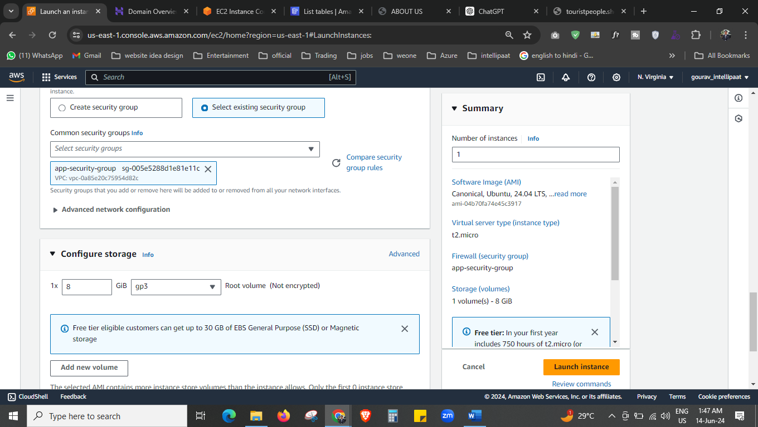

Now the 2nd ec2 is also created.

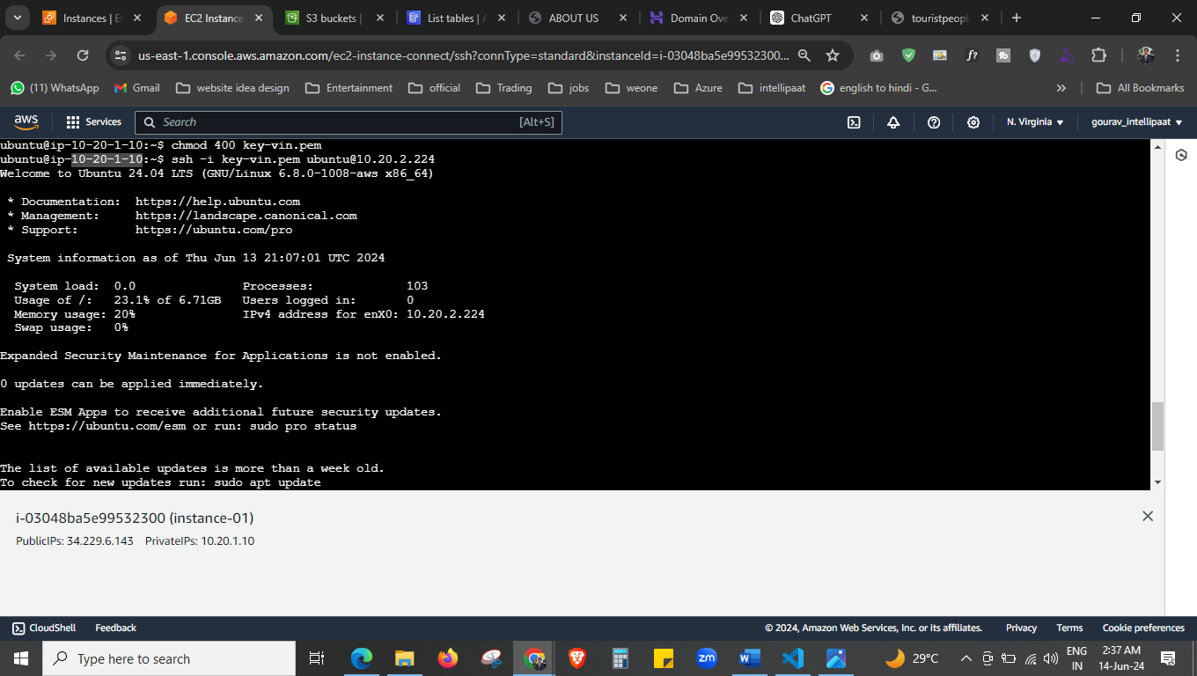

This is my 1st ec2 in public subnet, and through the public subnet I am accessing the private instance.

With this commandes

ubuntu@ip-10-20-1-10:~$ vi key-vin.pem

(paste your public instance key here)

ubuntu@ip-10-20-1-10:~$ chmod 400 key-vin.pem

ubuntu@ip-10-20-1-10:~$ ssh -i key-vin.pem ubuntu@10.20.2.224

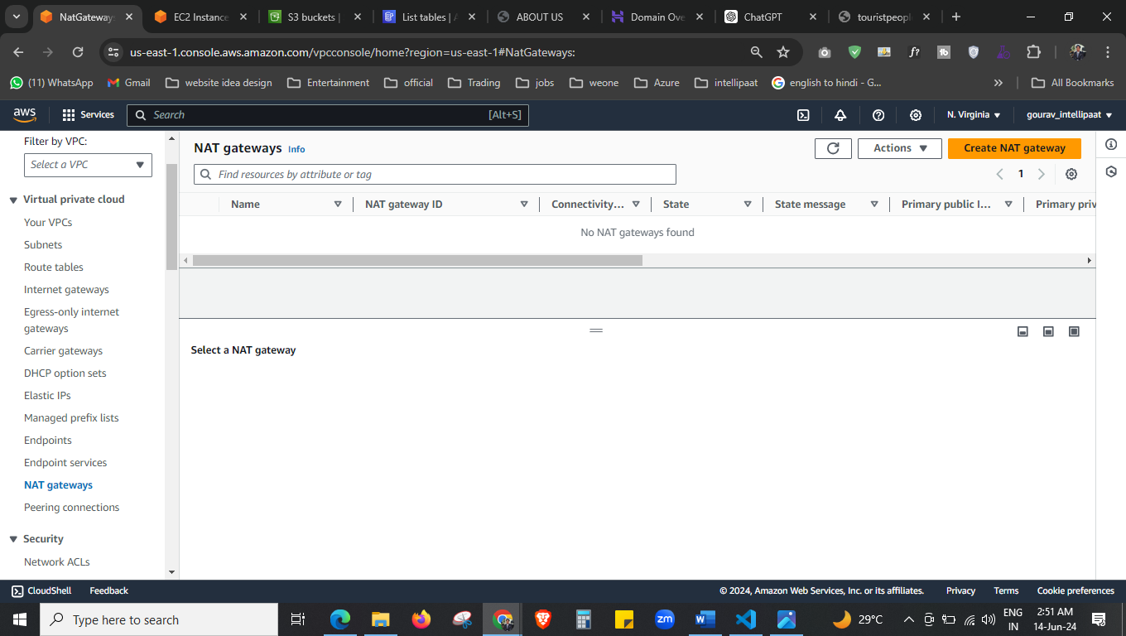

Now private route table did not have any internet connectivity, so we will create the NAT gateway now.

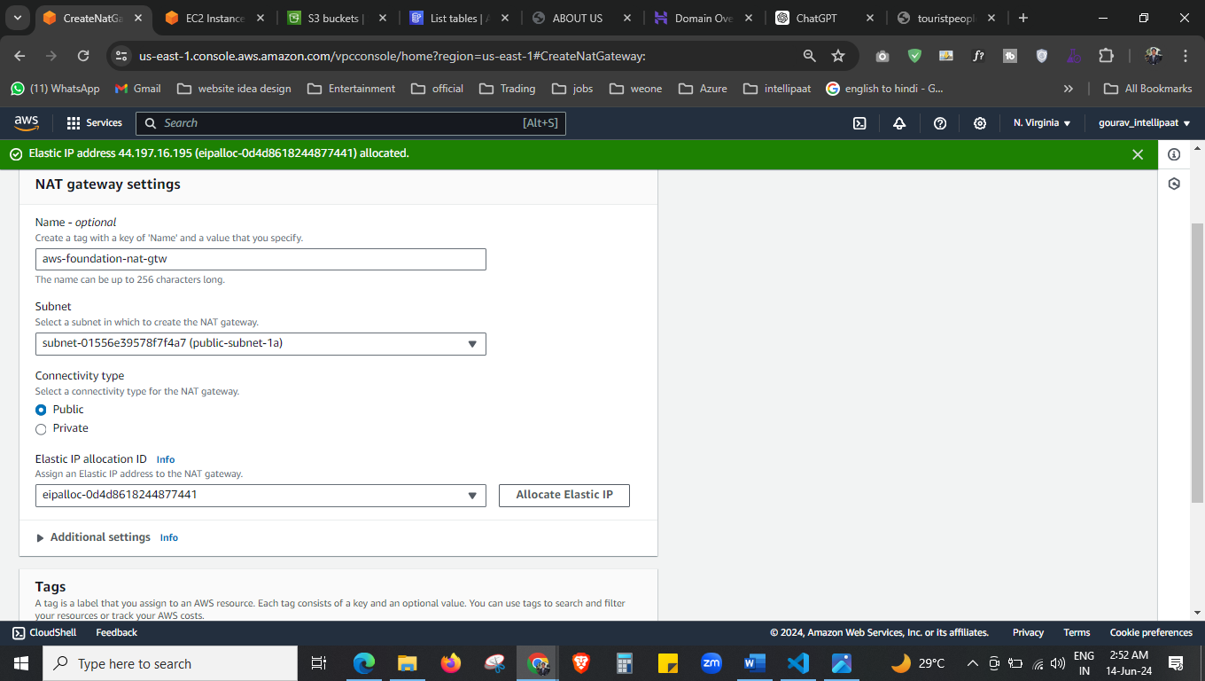



Here allocate the elastic IP, and name NAT gateway with pubic subnet.

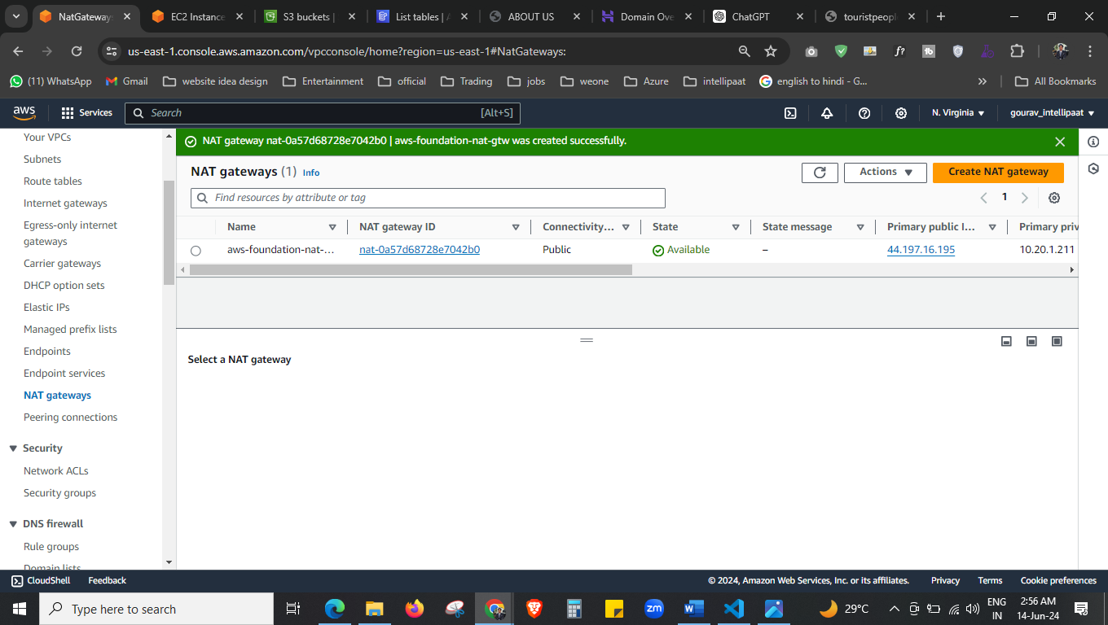

Our NAT is running now.

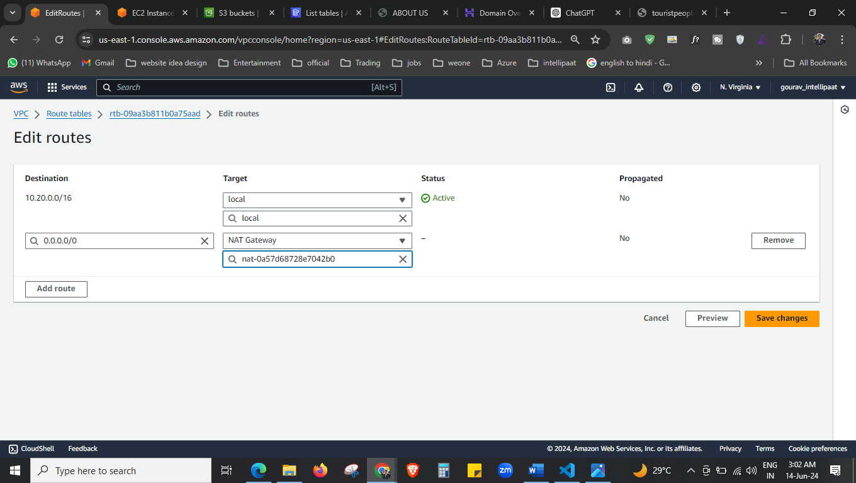

Go to private-rouote-table now and attached the NAI here.

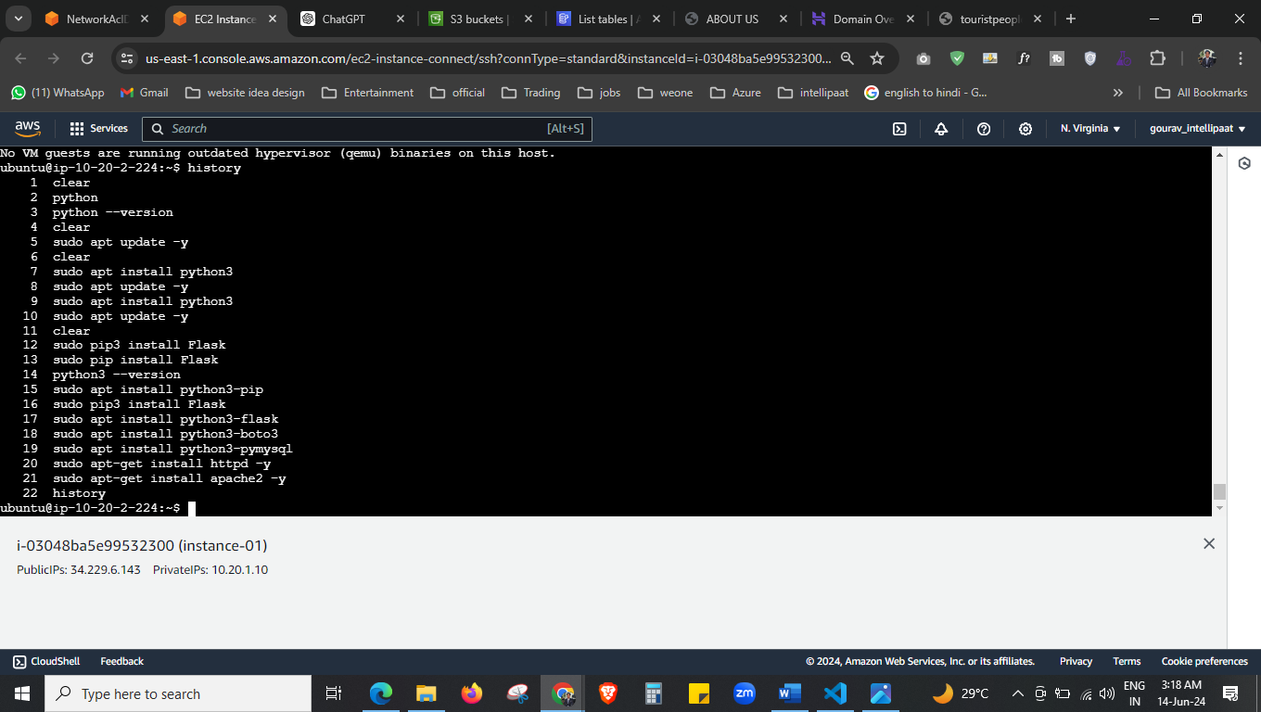

sudo apt install python3-pip

sudo apt install python3-flask

sudo apt install python3-boto3

sudo apt install python3-pymysql

we have install everything that is needed.

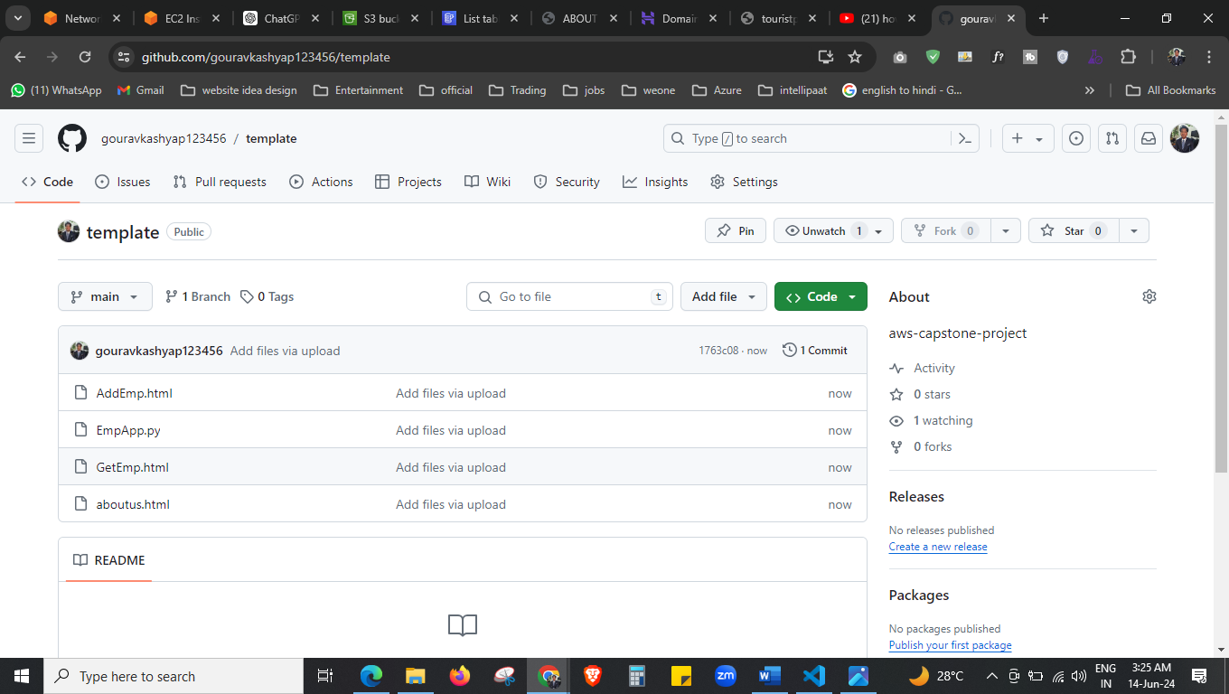

No I will transfer all my codes from github to mu ec2 instance, I saved my codes in github so that I used github here.

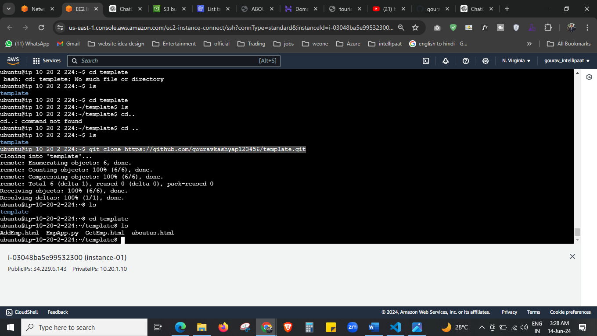



Here I clone my codes to my ec2 instance.

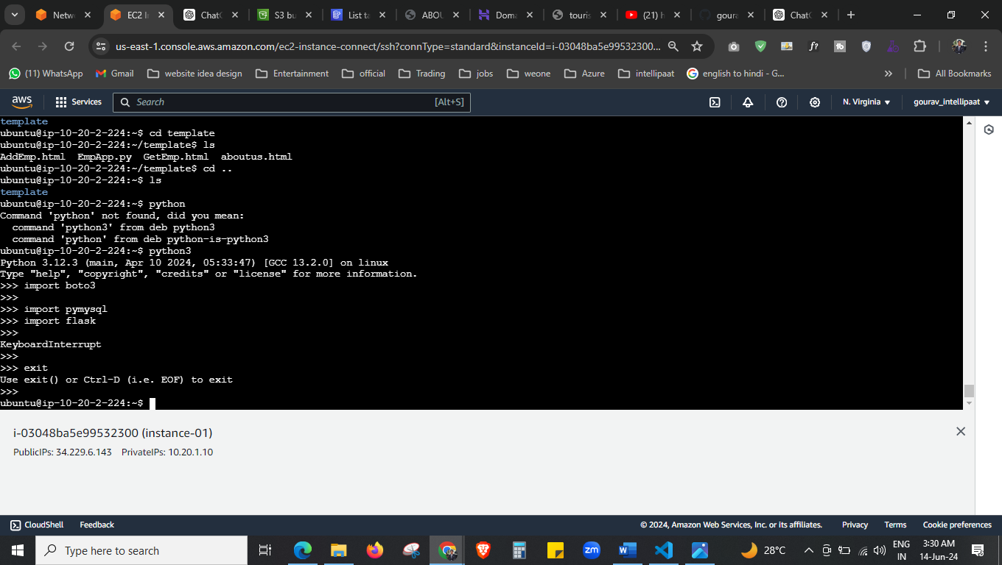



\now I import everything that I needed.

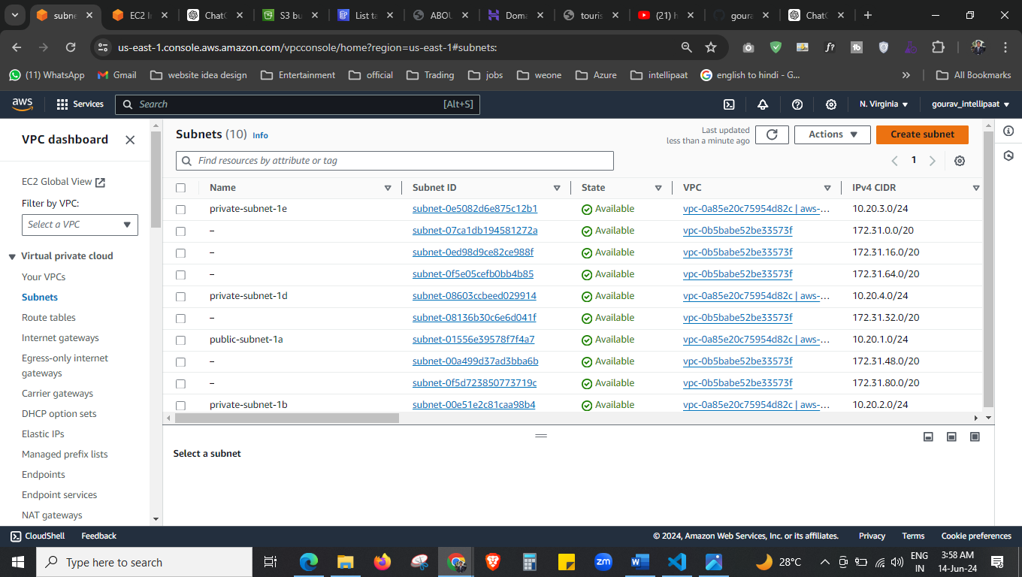



We are moving to Application load balancer, but ALB need atleat 2 public subnet and we have only one, so we will create the another public subnet also.

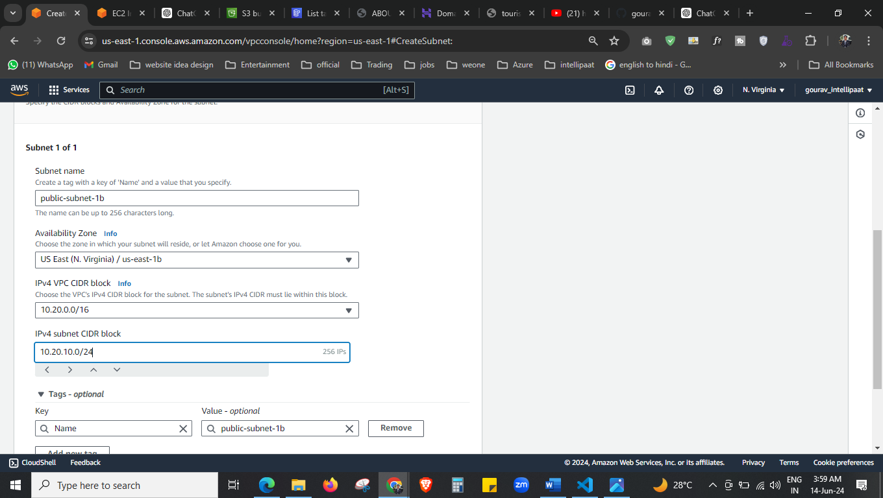

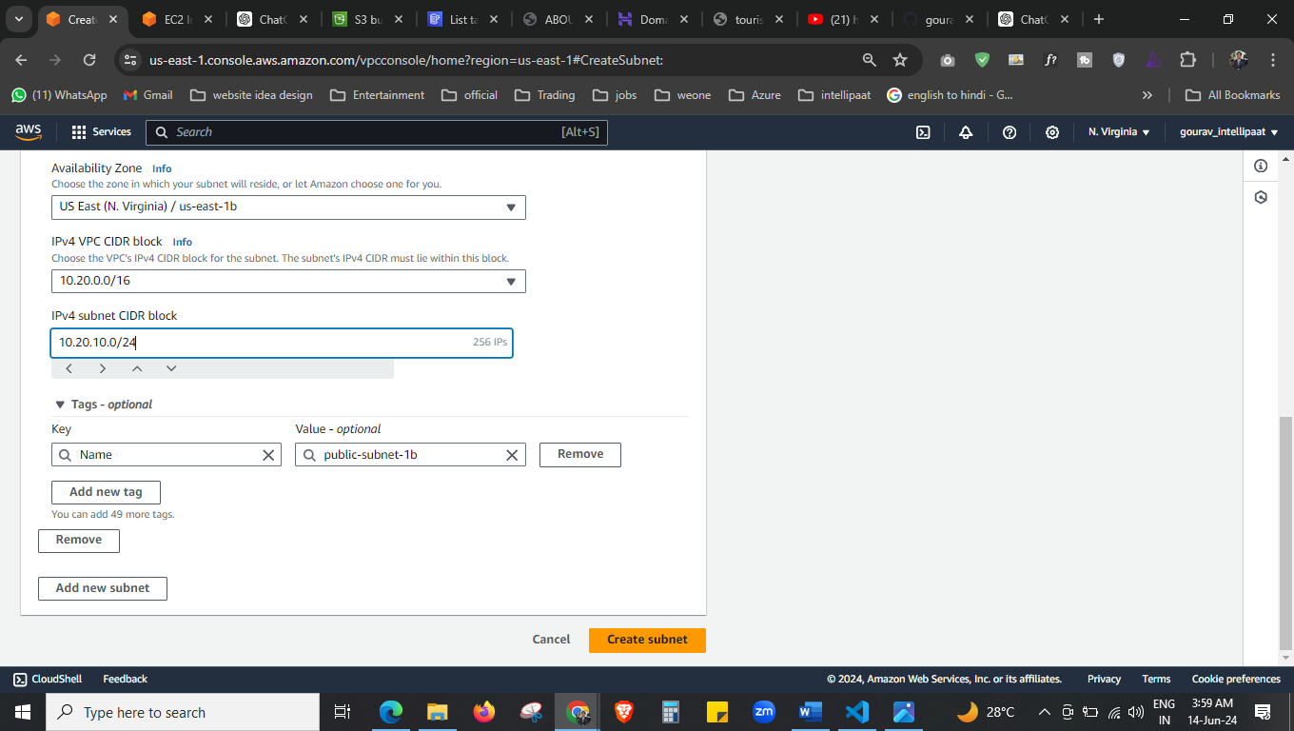



Create it.

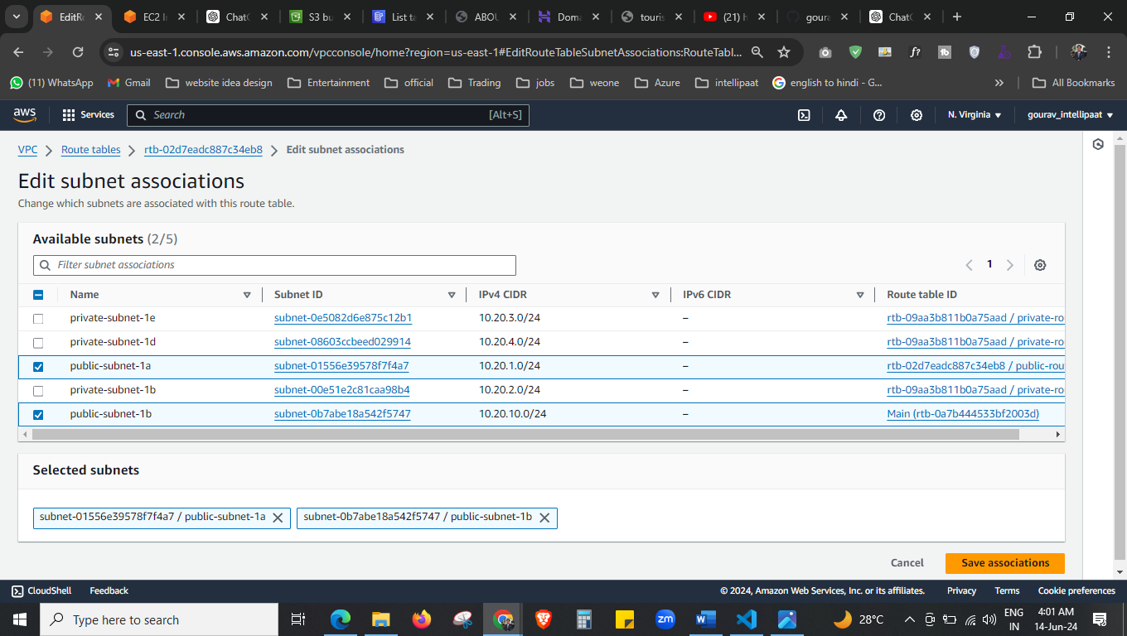

Here we added the route also.

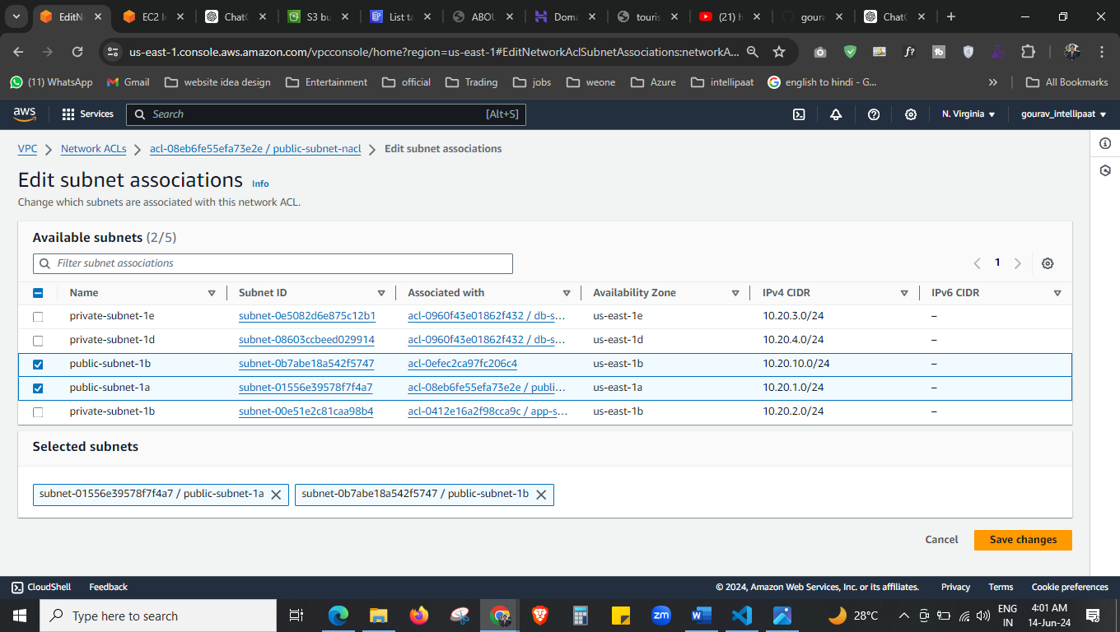

In network ACL also I have added the newly created public subnet.

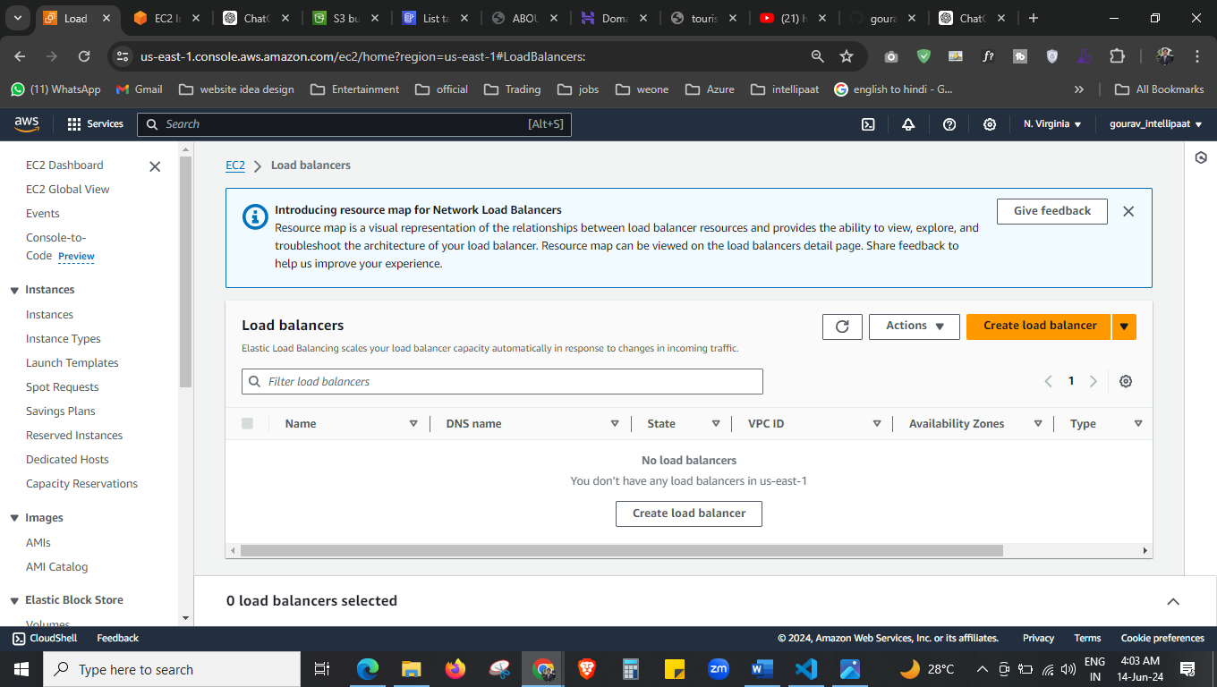

Now we are creating the application load balancer.

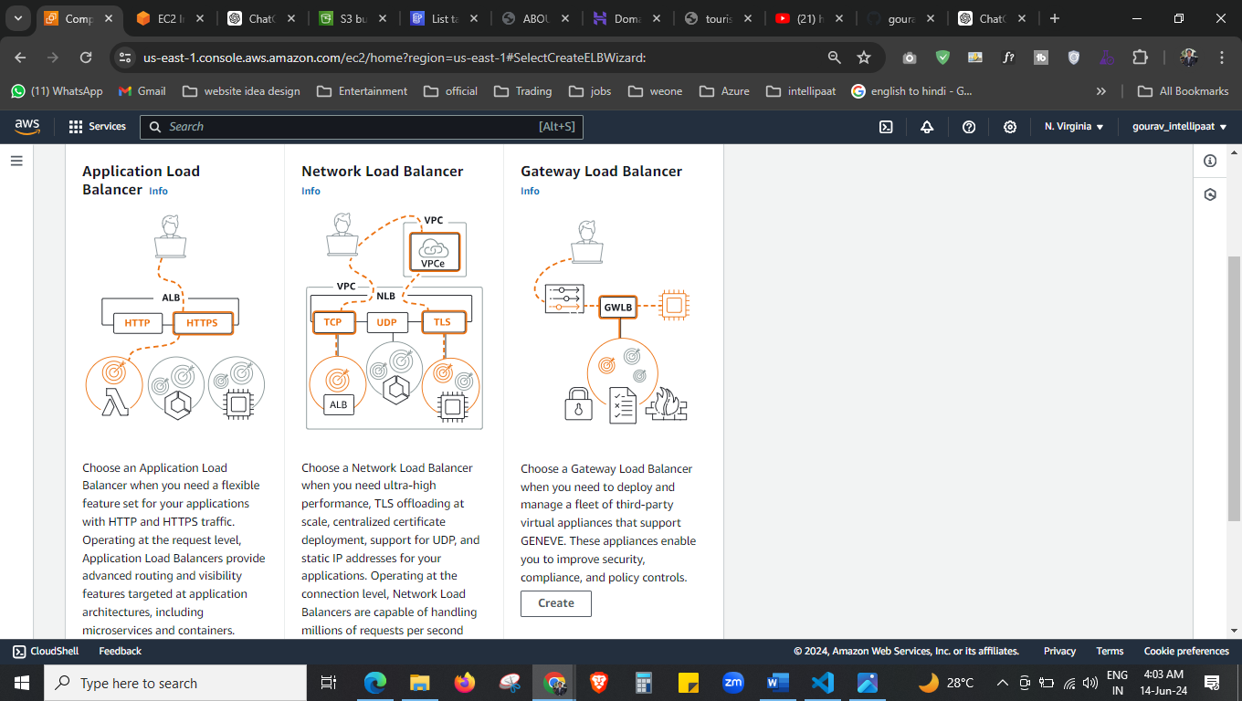



Select the first.

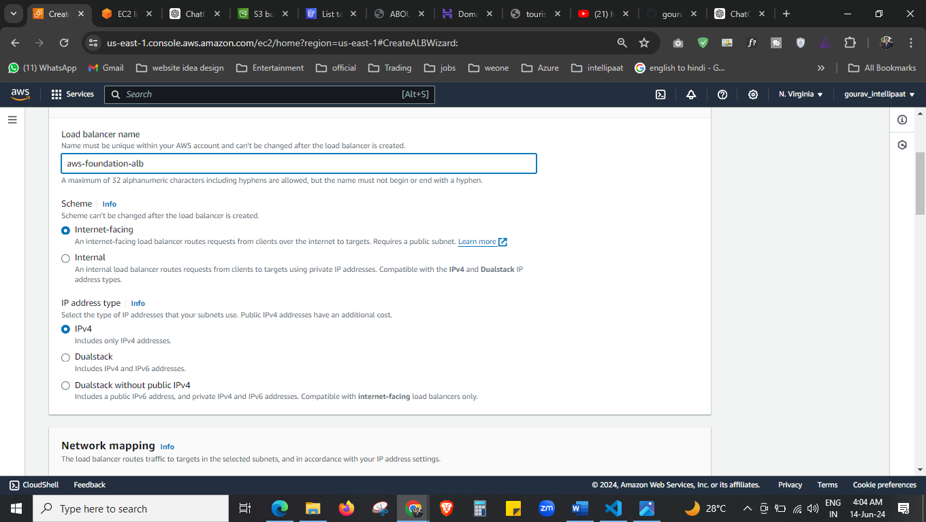



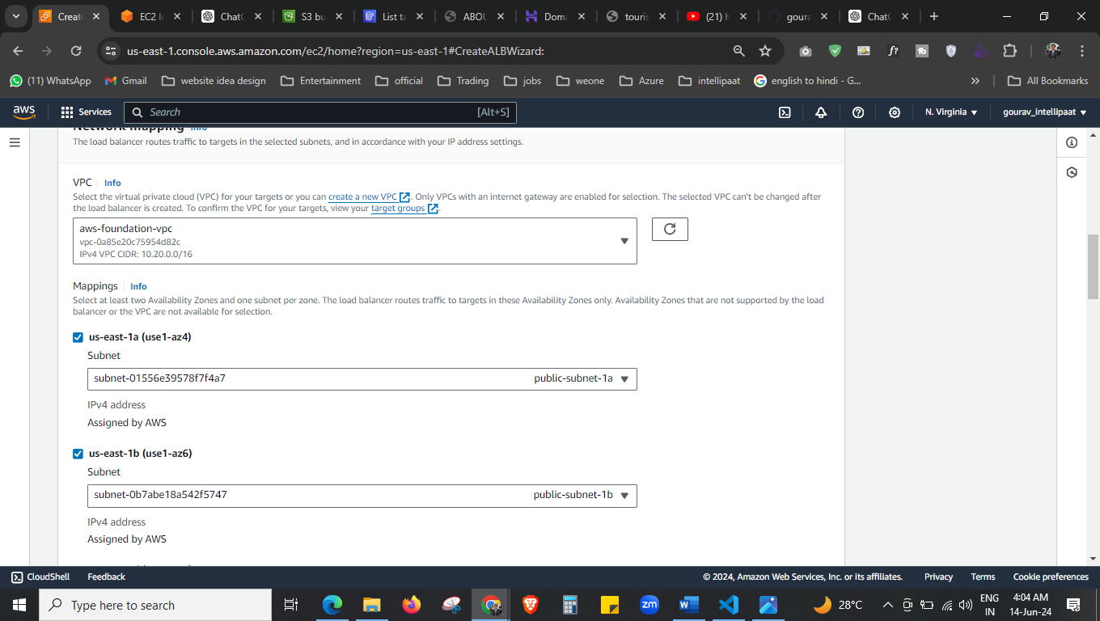



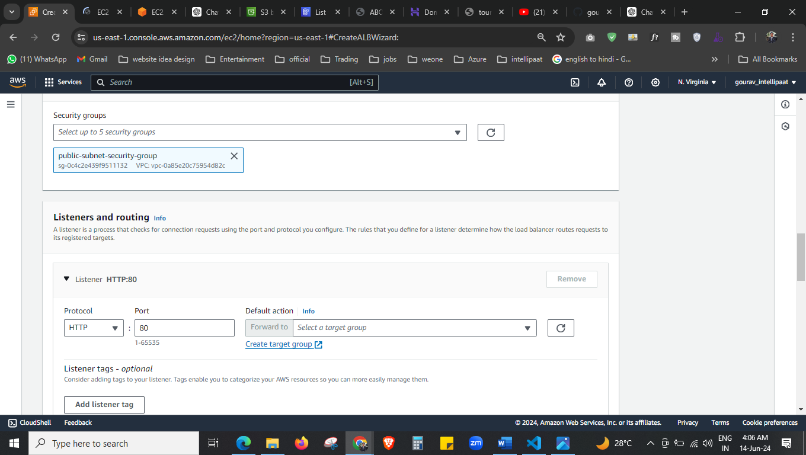



Select the existing security group, and create the target group also.

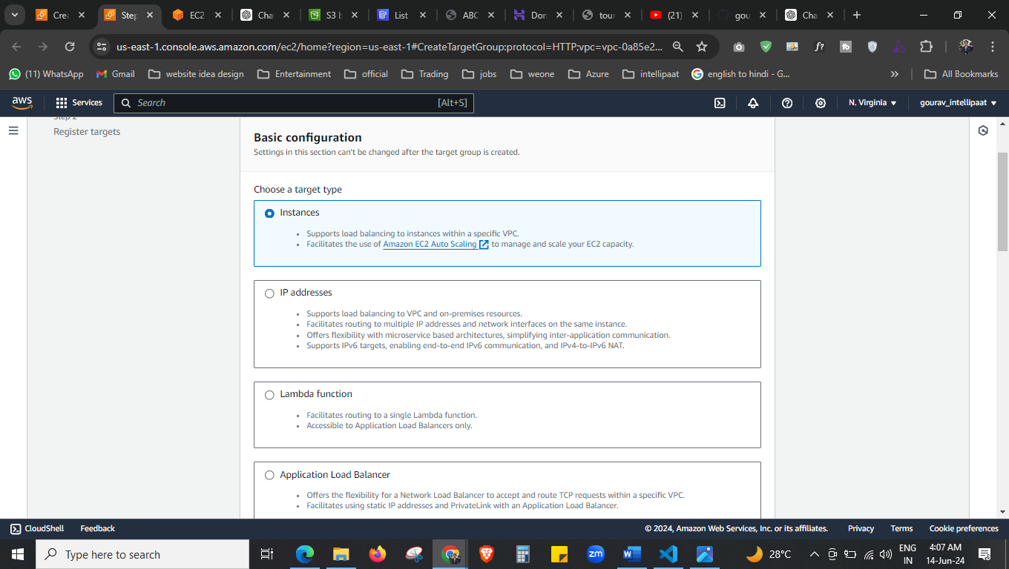

This is process of creating target group

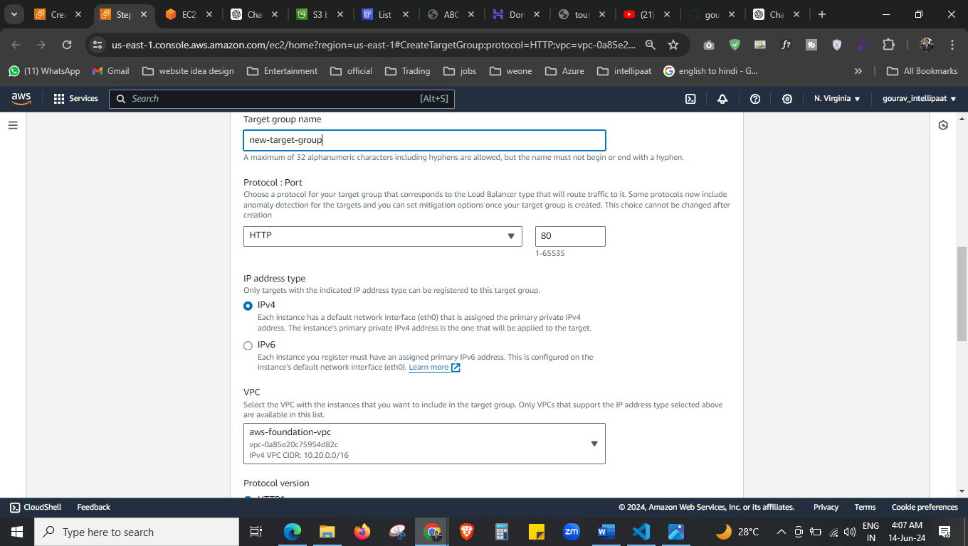

Target group is created now.

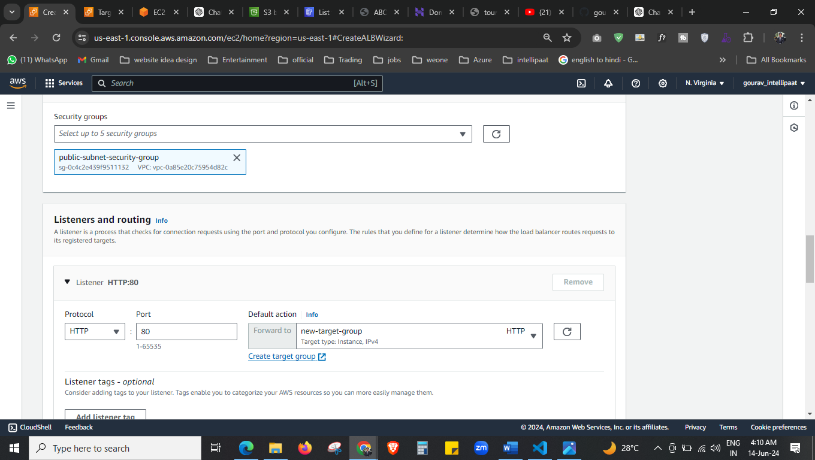

Select the target group now.

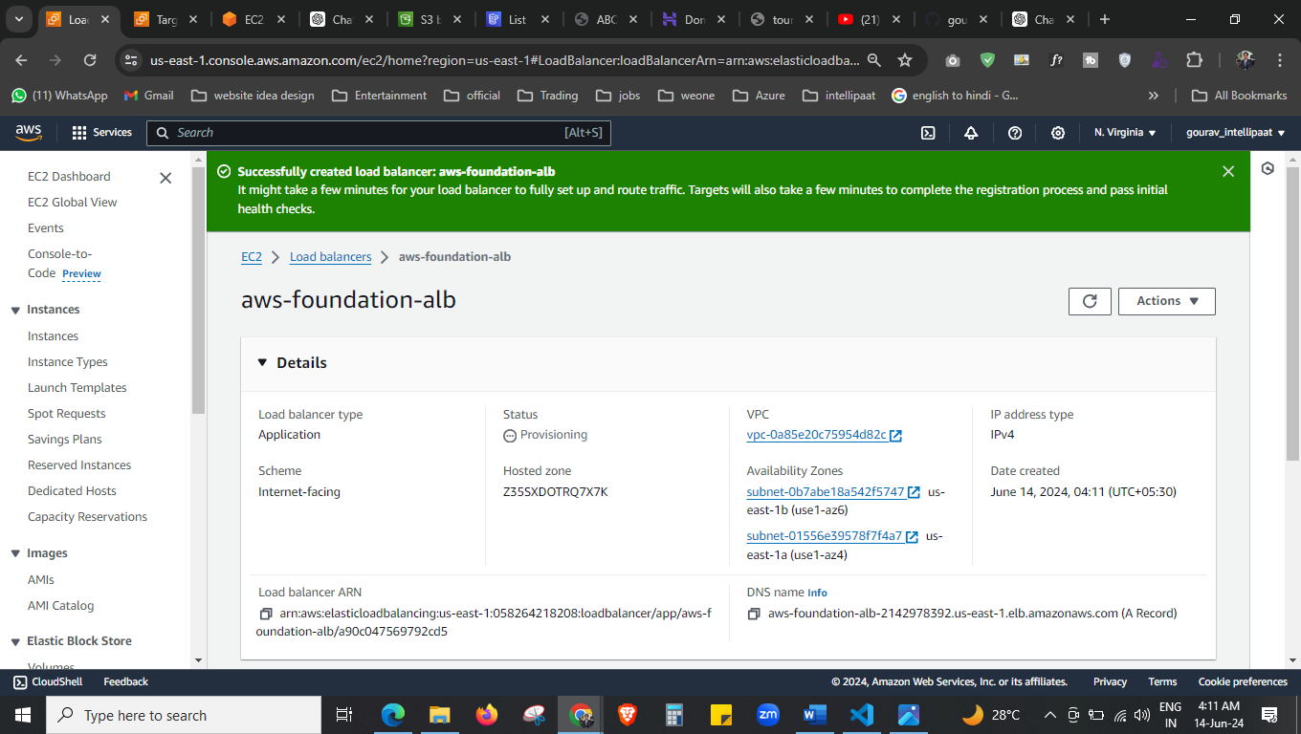

Here we have successfully created the load balancer.

Now the next step is to create the auto scaling but to create that we need AMI and launch template, lets create that first. 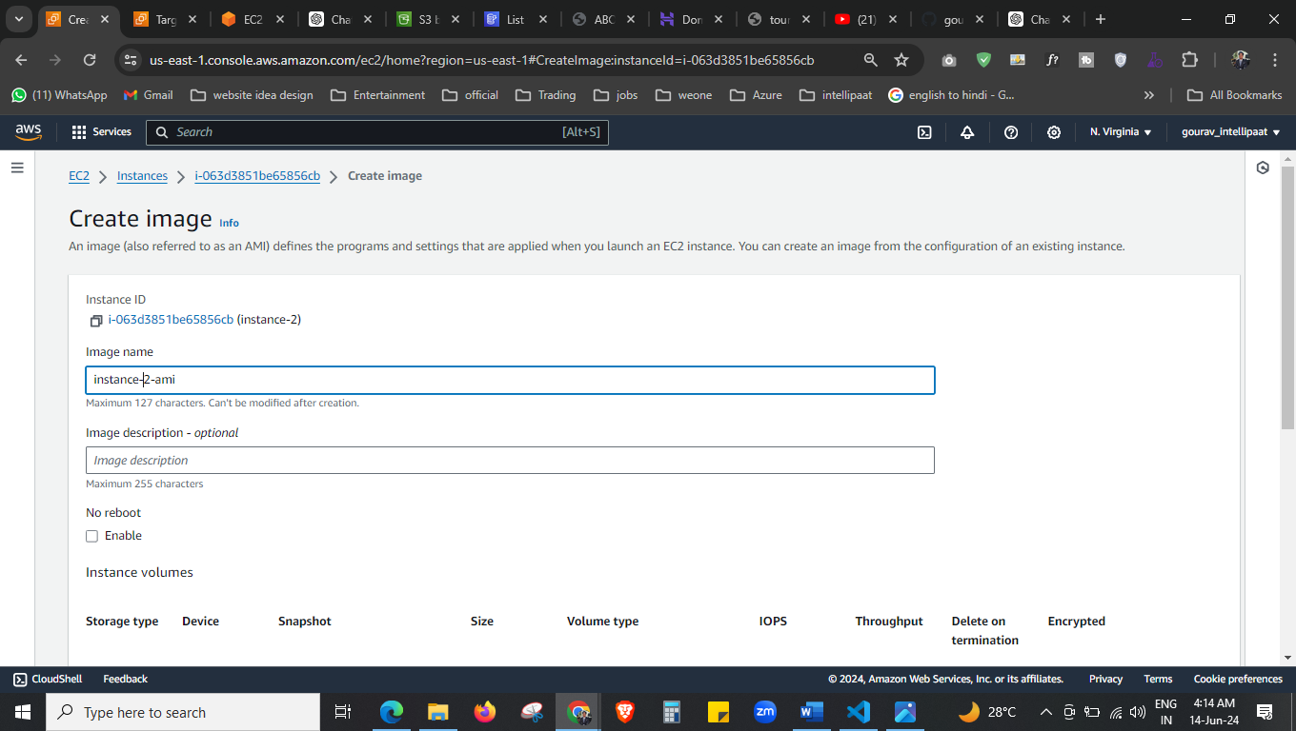

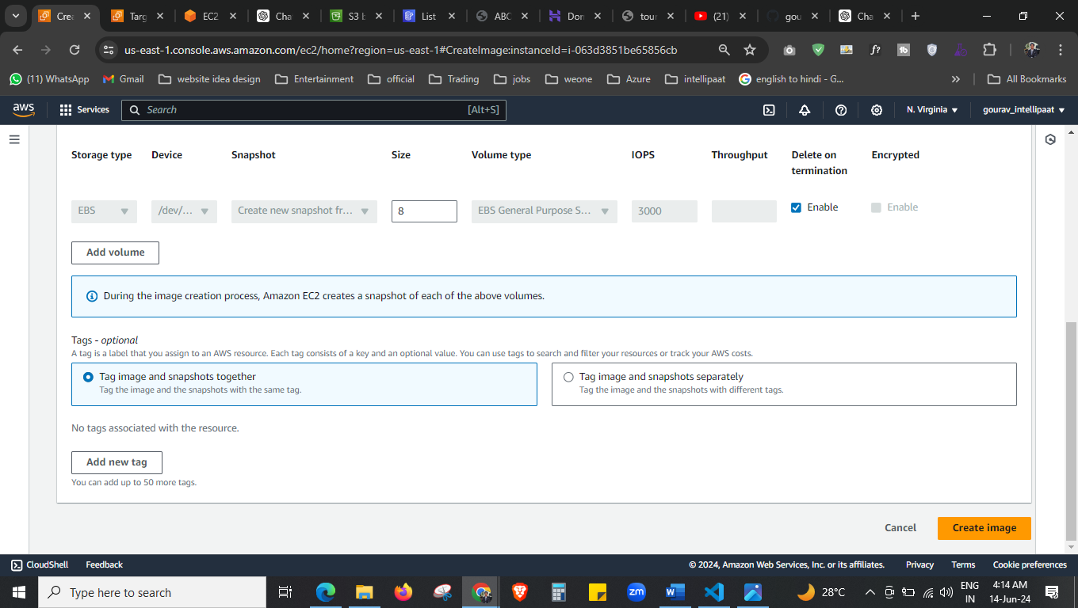



Create the AMI here.

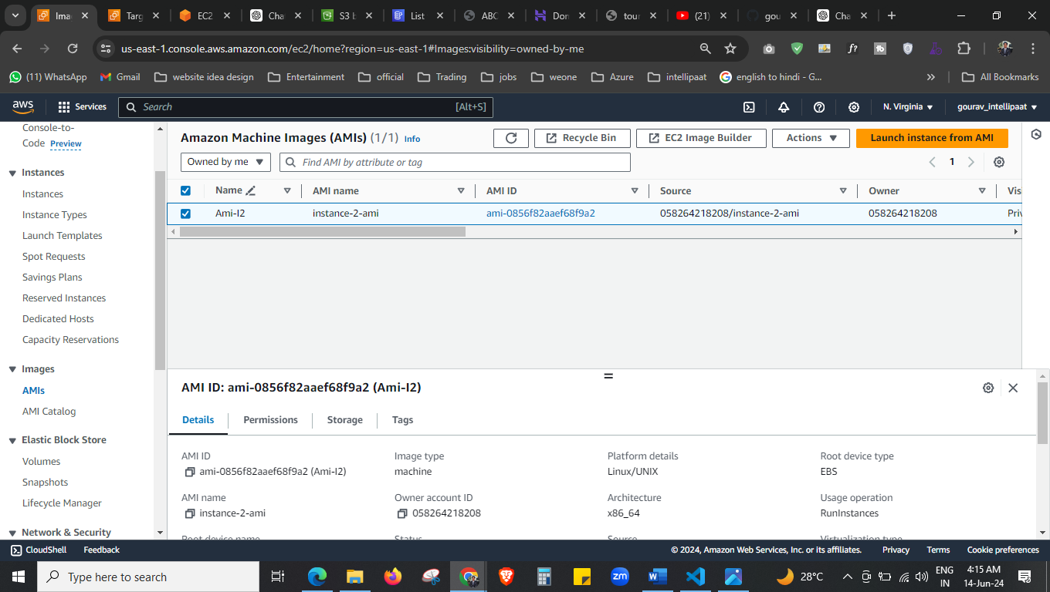



Our AMI is created now.

Now we have to give access to service, when service want to access other service we have to give the permission in the form of roles,

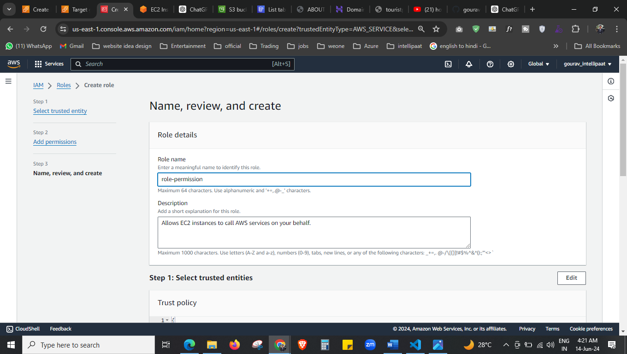

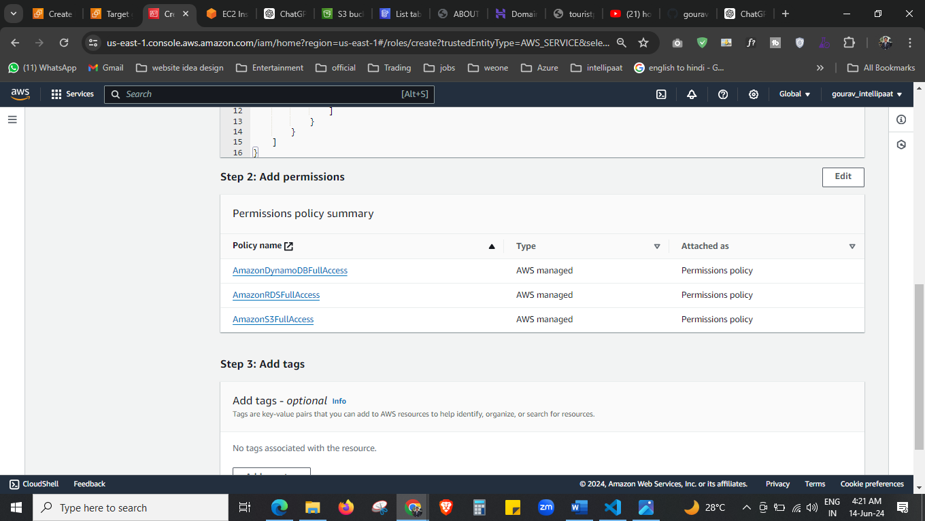



Create the role here.

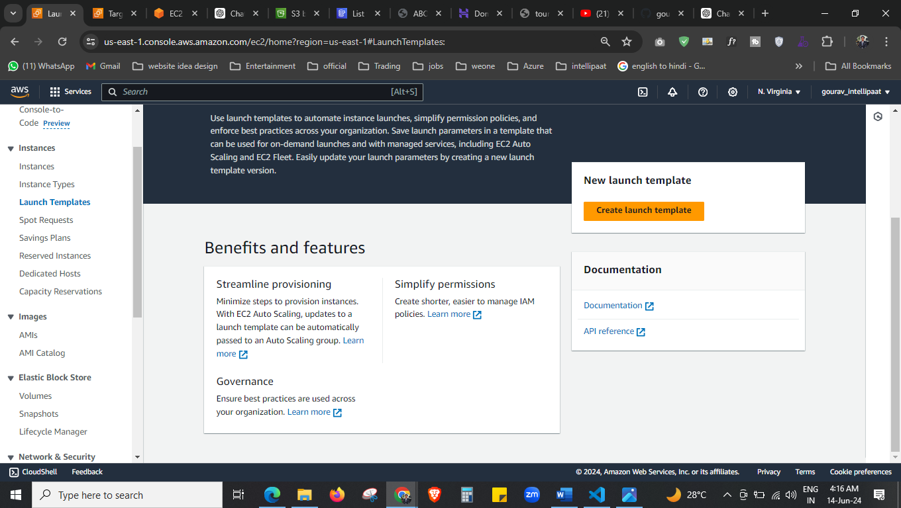

Lets create the launch template now.

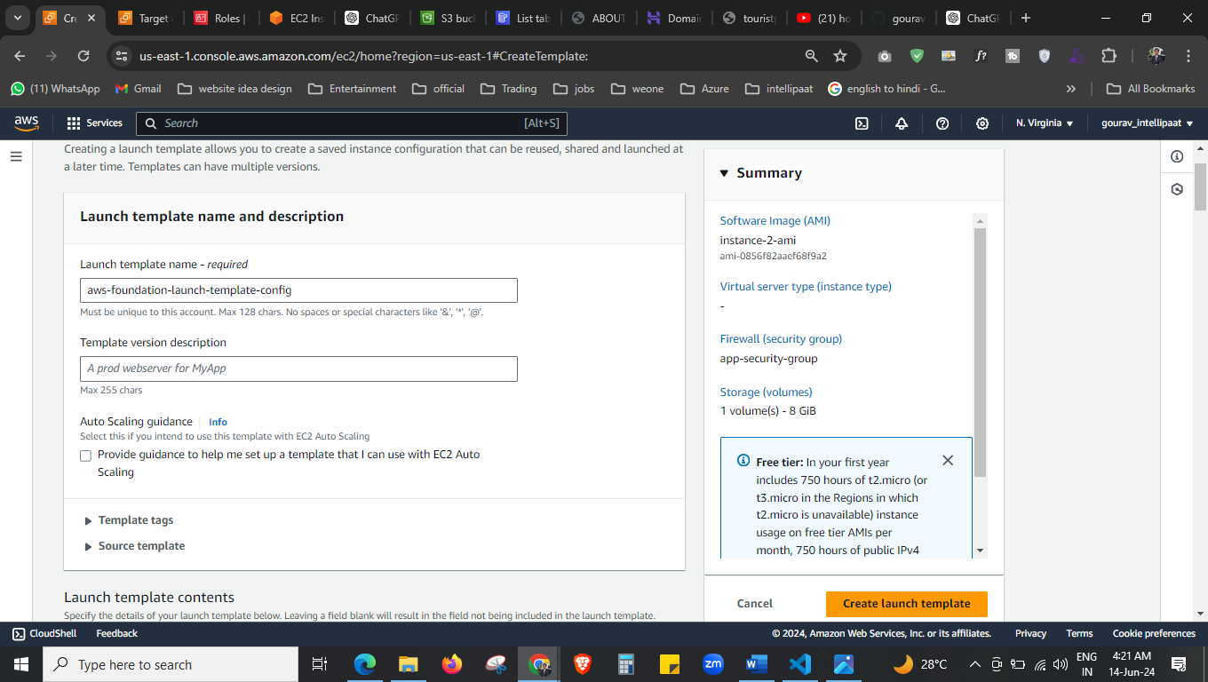



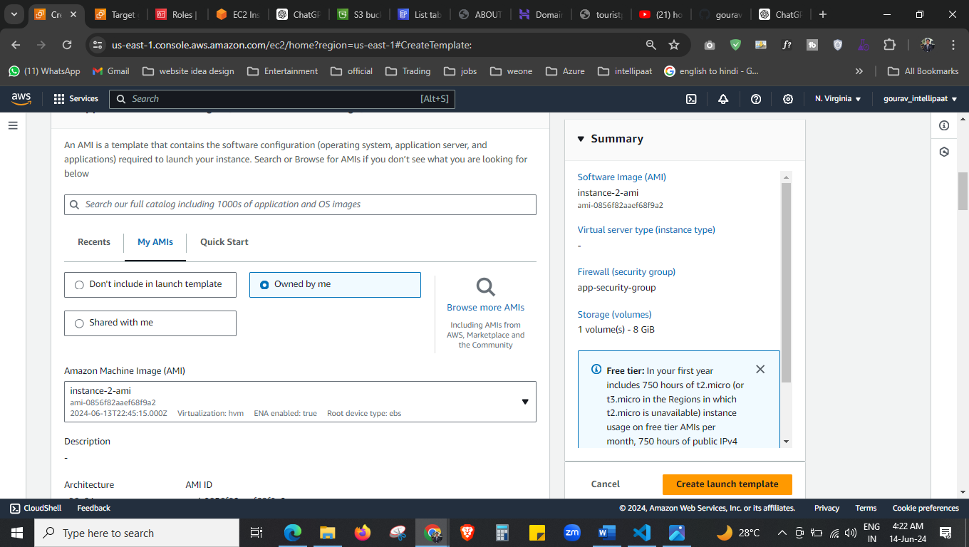



Select the AMI that we have created

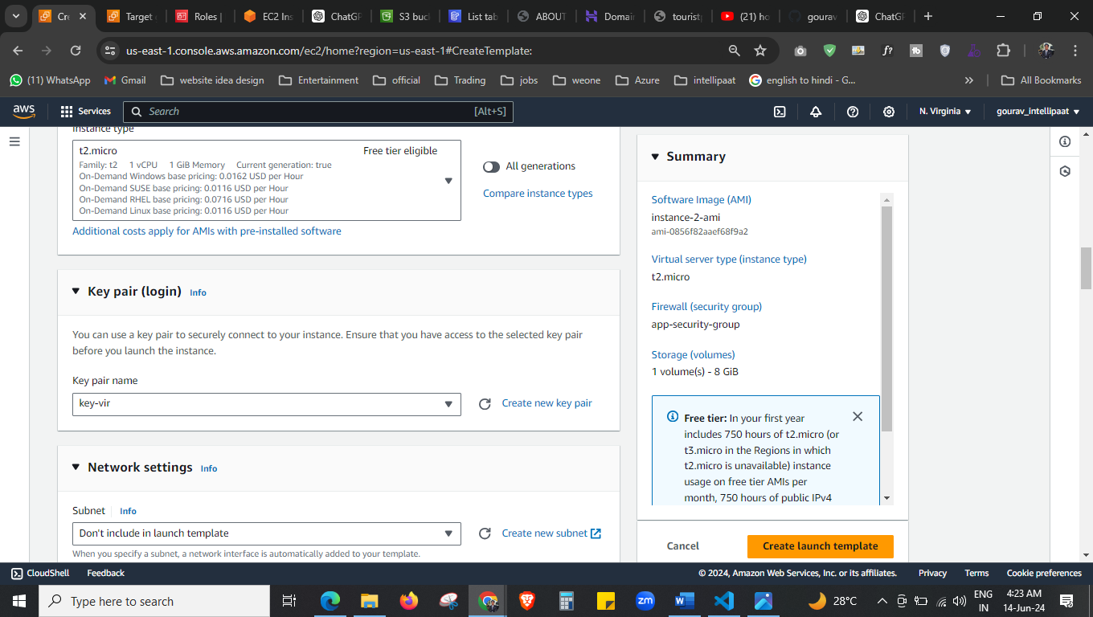select the t2.micro and key

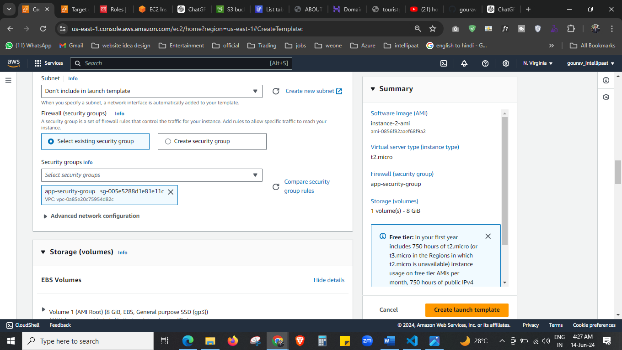 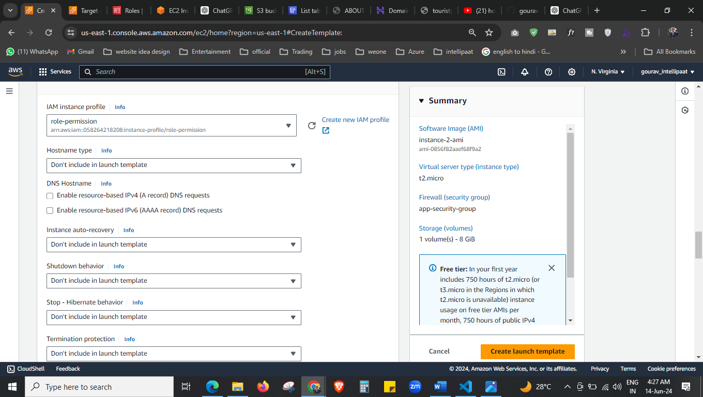



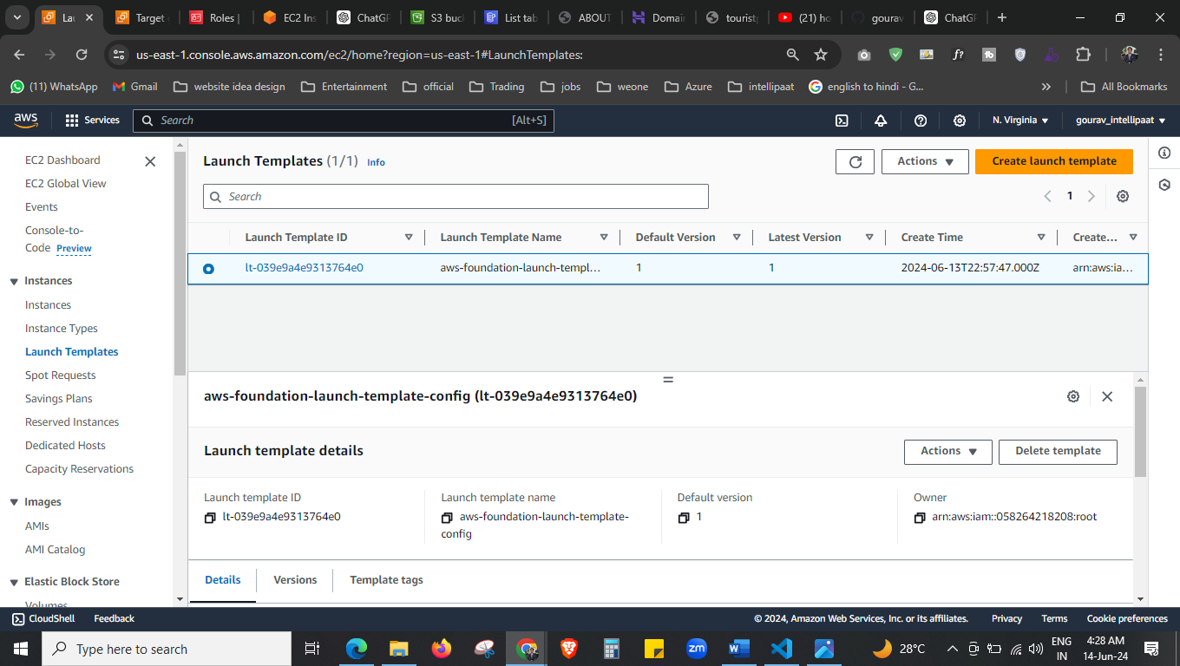

We have created the launch template now.

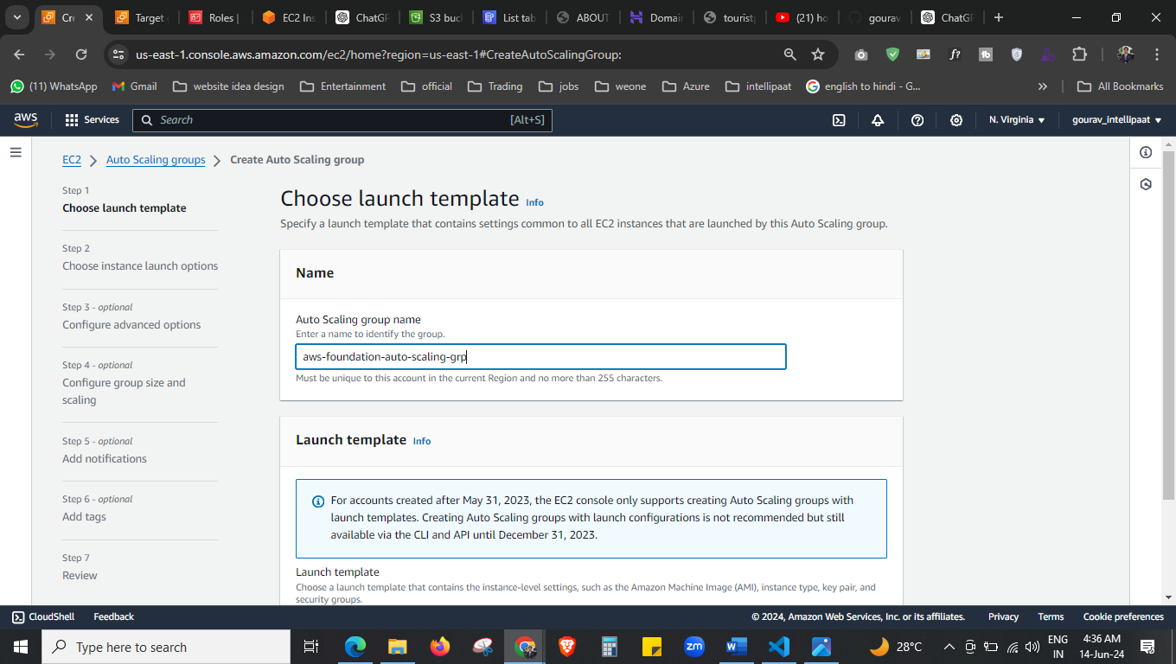

Creating the auto scaling group

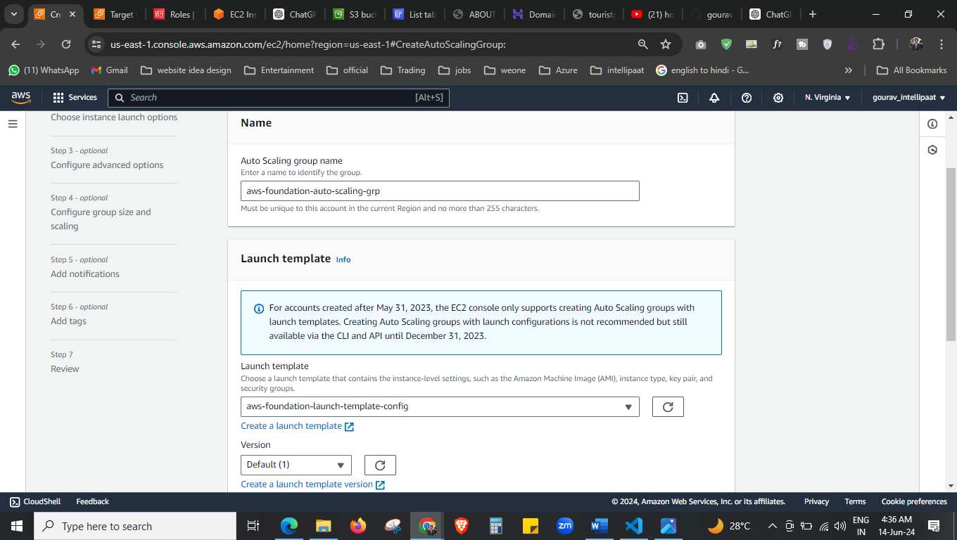

Select your template that we have created just now.

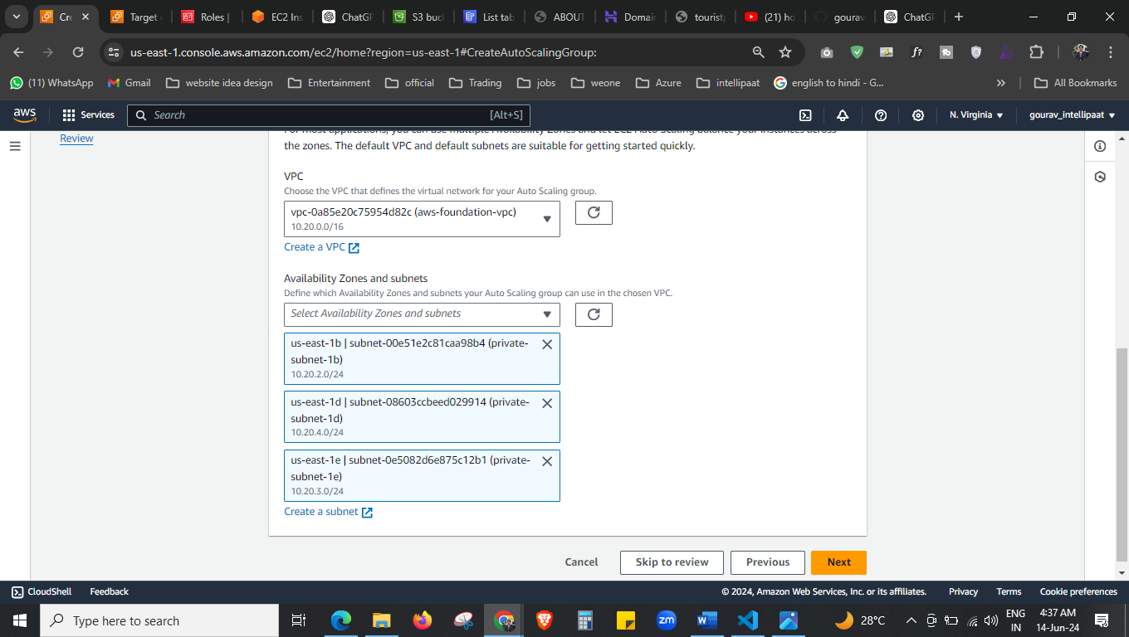

Select your VPC and all private subnet.

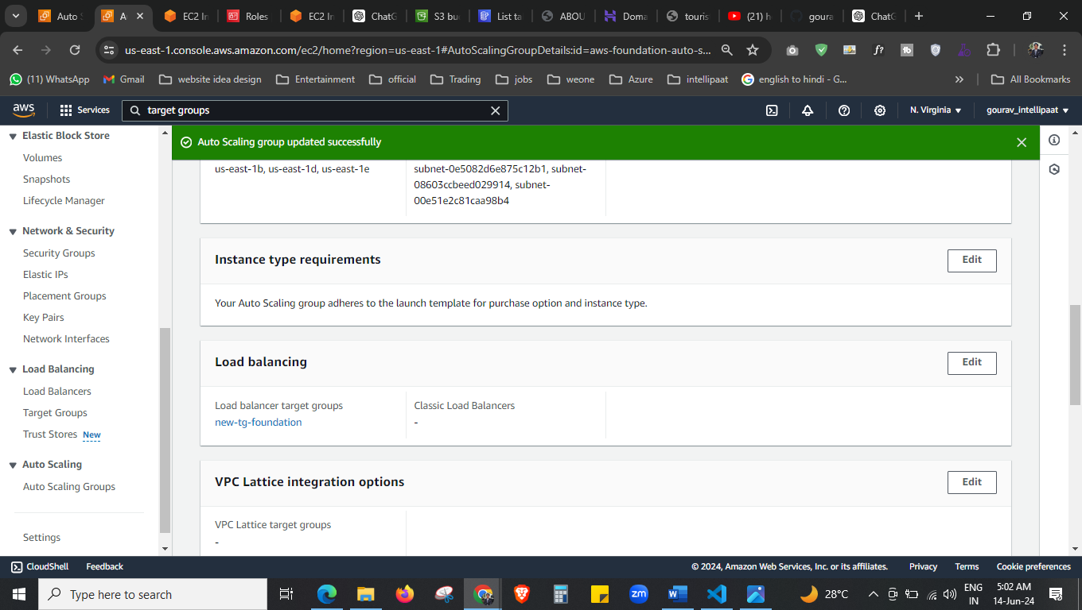



Add target group

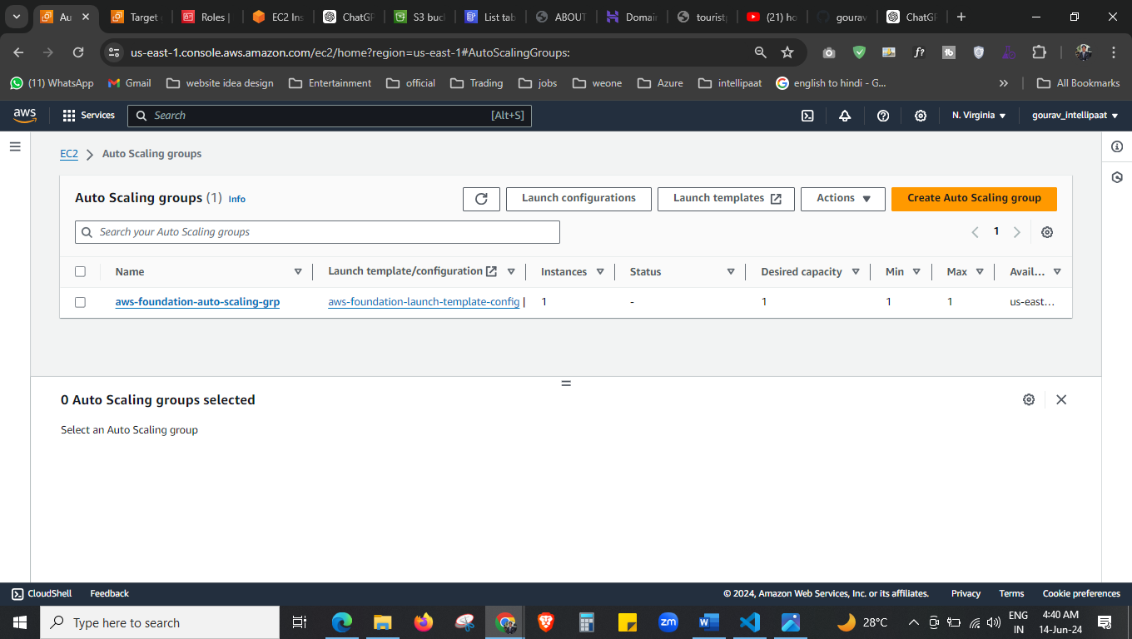

Auto scaling is created now.

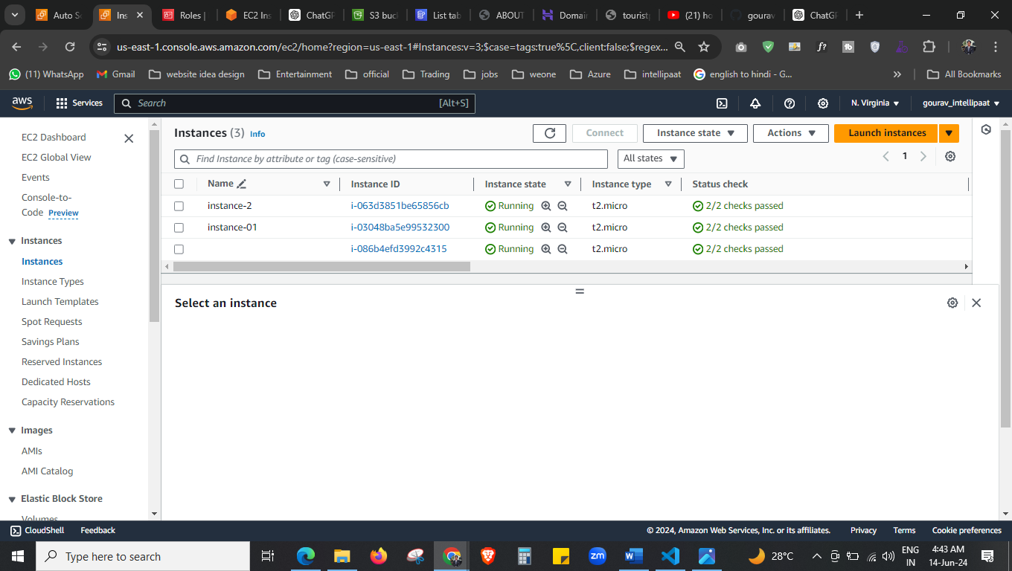



As the auto scaling is launched 1 instance is created.

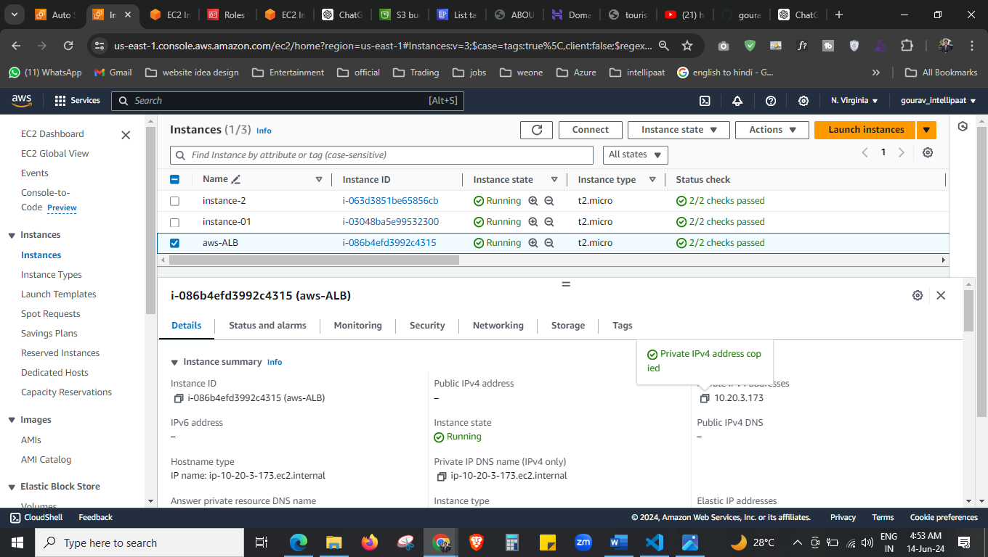



Now this auto created ec2 I name them, now I will connect it through the public instance.

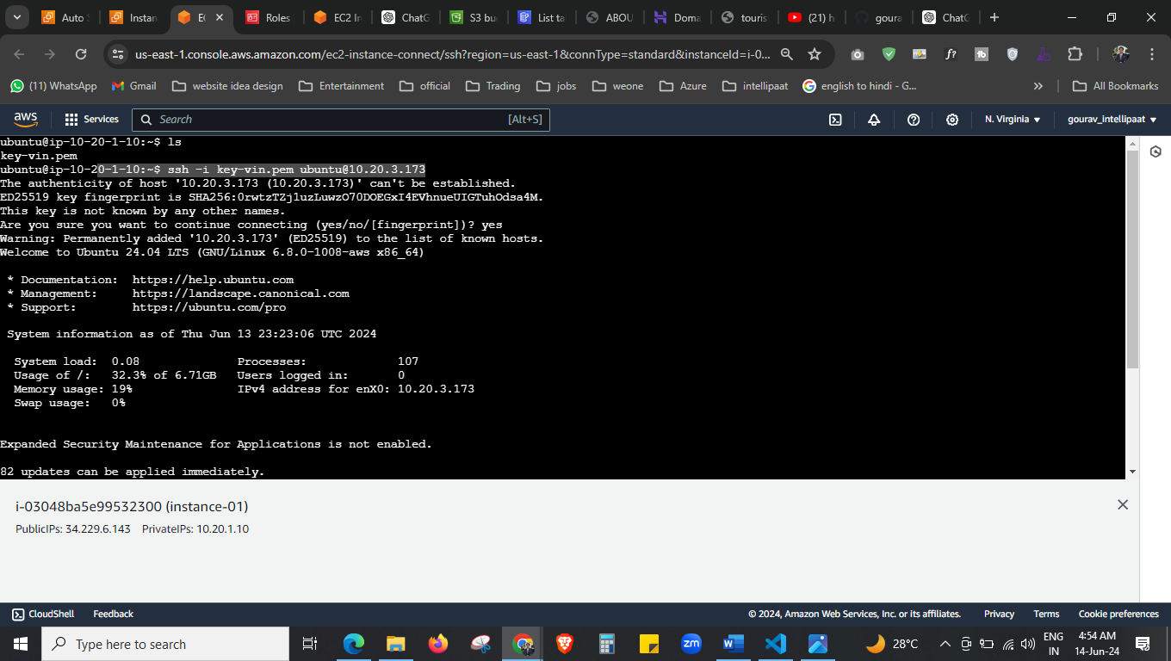 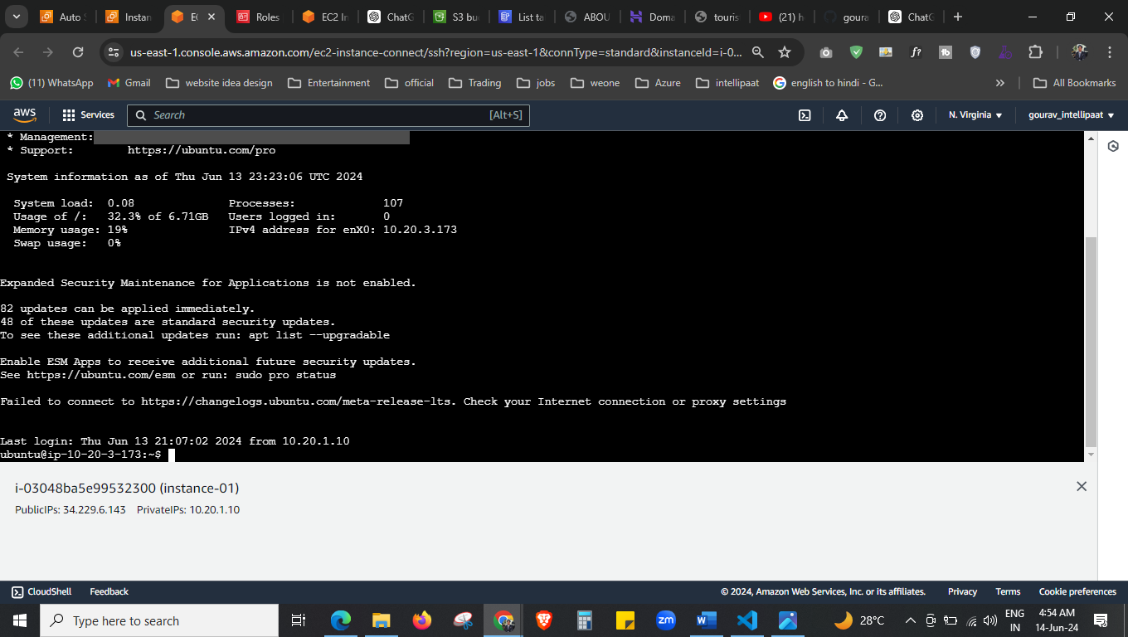



As you can see I connect this instance through my public instance, we cant directly connect to it.

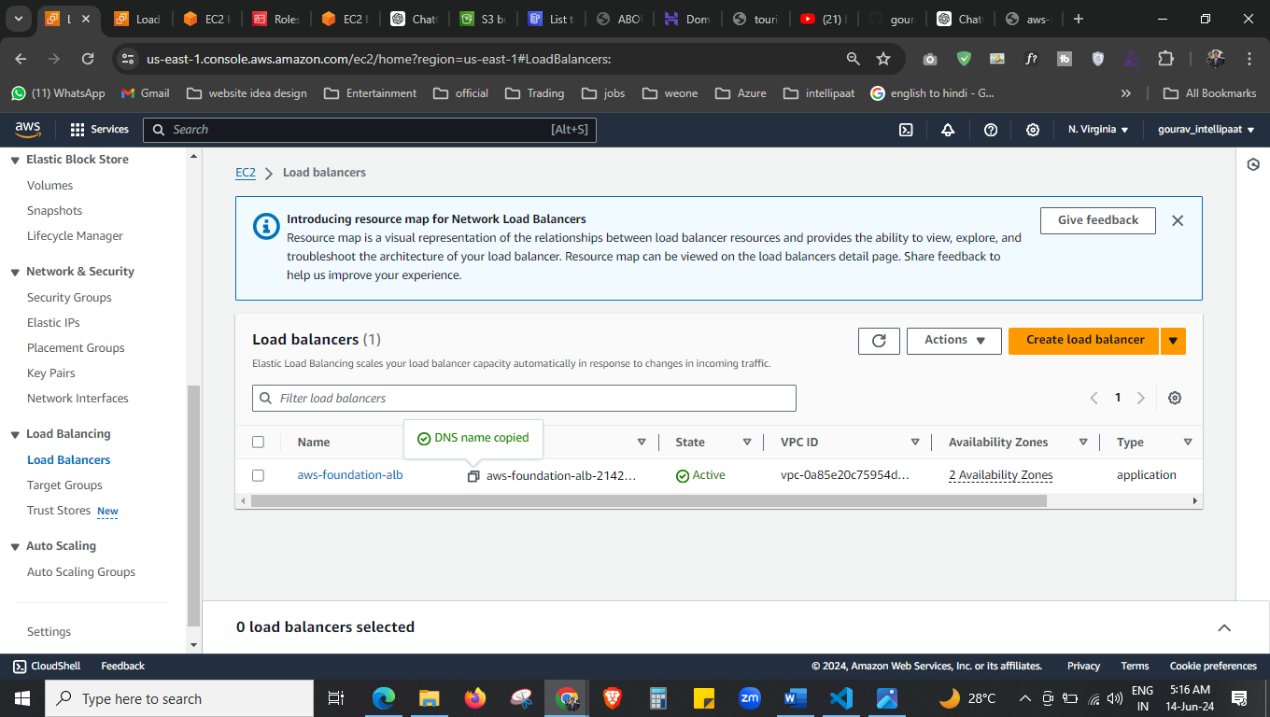

Copy the DNS name now and paste to html program. 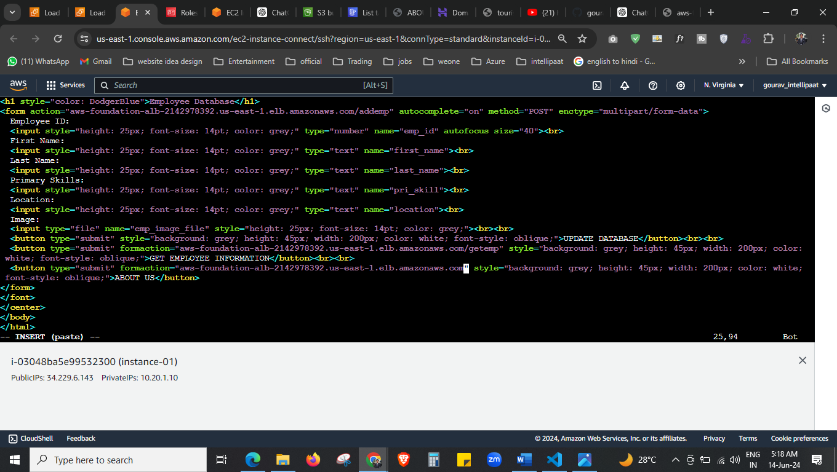



Paste here the DNS name.

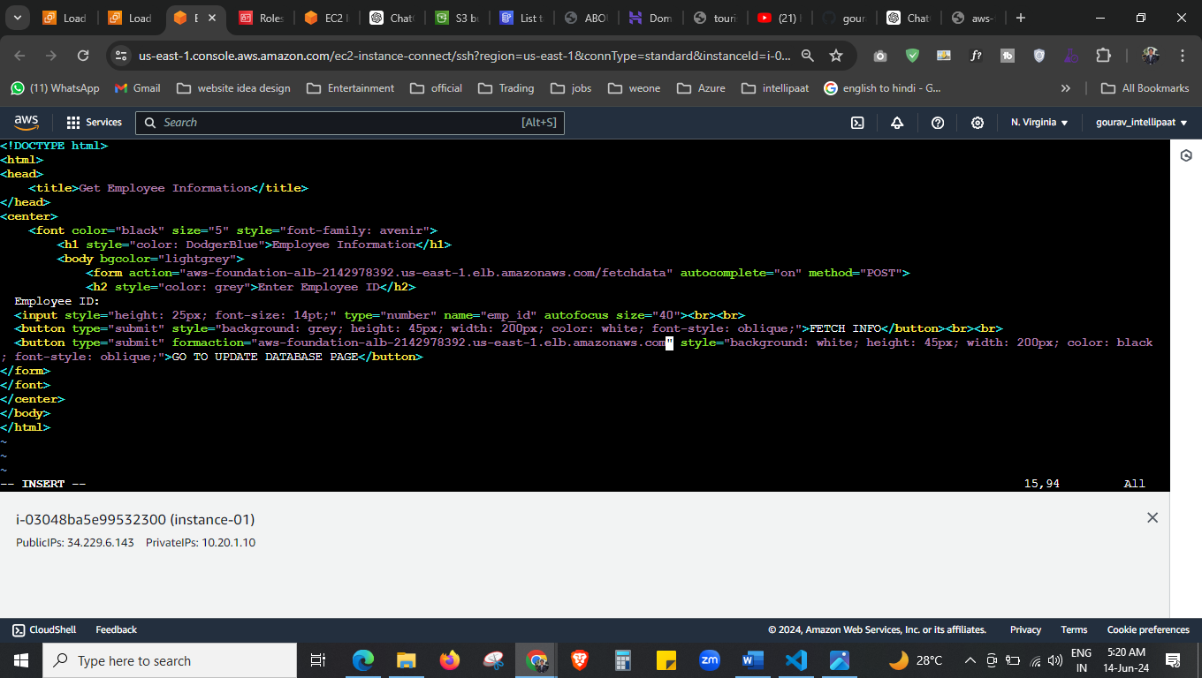

In every file we have to change the 0.0.0.0 by our DNS

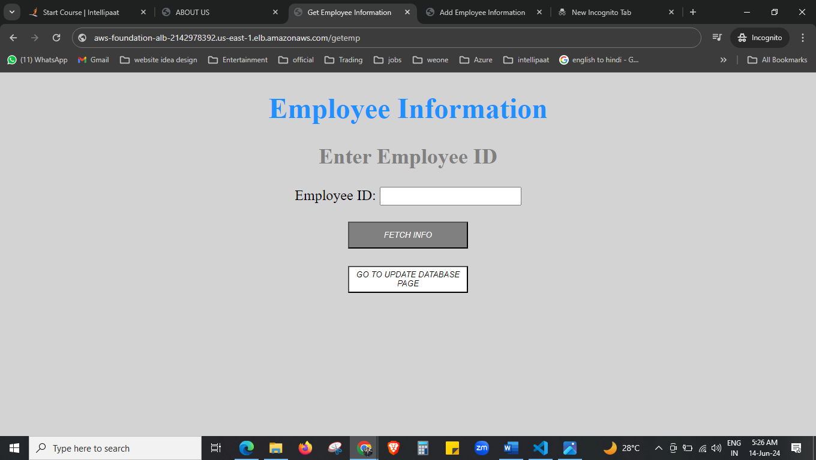

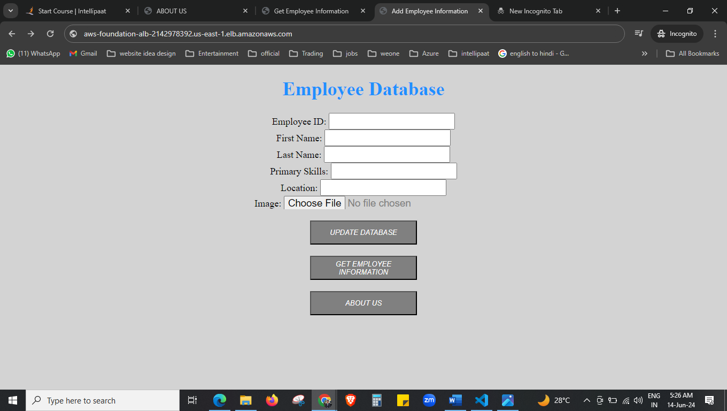

This is by DNS but we need to add it by route 53 alies record.

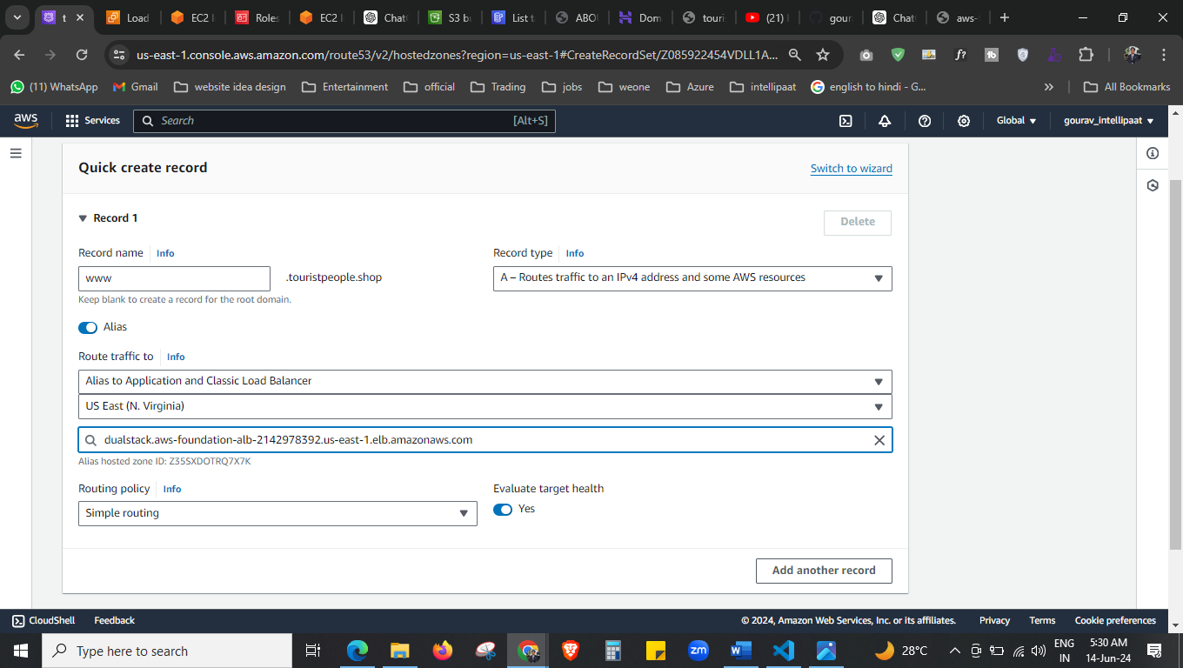



Here we added the DNS in route 53 alias record.

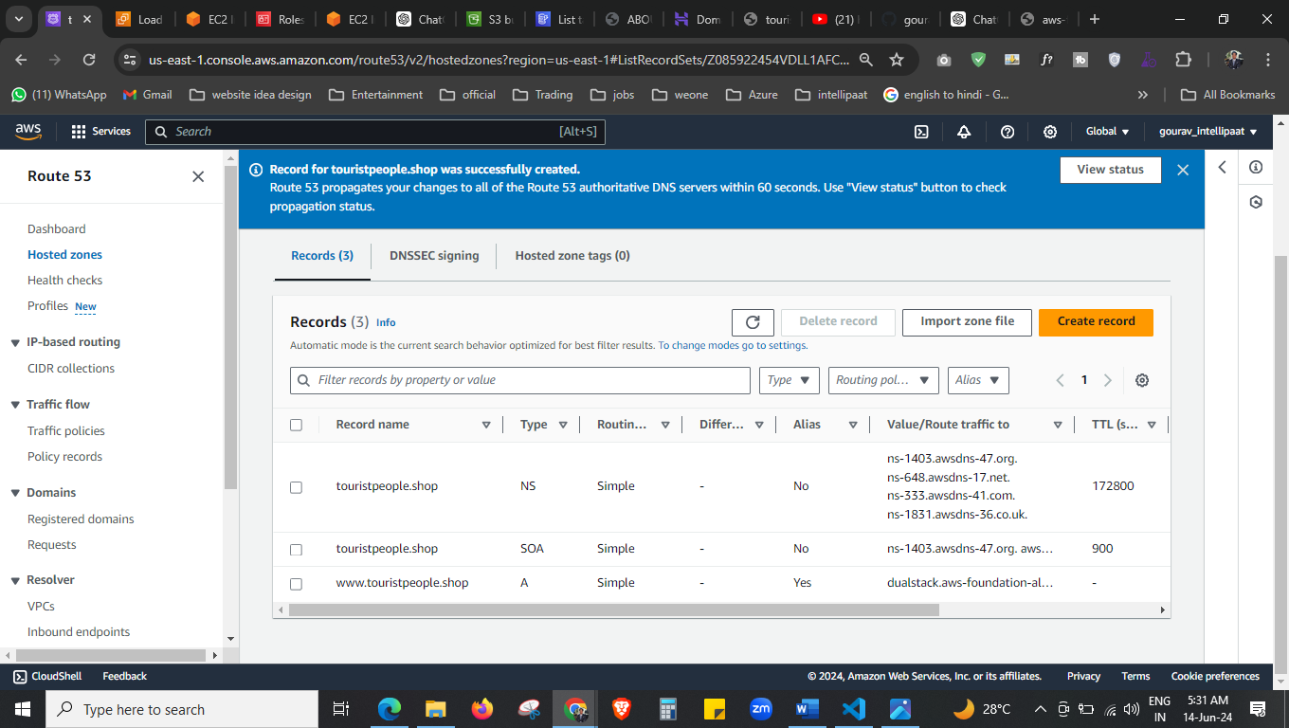  
its done now. 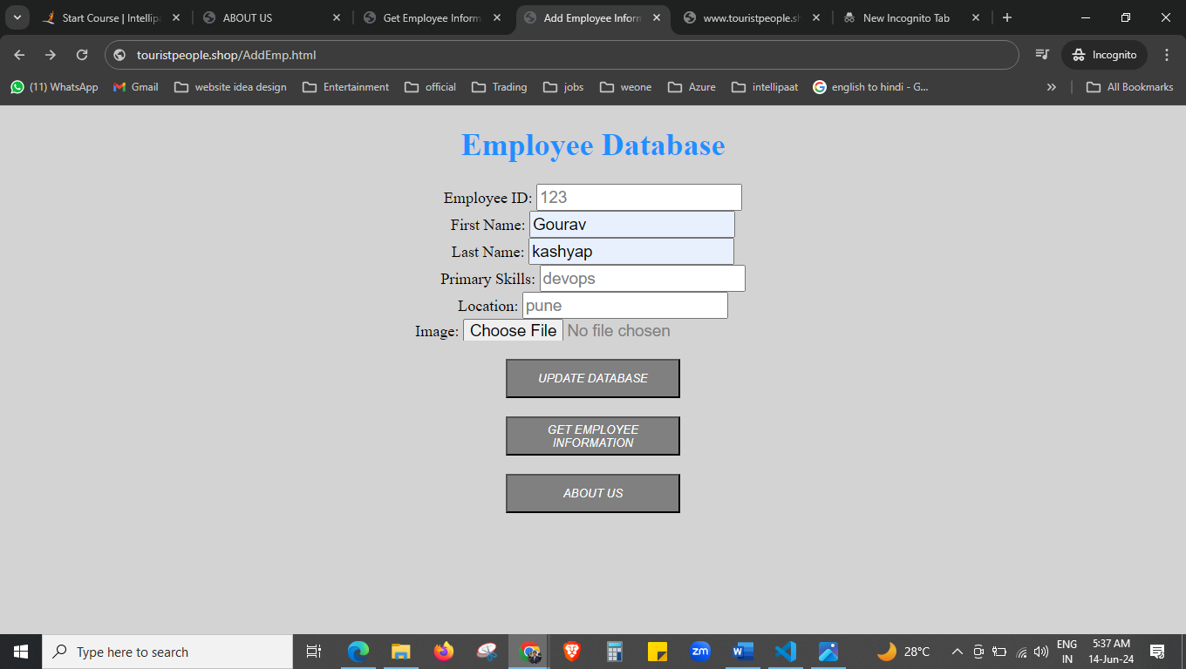 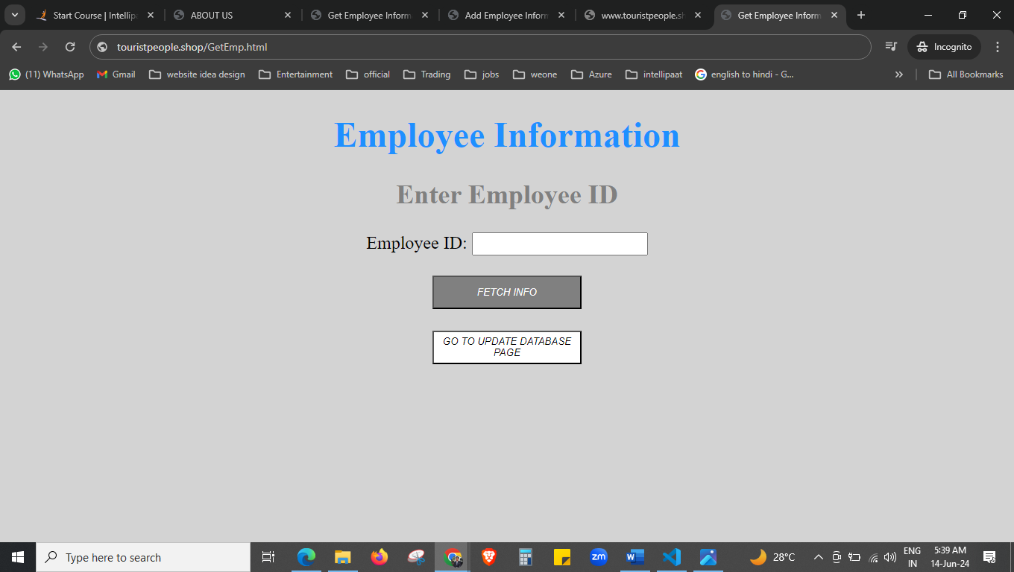



Now we are creating the lambda function for SNS

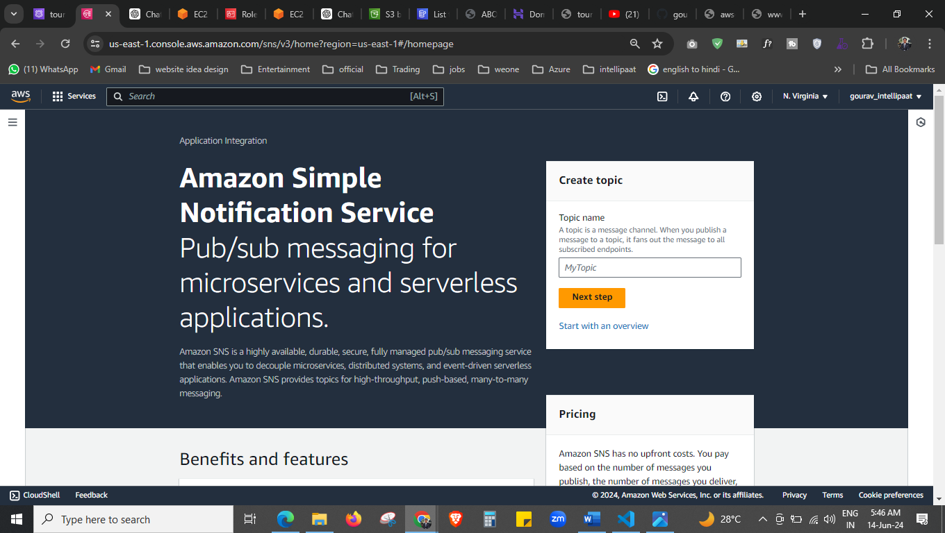



To create the lambda function first create the topic. 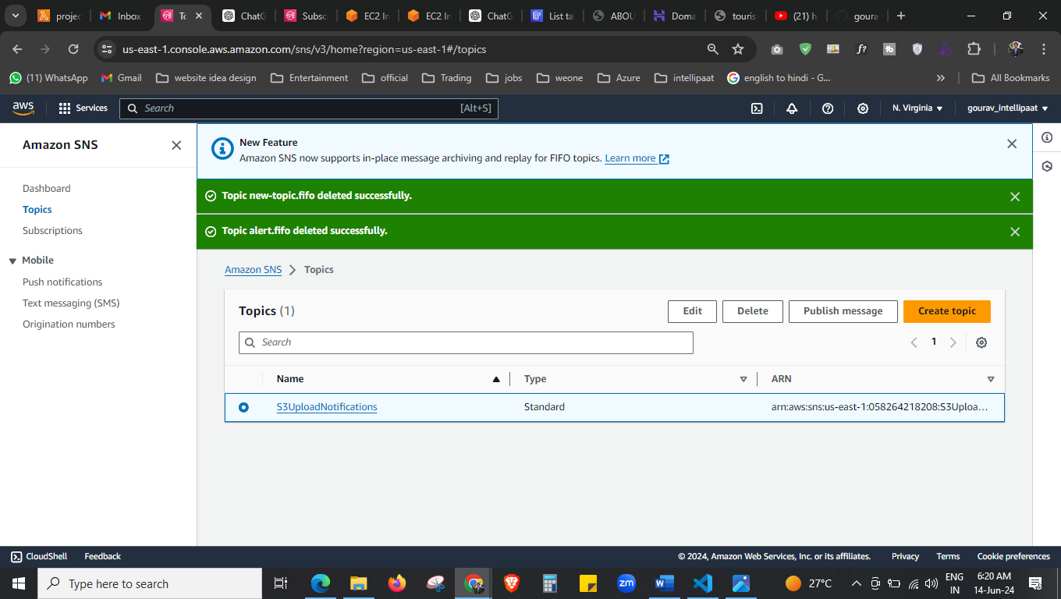

Topic is created now.

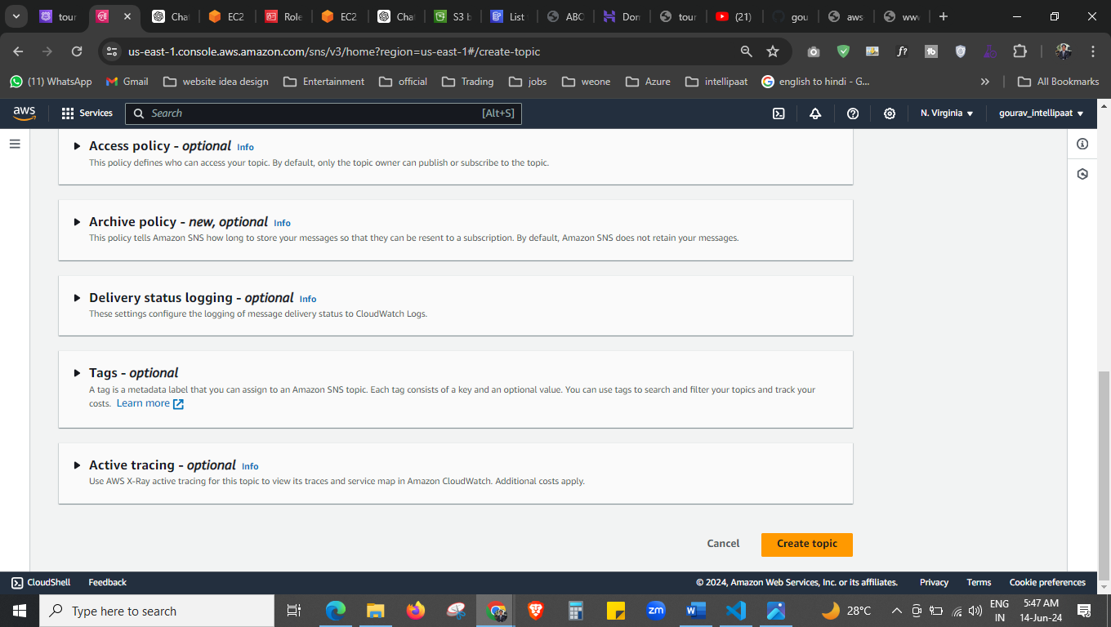

topic is created now.

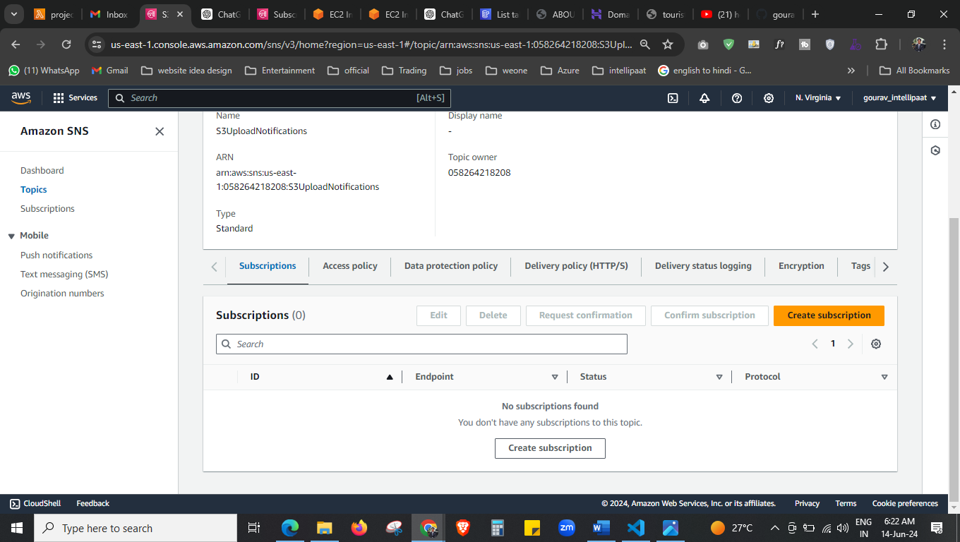



Now we have to create the subscription.

arn:aws:sns:us-east-1:058264218208:S3UploadNotifications 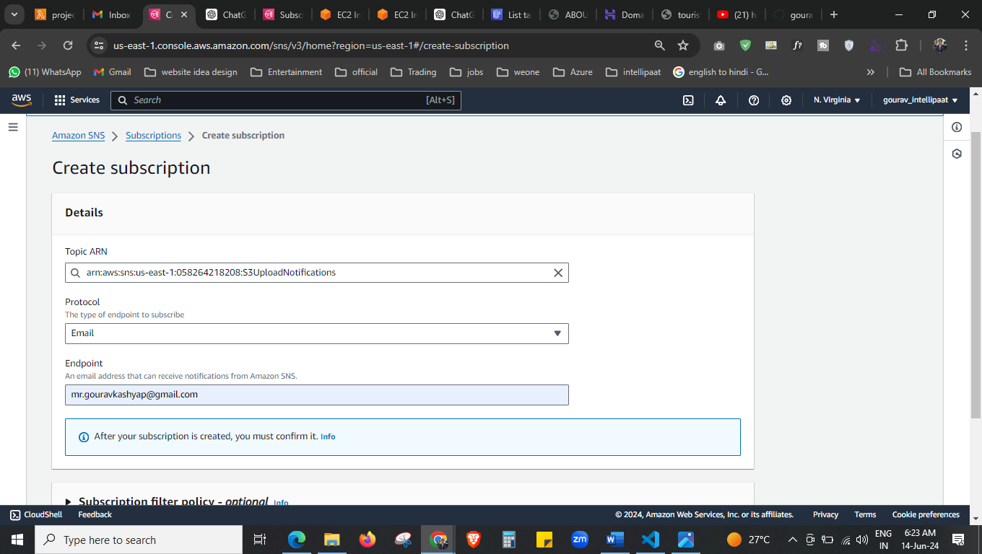 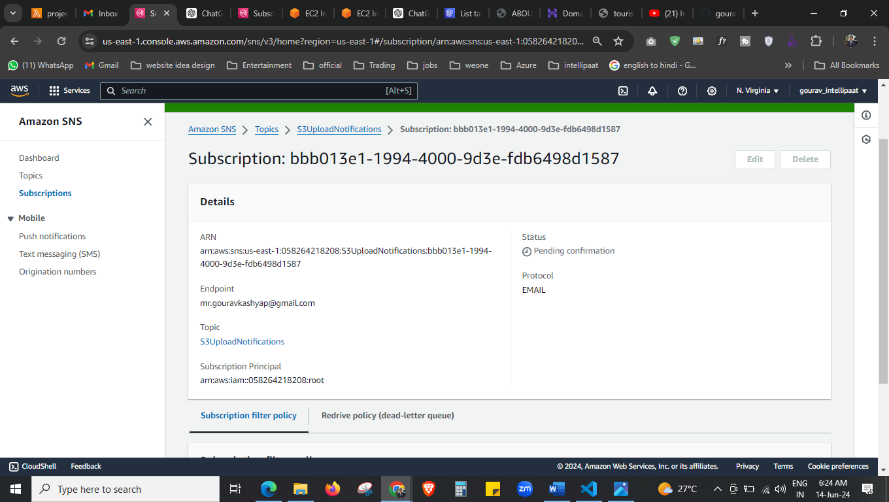



our subscription is created now.

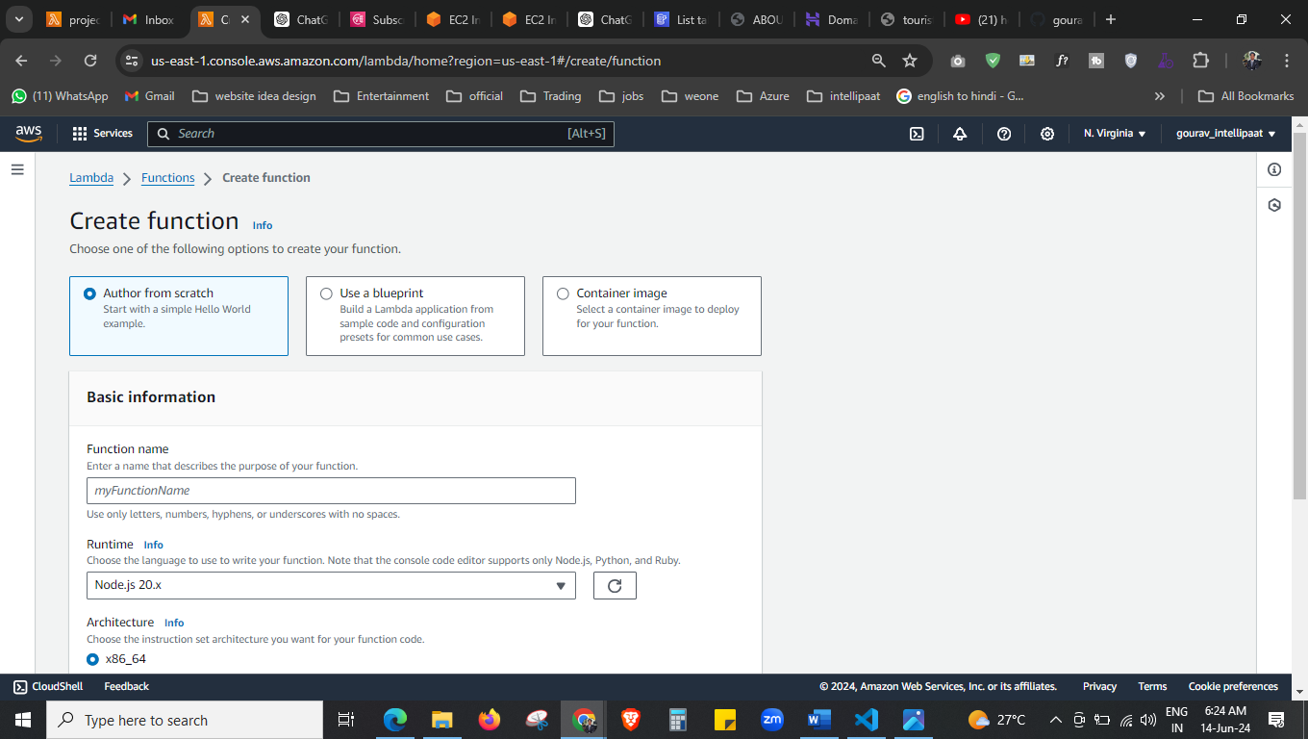



Topic and subscription is created, now we will create the lambda function.

Here I select the python and used this code.  
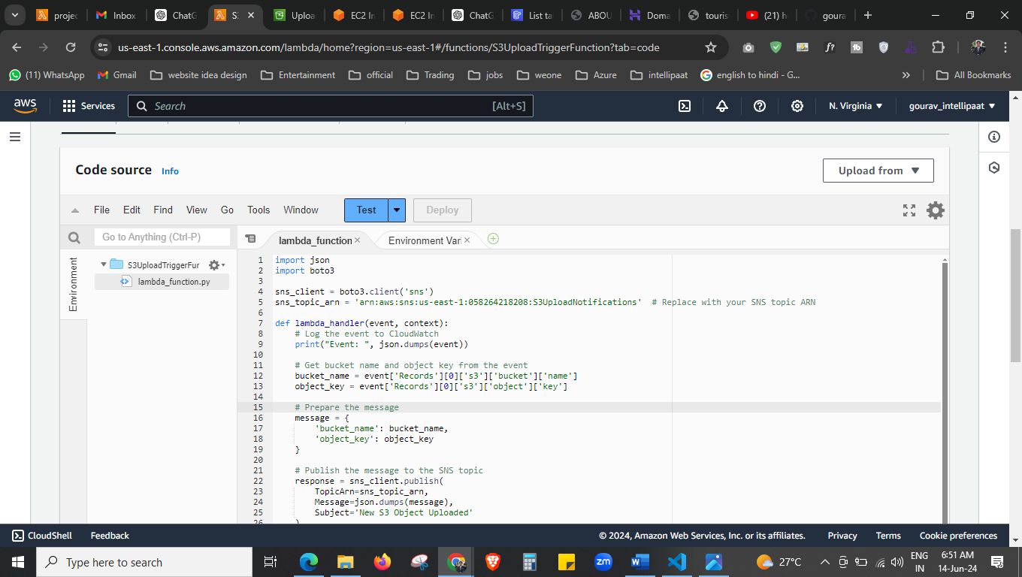

import json

import boto3

sns_client = boto3.client('sns')

sns_topic_arn = 'arn:aws:sns:us-east-1:058264218208:S3UploadNotifications'

def lambda_handler(event, context):

# Log the event to CloudWatch

print("Event: ", json.dumps(event))

# Get bucket name and object key from the event

bucket_name = event['Records'][0]['s3']['bucket']['name']

object_key = event['Records'][0]['s3']['object']['key']

# Prepare the message

message = {

'bucket_name': bucket_name,

'object_key': object_key

}

# Publish the message to the SNS topic

response = sns_client.publish(

TopicArn=sns_topic_arn,

Message=json.dumps(message),

Subject='New S3 Object Uploaded'

)

return {

'statusCode': 200,

'body': json.dumps('SNS notification sent successfully')

}

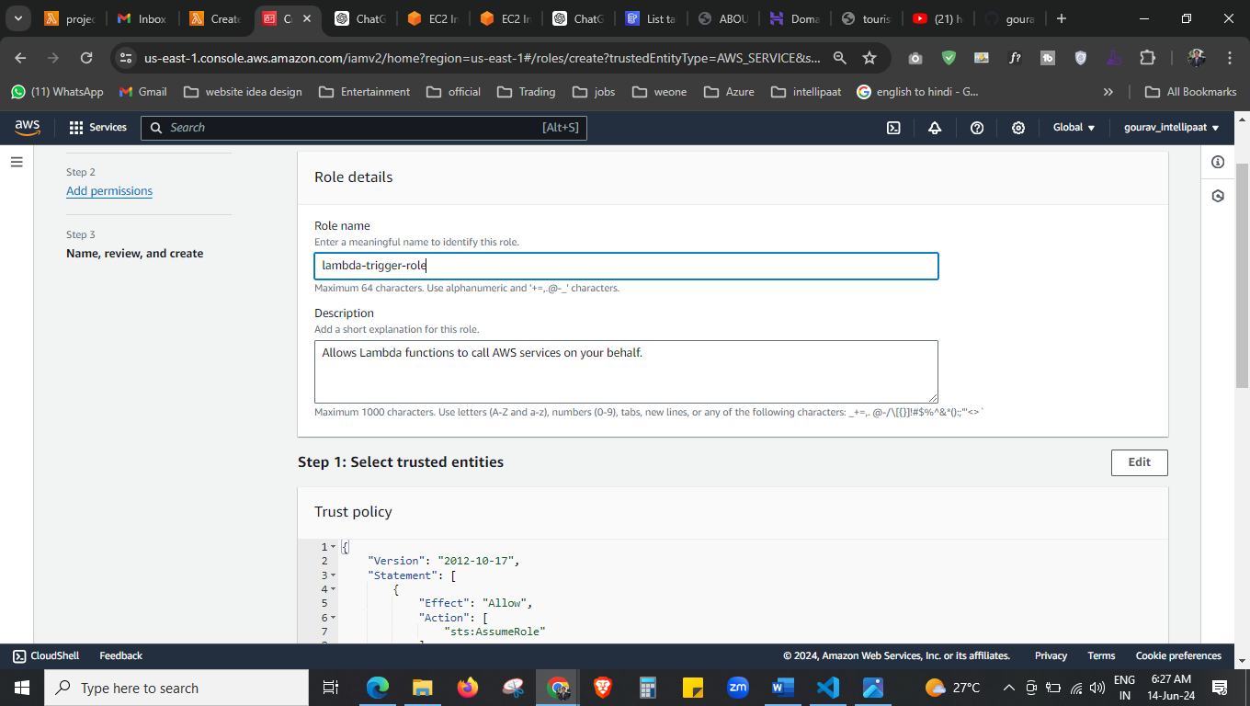

To create the lambda function first we have to give the permission in the form of role.

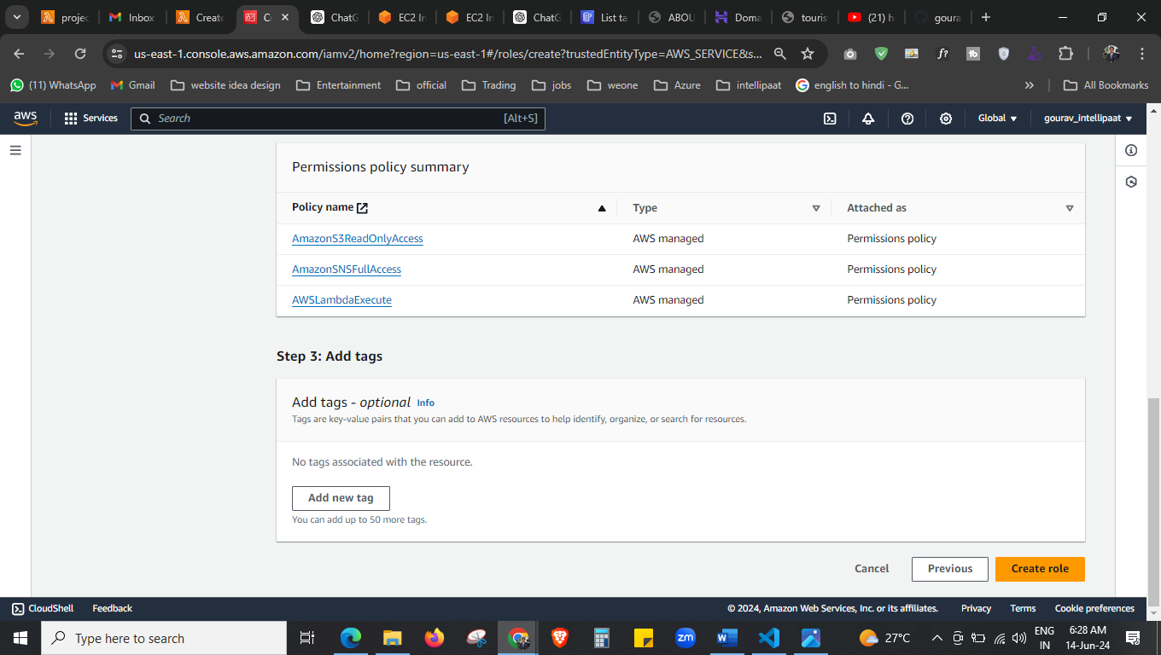



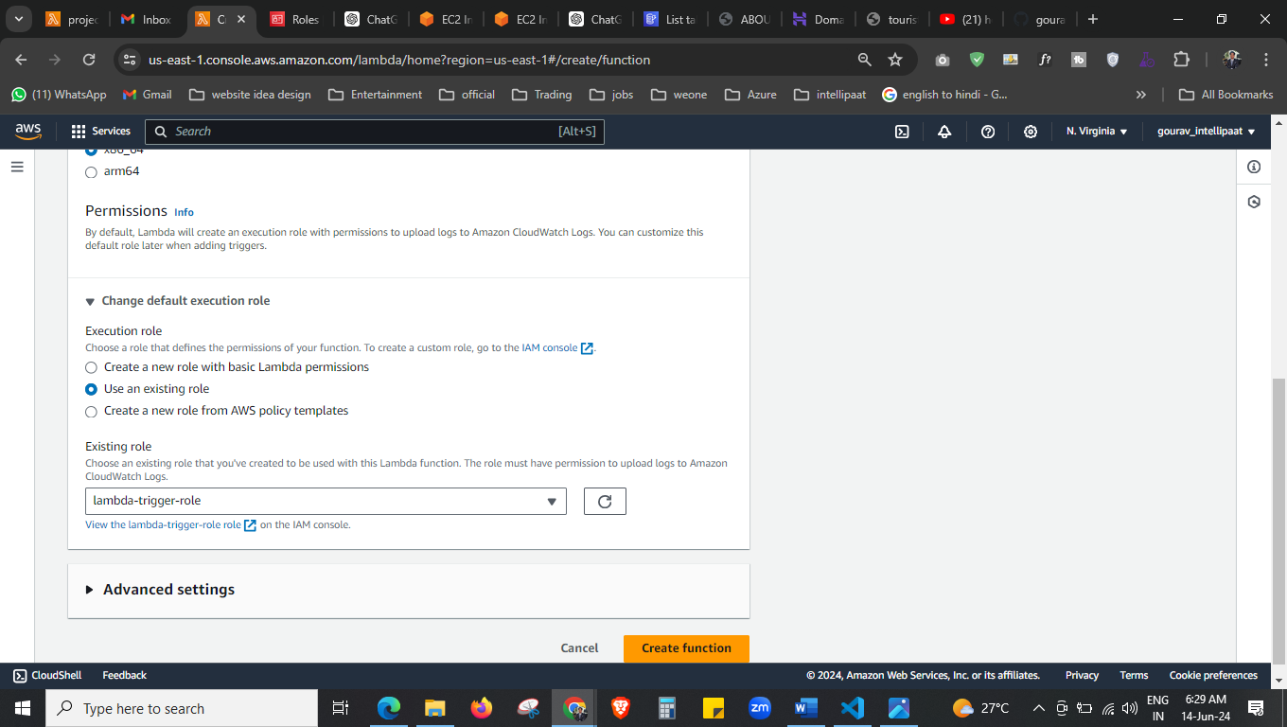



Its done now, create function.

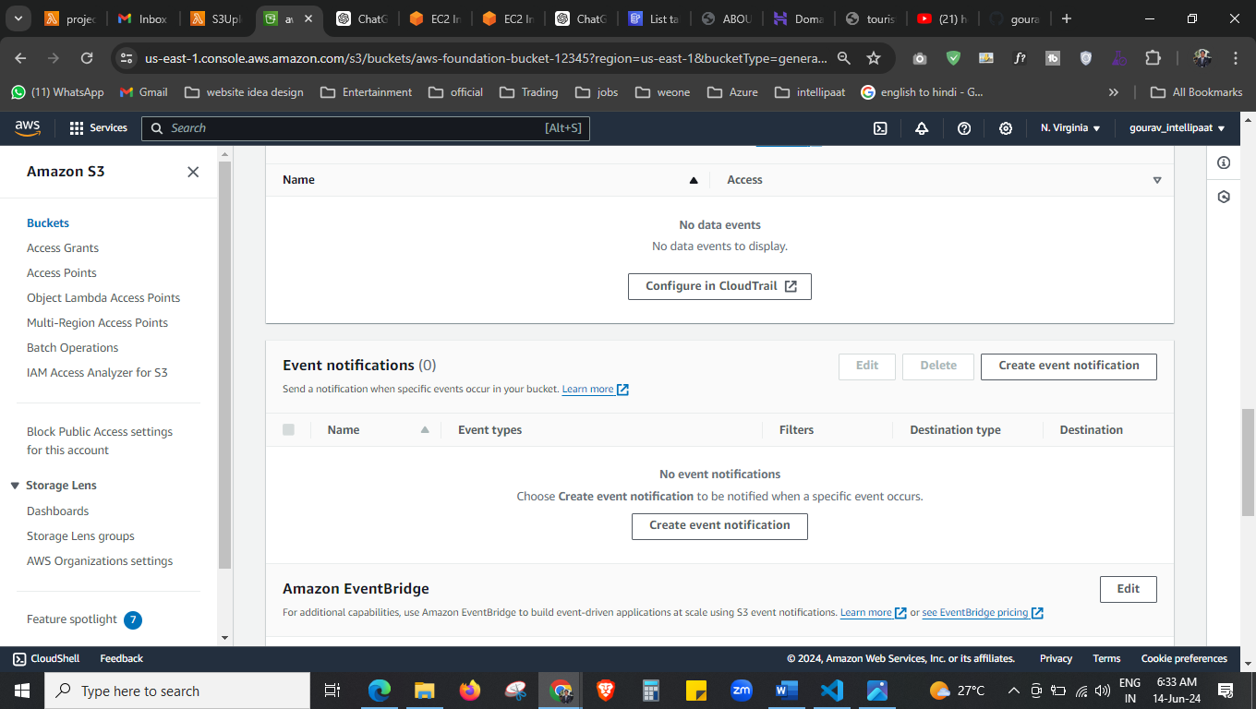



Now go to our s3 bucket and > properties > event notification

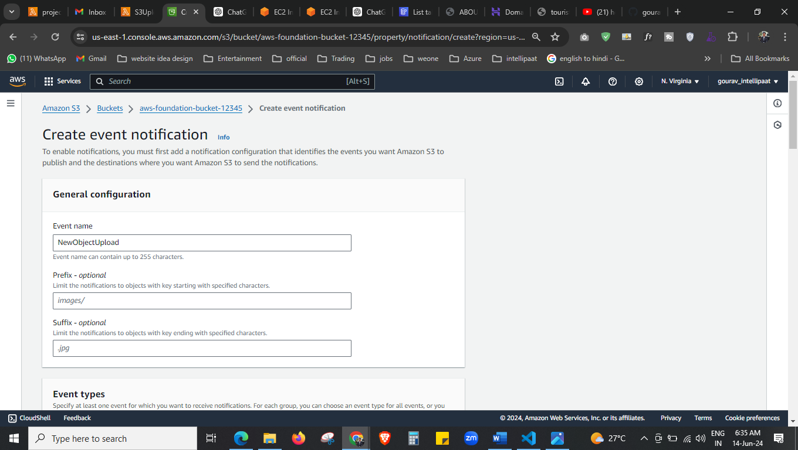 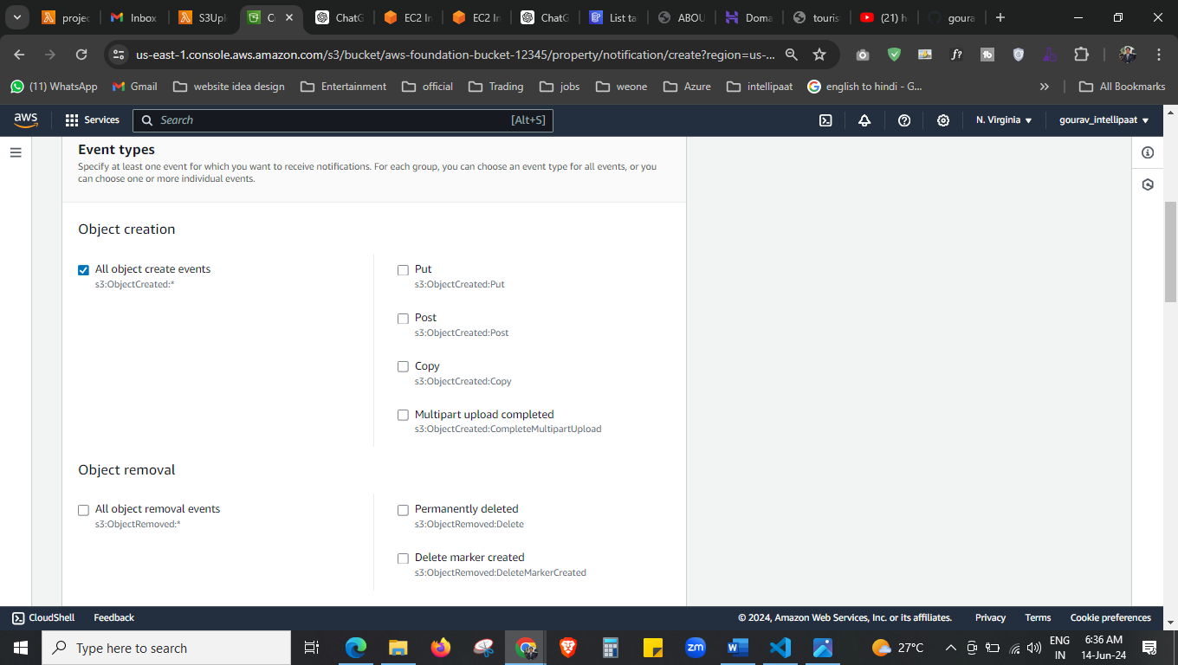



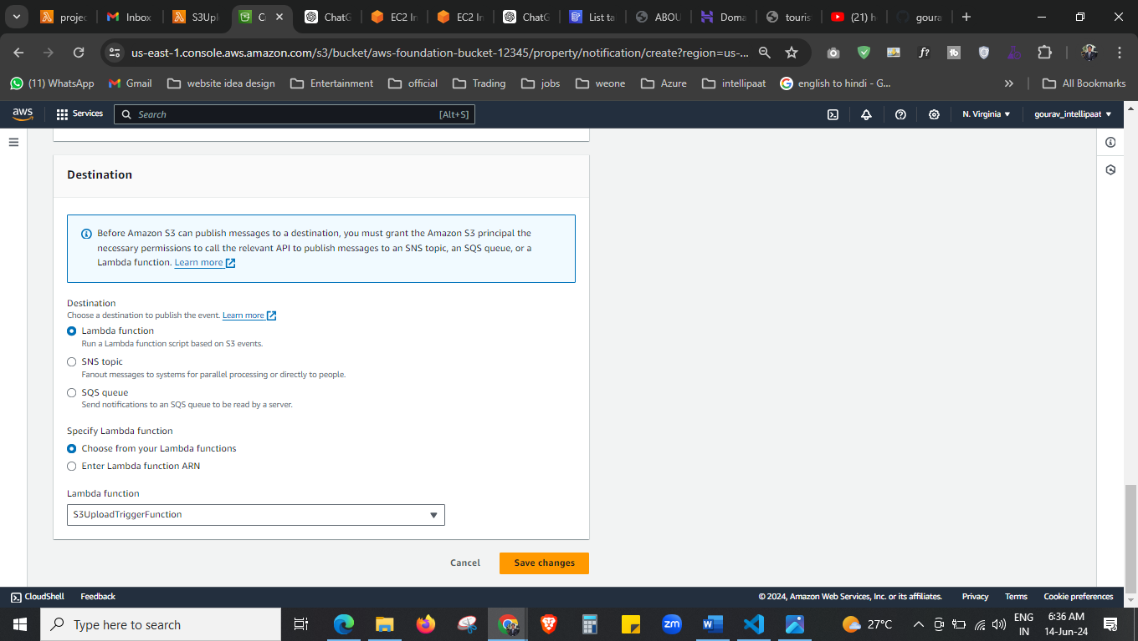



Select our function that we created.

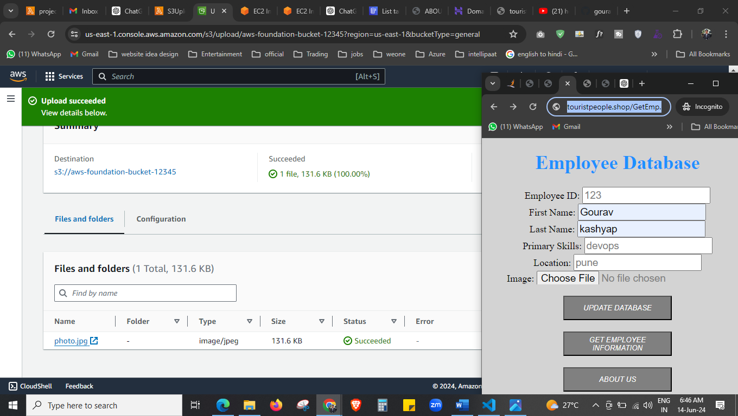



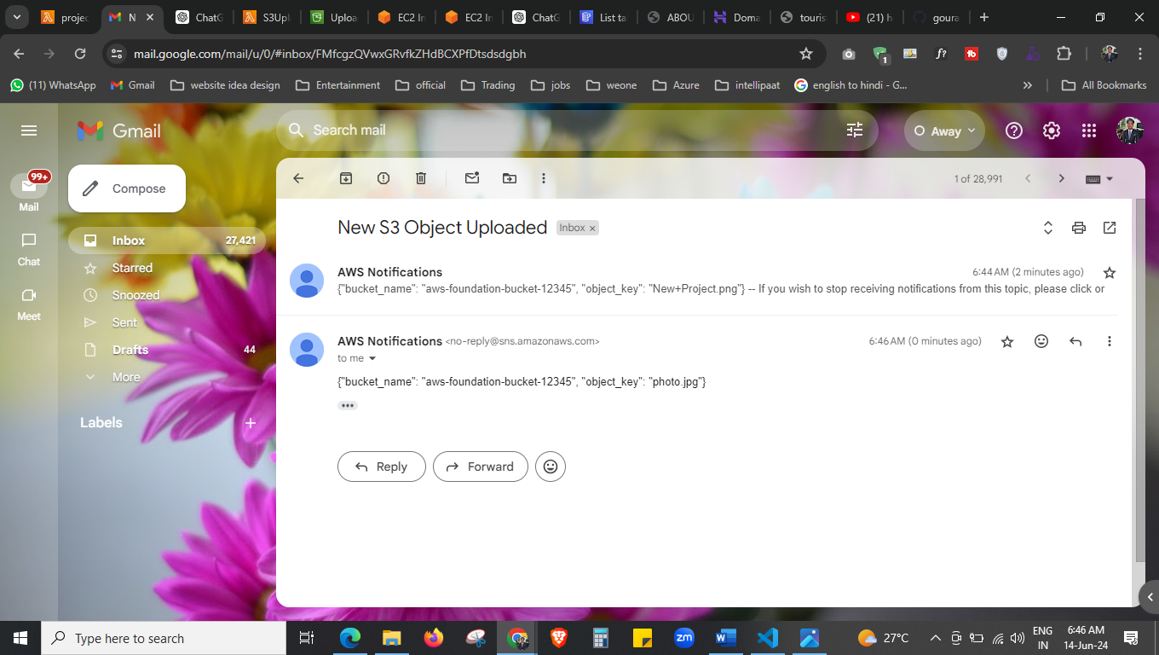



Here we get the notification when anyone enter the data and upload the image this function will trigger automatically and trigger.

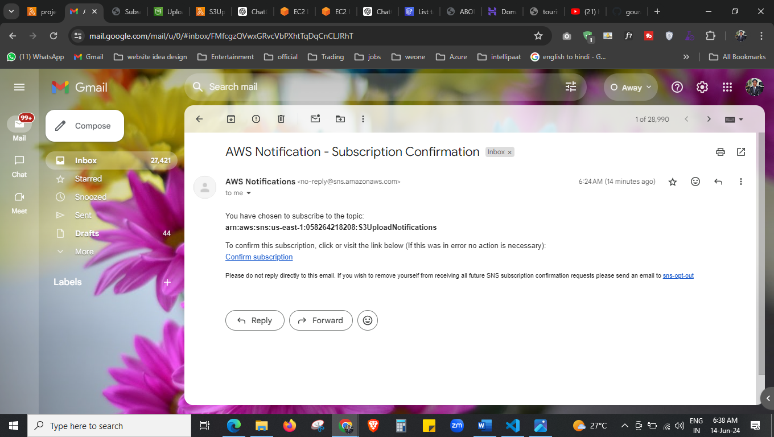 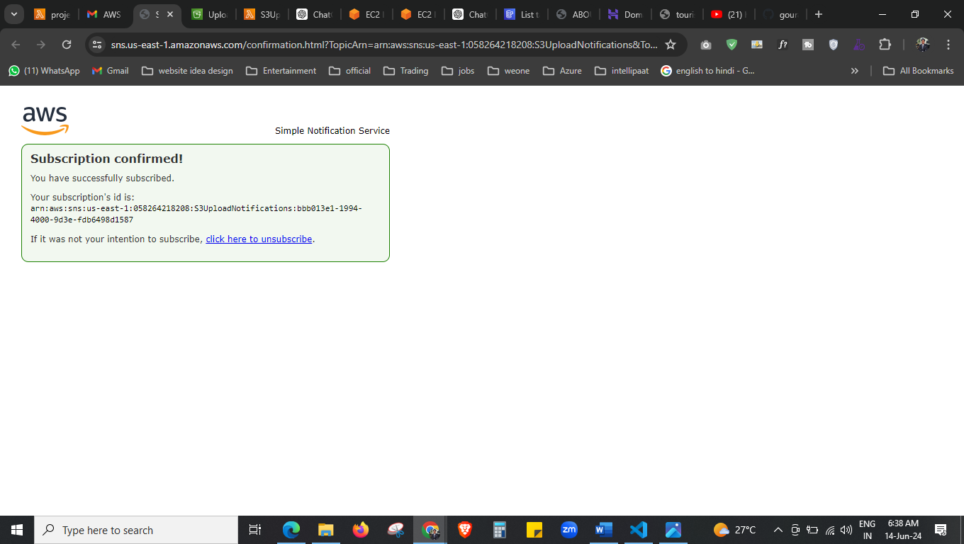after confirm the subscription you will get the mail.

